

PART

# II

## Elementary Services

*This page intentionally left blank*



CHAPTER

# 3

## Exposing SOAP and REST Services Using Service Bus

Service

he architecture team at Saibot Airport has decreed that all services are to be published through the Service Bus (SB). Any consumer of a service calls to a proxy endpoint exposed by the Service Bus and the bus routes that request to the actual service implementation The

**T**

Service Bus is the common virtualization layer that hides the where, how, and even the if of services from consumers. The Service Bus virtualizes the real location of the service as well as its implementation. It makes all services available over standardized protocols and message formats. It also can hide the fact that a service is currently unavailable by rerouting the request to an alternative provider or producing a result from a cache. As part of the virtualization of services, the service does protocol mapping—for example, REST to SOAP or JMS to EJB—as well as message transformation.

The Service Bus as the common entry point provides a number of important run time facilities.

All service access can be monitored, performance and SLA compliance can be tracked, authorization and security policies can be enforced and logging is done. The SB provides scalability through its stateless, easily clustered nature, which also prevents it becoming a single point of failure. The SB can do throttling on large volumes of service requests to prevent choking and general failure of the bus.

In this chapter, we meet the Service Bus. We will develop and deploy a number of simple services—some with SOAP/XML and one with a REST/JSON interface. JDeveloper and its Integrated WebLogic-with-SOA-Suite-Server will be our design time and run time environment.

### Introducing Service Bus

The Service Bus component in the SOA Suite provides an enterprise service bus with all the common characteristics and patterns associated with an “Enterprise Service Bus.” Simply put, the Service Bus in SOA Suite is a stateless, synchronous request/response engine that is a very fast, uniform intermediary between service consumers and heterogeneous services and backend systems, see Figure 3-1. The Service Bus implements the VETRO pattern. This acronym stands for Validate, Enrich, Transform, Route, and Operate. It has support for various other patterns, such as fan-in and fan-out, fire-and-forget, and so on.

Service consumers access an endpoint at the Service Bus using one of several supported transports and protocols. We will focus on HTTP as transport, SOAP and REST as protocols, and

SOAP/XML

Backend System

Implementation of Functionality

REST/JSON

External Service

Service

Bus

Validate Enrich Transform Route Operate

Service

**FIGURE 3-1.** *Service Bus virtualizes access to services and implements the VETRO pattern*

XML and JSON as message formats. Note that the Service Bus can leverage the many JCA adapters available with Oracle SOA Suite for receiving inbound messages, as well as a number of the native transports inherited from previous incarnations of the product.

The endpoint is exposed by a Proxy, the inbound end of a service in the Service Bus, as shown in Figure 3-2. The Proxy receives the incoming request message and, regardless of transport, protocol, or format, will set up a message context that gives the impression that all messages are SOAP messages and all payloads are XML. This context consists of a number of variables—$header, $body, and $attachments. These wrapper variables contain the Simple Object Access Protocol (SOAP) header elements, body element, and Multipurpose Internet Mail Extensions (MIME) attachments, respectively. Another variable—$inbound—provides metadata about the incoming message, such as transport and security.

The message context is handed over by the Proxy to the Pipeline—the central message processing unit in the Service Bus providing routing and transformation capabilities. The pipeline can be seen as a simple function that is invoked with a message context—based on the initial request—and returns the modified message context—based on the response of the underlying service implementation and whatever processing takes place in the pipeline.

The pipeline is a special type of program, visually constructed using a number of built in operations, many of which operate on the predefined message context variables or on custom XML variables. Among these standard operations are common programming instructions such as assign (value to variable), replace (value in variable), if else, forEach, call out (to Java Class or external service), and publish (a log message or some alert or report).

The first half of a pipeline processes the request message received from the Proxy—available through the message context variables. It typically ends with a Routing action that invokes a *business service* (which is the local bridge in the Service Bus to external services) or another SB pipeline. The values of the $body, $header, and $attachments variables at the time of this routing action determine the contents of the request message sent in the invocation.

Proxy

Business Service

**FIGURE 3-2.** *Message processing from proxy through pipeline to business service and the four*

*roles played by $body variable regarding the inbound and outbound payload from and to proxy and business service*

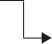

Pipeline

Transform

Enrich

Validate

$body

Response

$body

Route

Transform

Enrich

Validate

$body

Request

$body

Proxy

Proxy

Business Service

Business Service

The response from the routing call to either the business service or the pipeline sets the values of the three message context variables for the second half of the pipeline: the response flow. After the possible manipulations of the variables, their values at the end of the pipeline are used to compose the response message returned from the proxy to the service consumer. Note that response processing takes place in a different (Java) thread than the request processing.

A business service in Service Bus terms is a reference to an enterprise resource that provides (part of) the implementation of the functionality exposed by the proxy. This resource is invoked by the pipeline through the local representation provided in the SB by the business service component. Part of the business service definition is the adapter or transport over which the underlying service can be invoked, the endpoint(s) and possible load balancing and failover strategy to be used when accessing the enterprise service and the security measures that may have to be used for making calls to the service.

Simple services can do without a call to a business service. For example, when the functionality a service offers can be implemented through a transformation of the request message, there is no need to route to an external service. Note that is largely a theoretical possibility that we will use for our very first implementation only and that is not commonly used in real life.

Note that the Proxy, the Pipeline, and the Business Service are stand-alone components that are developed independent from one another and that are only loosely coupled. Several proxies can be associated with the same pipeline. A pipeline can be used by various proxies as well as other pipelines and a business service can be invoked from multiple pipelines.

##### Airport Information Desk Is the Human Service Bus

The Service Bus plays a similar role toward service consumers in the Service-Oriented Architecture at Saibot Airport as the Airport Information Desk does with regard to people with enquiries. The Service Bus is the entry point for parties invoking services published by Saibot Airport. It will sometimes provide the implementation of the service itself and relay the request to back-end systems in the majority of cases.

The Information Desk is very alike. It is the first point of call for anyone with a question concerning the airport. Questions can be asked over different channels, what we would call transports for the Service Bus: in person at the desk itself, via telephone, or through chat.

The Service Bus supports different formats and the desk will process questions in English, Spanish, and French. The Service Bus is stateless and does either one-way messages (without response) or synchronous request-reply. The Information Desk does not call back; one has to stay on the line or at the desk in order to get one’s answer.

Staff at the Information Desk makes use of various enterprise resources to get questions answered. These include internal IT systems, phone calls to colleagues, email forwarding to other staff members or even external contacts, lookup in manuals, the use of dictionaries, and of course use of Google and other public websites. The Service Bus enlists the help of various types of business services to fulfill service requests. It is the responsibility of the bus—like the desk—to decide which resource to call and how to ask the question from that particular resource given the original request—transforming that request to the format and wording understood by that resource.

When the internal systems change—the people working at the desk will change the way in which they find the answers to the questions. However, when that happens, nothing changes for the customers of the desk. Similarly, when the implementation for a service

changes, consumers of the public services exposed by the Service Bus will not be impacted. That is what we call encapsulation and separation between interface and implementation.

When the Information Desk starts to support a new channel (e.g., Twitter) or hires people who speak a new language (Dutch), nothing will change for the internal systems; all operations continue just like before, only the people at the desk have to adapt.

The Information Desk can easily scale up when demand increases: multiple people can man the desk and there are no special relationships between the clients and the staff. When someone at the desk gets sick, someone else will take over—or the remaining staff will have to work just a little bit harder. This of course is exactly parallel to the clustering capabilities of the Service Bus as well as its fail-over capacity.

In this comparison, the people at the desk are both the proxy and the pipeline; their avenues to answers to the questions asked can be regarded as the business services at their disposal. This includes the people they can call, computer applications they can check and manuals they can look into.

### Developing the Temperature Conversion Service

The value of a service is the product of the functionality it provides—how much does it do—and its reuse potential—how frequently will it be invoked to make its contribution. Unfortunately, the two factors are almost inversely proportional. It is up to the service architect and designer to strike the optimal balance between coarse and fine grainedness and determine the functional scope of each service. Of course, you will end up having services with all levels of grain size in your environment.

###### NOTE

*Flexibility in the implementation of services that allows easy change upon future requirements is also a large factor in determining its value—or rather its cost reduction potential. Sacrificing reuse for lower maintenance costs may well be justified.*

At Saibot Airport, a number of fine grained functions with very high reuse potential have been identified. These functions are utility services that offer conversions between the various appearances of the many physical units that international airports have to deal with, such as

speed, height, distance, weight, and temperature. Utility services such as these offer generic, often not business domain specific, functionality that can be reused throughout the enterprise and even beyond. The implementation is typically fairly straightforward and light weight.

We will start by creating a Service Bus pipeline that is exposed with a SOAP Web Service proxy to provide temperature conversions between Celsius and Fahrenheit. A simple transformation is all it takes to make the conversion. This means that the pipeline does not need to invoke any business services to produce its answer.

**Starting a New Service Bus Project**

Development of any SOA Suite 12*c* component is done through JDeveloper with the SOA Suite extension installed. The first step therefore is to start JDeveloper. Create a new application, for example, using the menu option File | New | Application… This will bring up the New Gallery.

From the Categories tree, click on General > Applications. Select *Service Bus Application with Service Bus Project* from the Items field.

The wizard for creating a Service Bus project appears. Enter the Application Name as ConversionServices. Enter a directory to create the application in. Click on the Next button. On the next page, enter the name of the Service Bus project: TemperatureConversionService. Accept the default directory. Verify that the Service Bus project feature is selected. Press Finish.

JDeveloper will now create the folders you specified if they do not already exist. The .jws file that holds the application definition and the .jpr file that represents the project are created. The Service Bus editor—shown in Figure 3-3—opens for the TemperatureConversionService. The editor is driven by the file overview.xml that is created in the project directory.

##### Create Folders

In Service Bus applications, folders are used to organize artifacts within a project. These folders will not be automatically created in Service Bus. It is recommended though to use a standardized folder structure that is the same across all Service Bus projects as well as similar where relevant with the structure used for SCA Composite applications.

At this moment, create the following folders in the TemperatureConversionService project:

*Schemas*, *WSDLs*, *Transformations*, and *Proxy*.

A folder is created through the New Gallery. Open the New Gallery from the context menu on the project node in the application navigator. Note that this context menu will contain the option Folder after the first time you have created one. In the Gallery, select Folder in the list of items shown when the General Category node is selected. Click on OK. Enter the name of the desired folder in the Create Folder dialog. Accept the default directory to create the folder in.

Then press OK. The project should now look like Figure 3-4.

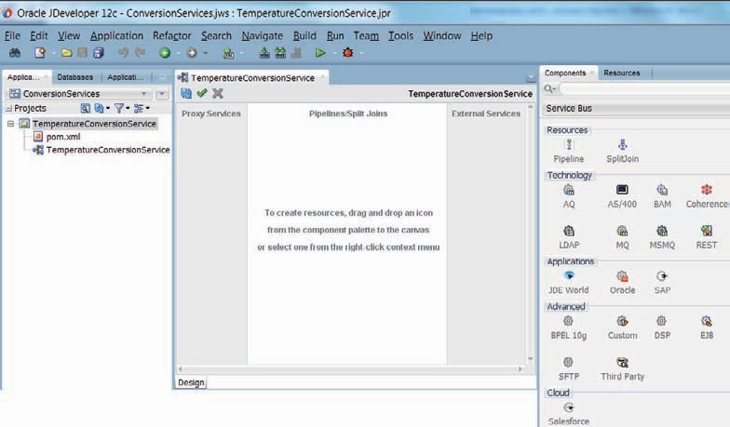

**FIGURE 3-3.** *JDeveloper showing the Service Bus project TemperatureConversionService*

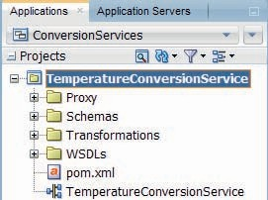

**FIGURE 3-4.** *Folder structure in TemperatureConversionService project*

###### NOTE

*Folders* Adapters *and* Business Service *will be added at a later stage.*

#### Importing the Design Resources

The designers at Saibot Airport have created not only the XSD documents representing the canonical data model, but also the specific service interface for the TemperatureConversionService. This contract consists of a WSDL document that defines the interface of the service and an associated XSD document with the definitions of the request and response messages prescribed for the operations in the service interface. This schema definition makes use of the file common.xsd that contains some basic canonical types used throughout Saibot’s services landscape. In this chapter, we will take a somewhat naïve view in that both XSDs are located locally, in the same directory. In later chapters we will reference generic, reusable resources such as common.xsd from the MDS (Meta Data Services) repository.

Select the option Import on the context menu for the WSDLs folder node. From the Import dialog, choose *Service Bus Resources*. Click on OK. Select Configuration Jar on the first page of the wizard Import Service Bus Resources. Select the jar-file TemperatureConversionServiceResources.jar in the source directory for Chapter 3. Click on Next. The wizard will present an overview of what resources it will import into the project—see the left part of Figure 3-5. Accept all (three) resources and click on Finish.

When the import wizard is complete, the two XSD files and the WSDL file are imported into the project. The application navigator tree looks as is shown on the right in Figure 3-5.

Let’s take a brief look at the TemperatureConversionService interface, starting with the WSDL for this service. The meat of the WSDL is found in the portType element. This service exposes a single operation, called *getTemperatureCelsiusToFahrenheit*, which is evidently offering to convert a temperature value in degrees Celsius into the Fahrenheit equivalent.

The input message to be passed into the operation is named

*temperatureCelsiusToFahrenheitRequestMessage* and the result is returned in the form of

a *temperatureCelsiusToFahrenheitResponseMessage*. These messages are defined in the messages element. The definitions of the both messages contain a single part, based on XSD elements in the imported XSD document TemperatureConversionService.xsd.

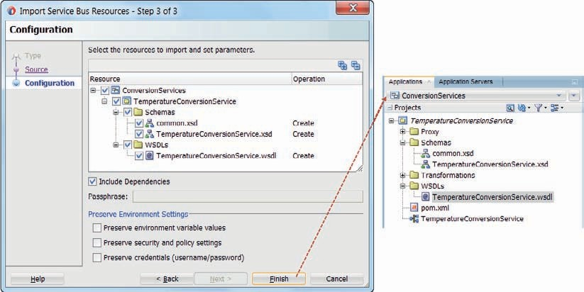

**FIGURE 3-5.** *The TemperatureConversionService project after importing the design resources*

Exploring dependencies from the context menu on the WSDL file quickly reveals the file level dependencies, as is shown in Figure 3-6.

#### Create the Proxy

What we are doing here is essentially contract-first development: based on the definition of the contract, that was created first, we are now ready to develop the service implementation. The Service Bus project will expose a proxy service as its entry point. This particular proxy will support an SOAP/XML over HTTP transport and protocol style.

A straightforward way to create the proxy for the TemperatureConversionService is using the option *Generate Proxy Service* on the context menu for the TemperatureConversionService.wsdl. When you activate that option, a wizard occurs—see Figure 3-7. On the first page, set the *Location* (where the proxy is to be generated) to the Proxy folder you have created earlier on in the project. Uncheck the check box *Generate Pipeline* that would instruct the wizard to automatically create a pipeline (with the same interface as the proxy) and link the proxy to the

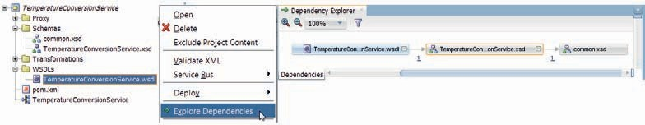

**FIGURE 3-6.** *The Dependency Explorer for TemperatureConversionService.wsdl*

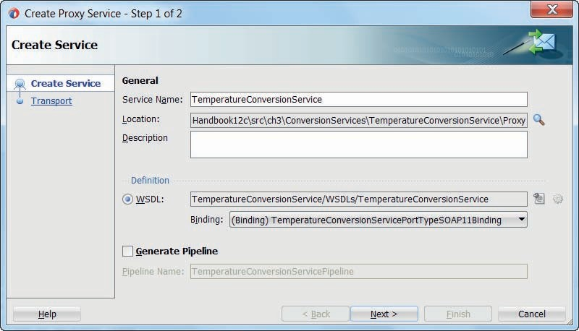

**FIGURE 3-7.** *The wizard for creating a Proxy Service*

pipeline. In later situations, we will use that option—as it is actually quite convenient. Right now, it is important to understand the various constituents of a Service Bus project.

Click on next.

In the second page of the Proxy Service wizard (Figure 3-8), we can specify the transport to be supported by this proxy service. Among the options are *jca—*for when we use the inbound mode of one of the technology adapters available with the SOA Suite, *local—*for proxies that are only

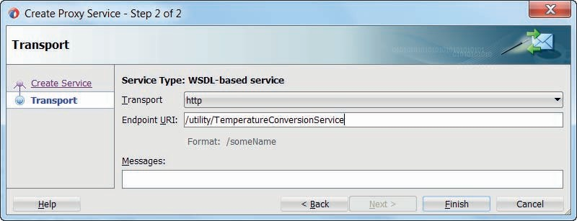

**FIGURE 3-8.** *Specifying the transport details for the new Proxy Service*

invoked by other proxies and pipelines-, *jms* and *ws—*for interactions according to the Web Services Reliable Messaging (WSRM) specification. For regular SOAP/XML style proxy services, we will use the default option of *http*.

In the Endpoint URI field we specify the endpoint at which this service will be published. The value we provide here will be combined at the run time with the host name and port of the actual machine running the SOA Suite to form the physical URL to which the HTTP/SOAP requests are to be sent.

Enter the value as /utility/TemperatureConversionService. Then press Finish.

Now the wizard will close and the proxy service is created in the designated folder Proxy.

Double clicking the proxy service will bring up the editor, shown in Figure 3-9.

The property Target Service is marked as invalid, because it is not yet set. Through this property we specify where the Service Bus should forward the message received by the proxy after it has been normalized to SOAP/XML format. After we have developed the pipeline that will perform the temperature conversion, we will revisit the proxy and set this property with a reference to the pipeline.

#### Create the Pipeline

With the proxy defined, we now need to develop the pipeline where the real action takes place— the relevant subset of VETRO activities. Regardless of the transport exposed by the proxy, the pipeline is created as if the service is regular HTTP/SOAP/XML-style (which in this case the proxy’s transport happens to be too). A pipeline in general is created without any special consideration for the proxy service(s) and other pipelines that will invoke it.

Create the pipeline using the menu option Service Bus | Generate Pipeline on the context menu for the wsdl document.

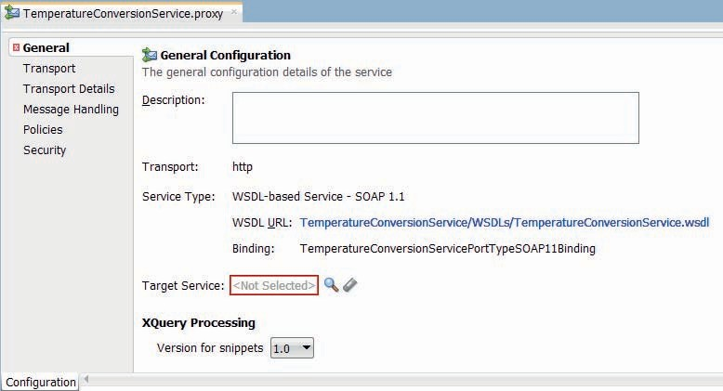

**FIGURE 3-9.** *The proxy editor for the TemperatureConversionService proxy*

The wizard for creating a service bus pipeline opens. On the first page, set the Name to *TemperatureConversionPipeline* and the Location to a new *Pipeline* folder that you create from the browse dialog. Click on the Next button. Accept the already selected Service Type settings, derived from the wsdl. Uncheck the check box *Expose as a Proxy Service*. In this case, the proxy already exists and is waiting to be connected to the pipeline. Press *Finish*. The wizard will now create the pipeline that supports the interface defined in the WSDL document TemperatureConversionService.wsdl.

The pipeline editor has two tabs, labeled *design* and *configuration* respectively. On the design tab, the message flow through the pipeline is visualized. The component palette exposes all the actions we can make use of when programming the pipeline. We can drag and drop these actions to the visual flow editor to add them to the pipeline. This is shown in Figure 3-10.

The configuration tab allows to set properties for various aspects of the pipeline’s behavior. This includes settings for how to deal with large messages and attachments, the transactional behavior, the way the pipeline determines from a request message which operation in the service interface is invoked, as well as optionally the strategy to use for ensuring the sequence for processing messages. For the very simple TemperatureConversionService we will accept all default configuration settings.

On the design tab, add a Pipeline Pair to the message flow by dragging it from the component palette and dropping it below the *TemperatureConversionPipeline* icon. A pipeline pair is a container component used to organize part of the message flow through the pipeline—as illustrated in Figure 3-2. The word pair in the name refers to the fact that there is a matching couple of flows: one that describes the journey of the incoming request message on its way through the VET (Validate-Enrich-Transform) stages to possibly some routing to an onward destination, and a matching one for the response message received back from the next step in the pipeline and the validation, enrichment, and transformation it undergoes before being handed back as response to the next step up the call chain. Note that the earlier discussed variables

$body, $header, and $attachments can be read and operated on in the activities in the pipeline.

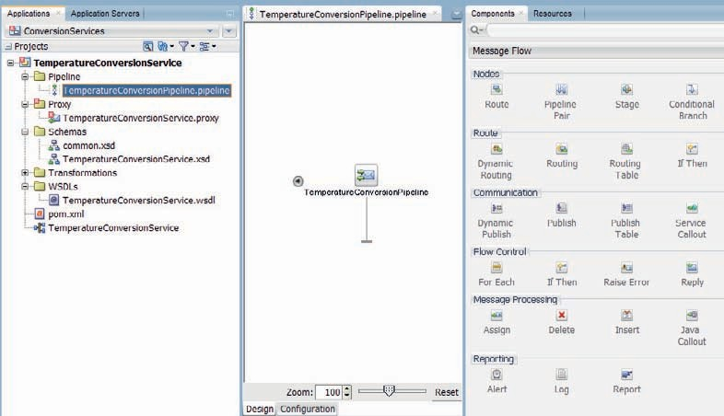

**FIGURE 3-10.** *Pipeline editor and Component Palette with all available pipeline activities*

Inside each of the two flows in the pipeline is currently a single stage included. A stage is the smallest activity container available in pipelines. In the pipeline editor, stages are used to optimally organize, present, and navigate the pipeline. A stage has a user defined name, it can contain one or more activities. It can have an error handler. Stages can be expanded or collapsed, moved around, copied and pasted, removed and recreated. Stages cannot be nested.

In the *TemperatureConversionPipeline* we will initially do just one thing with the request message: transform it into a response message with the properly converted temperature value. Before we can configure this transformation through the replace activity, we will first create the XSLT document that handles this particular transformation.

##### Create the Transformation

Manipulation of variables that hold XML data is very common in Service Bus pipelines. This XML content is frequently read from the body or headers of incoming messages or written to outgoing messages. Custom variables can also be defined in pipelines; these too hold XML content that is assigned and manipulated. Manipulation of variables is done using XQuery or XSLT. Both are equally well supported in the SOA Suite, in SCA composites as well as in Service Bus projects.

XQuery is better suited for fine-grained manipulation of individual nodes in XML documents and XSLT is more appropriate for transformation of the entire documents. Deciding which of the two to use for wholesale transformation of the contents of a variable seems a matter of preference; both XQuery and XSLT do such transformations well and there is no inherent preference for either from the run time engine.

In the case of the *TemperatureConversionPipeline* we will develop an XSLT stylesheet that we will use to transform the contents of the $body variable. The value that is passed into the pipeline is based on the XSD element *temperatureCelsiusToFahrenheitRequestMessage*. The value that the $body variable should have at the end of the [response part of the] pipeline— the value that is returned as the response from the pipeline—has to be based on the element *temperatureCelsiusToFahrenheitResponseMessage*. The XSLT stylesheet we are about to create has to perform a transformation between these two elements.

Click on the node Transformations. Open the context menu and select New | XSL Map.

The wizard for creating an XSL Map File appears—Figure 3-11. It supports version 1.0 of XSLT. Set the File Name to temperatureCelsiusToFahrenheitRequestToResponse.xsl. First set the Primary Source, which in this case is also the only source used in the transformation. Press the Browse button in the Sources frames. Browse to the *temperatureCelsiusToFahrenheitRequestMessage* element in the TemperatureConversionService.xsd file, and select it as the source element. Using the Browse button in the Target frame, select the *temperatureCelsiusToFahrenheitResponseMessage* element as the target element. This instructs the tool that the map we are creating should produce an XML document with the structure of the target element—and that it may expect an XML input document of the source type. Note for future reference that an XSL Map can also use auxiliary XML sources and input parameters. Press OK.

The XSL Map editor opens for the newly created XSL document. On the left side, the map editor shows the source structure providing the input to the transformation. On the right side is the target structure that the transformation will produce. In the middle we will add the map itself—the XSLT instructions for constructing the target from the source.

For simple source element to target element mappings, the Design view of the mapping editor is well suited, as we will experience now: drag the temperature source element to the temperature target element. This does not do any value conversion, as it will perform a straight copy of the temperature value. Applying the actual conversion formula is easier in source mode. Switch the map editor to source mode and change the expression

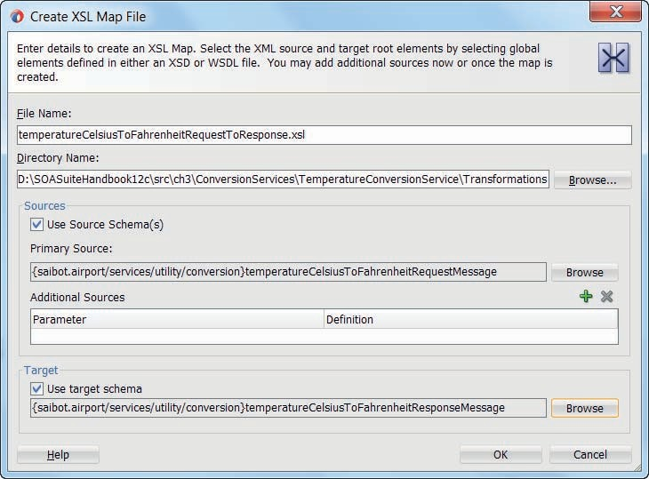

**FIGURE 3-11.** *The wizard for creating the XSL Map file (an annotated XSLT document)*

 <xsl:value-of select="/ns0:temperatureCelsiusToFahrenheitRequestMessage/ ns0:temperature"/>

that was created when we dragged the temperature element to the following expression that actually performs the conversion:

<xsl:value-of select="(/ns0:temperatureCelsiusToFahrenheitRequestMessage/ ns0:temperature * (9 div 5) +32)"/>

Back in the Design mode, the editor looks as is shown in Figure 3-12. It is probably easy to understand why creating this particular conversion is easier in source mode than in design mode.

We can test this transformation. Click on the icon as is indicated in Figure 3-12. The XSL Map tester is opened. Select—or generate—a source XML file. Press OK to run the transformation on the source document. The transformation result is shown, with the Fahrenheit temperature value.

##### Add the Transformation to the Pipeline

Now that we have created the XSLT stylesheet that will do the required transformation of the contents of the $body variable, it is time to add a *Replace* activity to the pipeline that will use the stylesheet to manipulate the variables value.

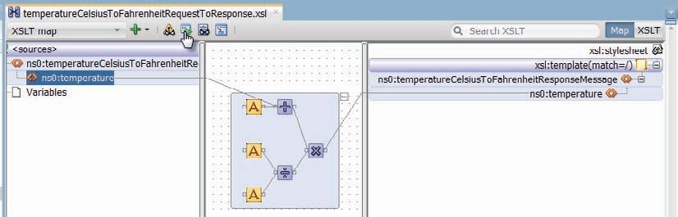

**FIGURE 3-12.** *The XSL Map editor for the Celsius to Fahrenheit temperature conversion*

Drag the Replace activity from the Message Processing section on the Components palette and drop it in the *stage 1* container in the Request Pipeline. Note: Because this pipeline does not route to another component, the Request and Response pipelines are directly sequential and we could have positioned the Replace in the Response pipeline just as easily. Figure 3-13 shows the pipeline with the Replace activity.

The Properties window is used to configure the Replace activity. Note: If the Properties window is not currently shown, it can be made to appear using the Window | Properties menu option or using the Ctrl + Shift + I shortcut key.

The configuration of the Replace activity consists of:

* *Location* (which variable is to be manipulated and what part of the variable’s XML content)—in this case, as in most, that is the *body* variable; the specific part of the XML

content of the variable that is to be replaced is indicated using an XPath expression that selects the XML node to be manipulated. Here, as is common, the XPath expression is left empty, indicating the entire contents of the variable.

* *Value* (what is the expression used to derive the value to be applied to the Location)—the combination of the source value retrieved from the $body variable using the XPath expression

$body/con:temperatureCelsiusToFahrenheitRequestMessage and the XSLT stylesheet used for the transformation of that source value: temperatureCelsiusToFahrenheitRequestToResponse. xslt—as shown in Figure 3-14.

* *Replace Option* (either *Replace entire node*—to specify that the nodes selected by the XPath expression you defined are replaced along with all of its contents, or *Replace*

*node contents*—to specify that the node is not replaced but only the contents are). In this case, only the node’s contents are replaced. Note: Selecting *Replace node contents* and leaving the XPath field empty is more efficient than selecting *Replace entire node* and setting the XPath to ./*, even though the two have the same effect.

The pipeline can be tested too, just like the XSL Map. The context menu on the pipeline node in the application navigator offers the item *Run*. Selecting this option will deploy the entire Service Bus project to the integrated WebLogic Server-with-Service-Bus-run-time, and it will open

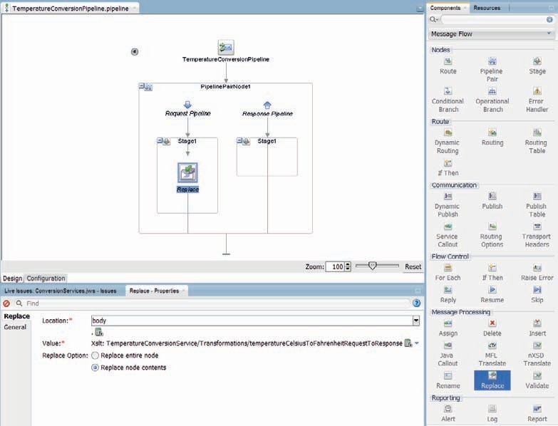

**FIGURE 3-13.** *The Replace activity that transforms the body variable’s contents to the response*

*format with Fahrenheit temperature value*

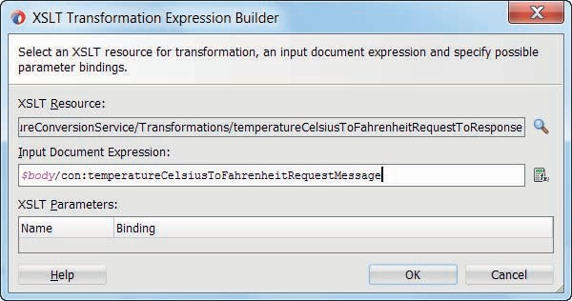

**FIGURE 3-14.** *Configure the XSLT Transformation to be performed by the Replace activity*

the Pipeline Tester in JDeveloper. This tester allows us to specify the input to the pipeline—an XML temperatureCelsiusToFahrenheitRequestMessage element. We can then press the Execute button and the pipeline will be invoked. The tester subsequently shows the response produced by the pipeline, as well as the invocation trace which is a step by step execution overview of what went on inside the pipeline. Figure 3-15 demonstrates this.

###### NOTE

*The pipeline can only be tested when the project does not have any outstanding compilation errors. At this point, the proxy is still in error because it does not have its* Target Service *set. See the next section to fix this.*

##### Link the Proxy to the Pipeline

When we created the proxy earlier on, we unchecked the checkbox to auto generate a pipeline into which the proxy would feed the messages it receives. To get a good understanding of the different constituents of a Service Bus project, we have created the proxy and pipeline separately. Now is the moment to establish the link between the TemperatureConversionService proxy and the pipeline we have just created. Open the proxy editor for this proxy and on the General tab open the Resource Chooser for the Target Service property. Select the *TemperatureConversionPipeline* as the target for this proxy, as shown in Figure 3-16. Note that the icon signaling an open issue now disappears from the proxy.

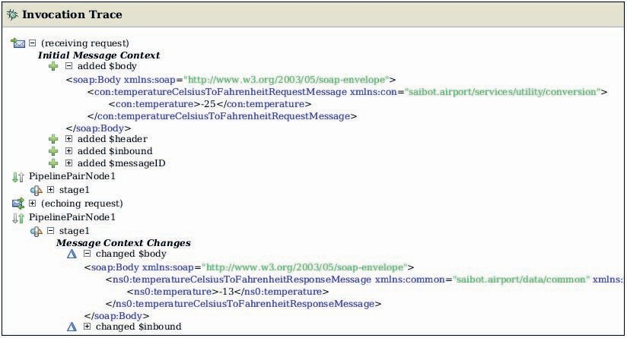

**FIGURE 3-15.** *Demonstrating the Pipeline Tester output for the TemperatureConversionPipeline*

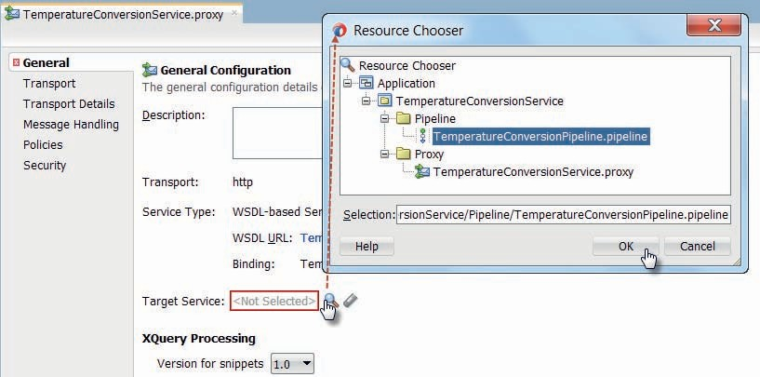

**FIGURE 3-16.** *Configuring the Pipeline as the Target Service for the Proxy*

This completes the implementation of the TemperatureConversionService. With a proxy linked to a pipeline that transforms from the input format—with a Celsius temperature—to the output format—with a Fahrenheit temperature—we have a completely functional service, shown in Figure 3-17. Or that is what we will try to establish in the next section.

#### Run the TemperatureConversionService

The TemperatureConversionService could be deployed to a stand-alone SOA Suite run time environment with Service Bus engine support. However, far easier would be to run the service on the integrated WebLogic Server in JDeveloper. Simply run the service from the context menu on the TemperatureConversionService proxy node. If the Integrated Server is running, the project will be deployed and a window will be displayed, ready for testing. If the Integrated Server is not running, then it will be started, the project will be deployed and a window labeled Proxy Service

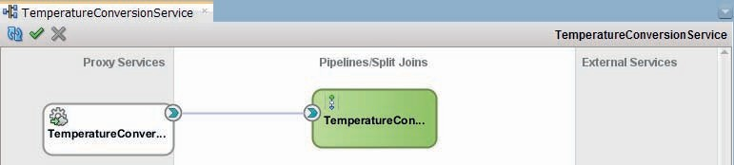

**FIGURE 3-17.** *The Service Bus project overview with the proxy service wired to the pipeline*

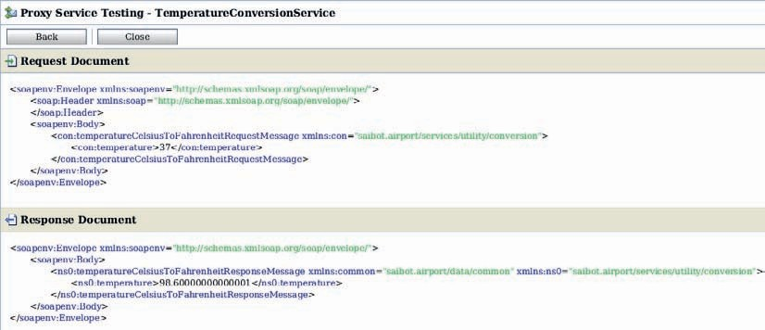

**FIGURE 3-18.** *Testing the TemperatureConversionService*

Testing will be displayed in JDeveloper, as shown in Figure 3-18. Complete the XML payload with a suitable value for the temperature and press Execute. The service is invoked and the Service Bus will produce the Fahrenheit temperature value.

Alternatively, we can invoke the service at its endpoint http://localhost:7101/utility/ TemperatureConversionService, using tools such as the Http Analyzer in JDeveloper – as illustrated in Figure 3-19 - or the popular freeware test tool SoapUI that we will be using throughout this book.

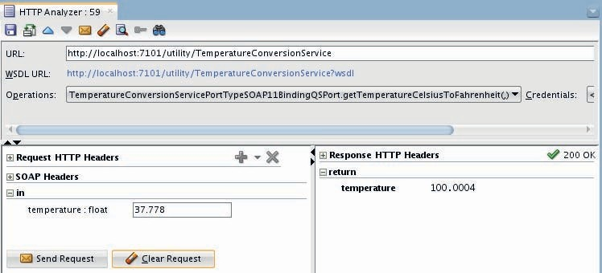

**FIGURE 3-19.** *Testing the TemperatureConversionService using the Http Analyzer tool in*

*JDeveloper*

###### NOTE

*The WSDL URL consists of the service endpoint with the string ?WSDL concatenated to it.*

### Extending the Temperature Conversion Service with Validation, Exception Handling and Reporting

The TemperatureConversionService is a real service, but it hardly scratches the surface in terms of the capabilities of the Service Bus it leverages. In this section, we will make use of some of those capabilities to enhance the service. First we will add validation to check if incoming request messages satisfy the interface. Then we will add exception handling to the pipeline in order to appropriately respond to such contract breach by the service consumer. Finally we take a brief look at how we can monitor the activity in the SB with regards to the TemperatureConversionService.

#### The V in VETRO—Adding Validation

The *temperatureCelsiusToFahrenheitRequestMessage* that is the input to the TemperatureConversionService’s *getTemperatureCelsiusToFahrenheit* operation contains a temperature element that is defined in the common.xsd schema definition, shown

in Figure 3-20.

This makes clear to any invoker of the operation that the value for the temperature element should be numerical—a float—and the value should not be lower than −273.15, the absolute minimum temperature on the Celsius scale.

However, the current implementation of the service does nothing to stop calls from coming in that contain quite invalid temperature values. You can easily verify this by making test calls with non-numerical values or values below the absolute minimum. Nonsensical Celsius temperature values are happily converted by the service into equally ridiculous Fahrenheit temperatures.

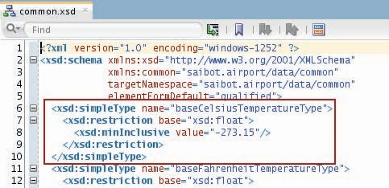

**FIGURE 3-20.** *The XML Schema Definition for the baseCelsiusTemperatureType*

When a non-numerical string value is used for temperature, the Service Bus built-in fault processing takes over to return a decent NaN (not a number) indication—that is basically the tip of the stack trace produced during the failed XSLT transformation.

Validation is required here, as in most cases, to prevent incorrect messages to even reach the hinterland and put an unnecessary load on pipeline activities and underlying business services. Additionally, explicit validation allows us to control what happens in case of incorrect request messages, rather than having to rely on whatever Service Bus mechanism kicks in.

##### Add a Validate Activity to the Pipeline

Open the pipeline editor. Drag the Validate activity from the component palette to *stage 1* and drop it above the Replace activity (after all it is VeTro and not TeVro). Configure the Validate activity in the property editor, as shown in Figure 3-21. It should verify if the contents of the

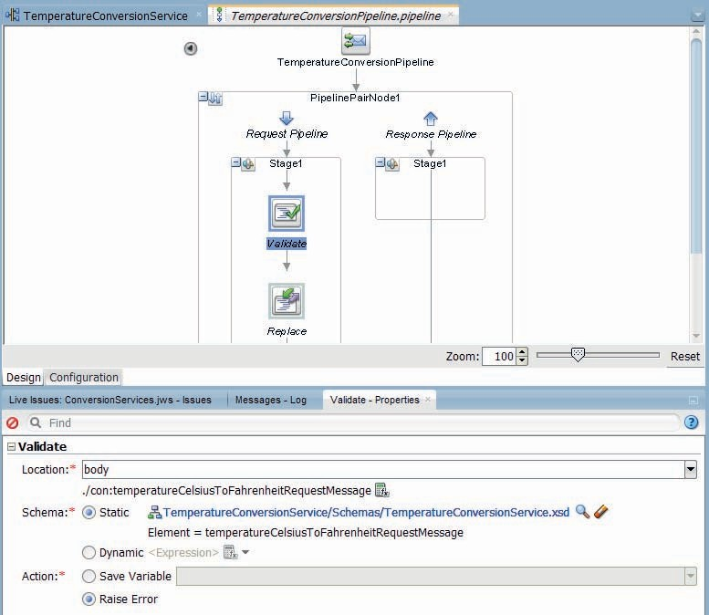

**FIGURE 3-21.** *Configuring the Validate activity to validate the contents of $body against the*

*temperatureCelsiusToFahrenheitType in the TemperatureConversionService.xsd document*

$body variable—which at this point contains the incoming request message—is indeed correctly based on the *temperatureCelsiusToFahrenheitRequestMessage* XSD element.

Set the *Location* property to body—since the $body variable’s contents is to be validated. The XPath expression is set to ./con:temperatureCelsiusToFahrenheitRequestMessage using the XPath expression editor. This indicates that the validation concerns the con:temperatureCelsiusToFahren heitRequestMessage child element in the contents of the variable.

Select the *Static* radio button for the *Schema* property, because this validation is always based on the same XSD element. With the *Dynamic* option we can configure how at run time the required XSD Element to validate against should be determined. Select the

*temperatureCelsiusToFahrenheitRequestMessage* element in the TemperatureConversionService

.xsd schema definition as the definition against which the Location—the *temperatureCelsiusToFahrenheitRequestMessage* child element in the $body variable— should be validated.

The *Action* property is used to specify what should happen in case of validation failure. The options are to save the result of the validation—a boolean result—in a custom variable or to raise an error in case of failed validation. Select the Raise Error radio button for the current pipeline.

##### Test the TemperatureConversionService with Validation

It is easy to see the effect of the validate activity. Just run the proxy again in order to redeploy the Service Bus project with the TemperatureConversionService. The service tester opens in JDeveloper. Now deliberately provide an incorrect value for the temperature element—for example, a numerical value smaller than −273.15 or a non-numerical value—and invoke the service. The response from the service this time will be a standard SOAP Fault message that the Service Bus produces in case of an unhandled exception. This fault message contains a child element called ValidationFailureDetail that indicates exactly what the validation failed on. In Figure 3-22, the temperature element’s value −900 was found to be less than the minimum (−273.15) allowed for elements of type baseCelsiusTemperatureType.

The service interface does not include a fault message for the *getTemperatureCelsiusToFahrenheit* operation, so returning one may not be expected by the service consumer. We can resolve this inconsistency by either modifying the definition of the operation in the service interface or adding an exception handler to the pipeline and deal with the validation failure in some other way.

###### NOTE

*A distinction can be made between functional faults and technical faults. Functional faults represent situations that have been identified in our functional analysis. These are cases where due to business circumstances or even illogical combinations of data in the request message an operation cannot perform its task as expected. Such faults are explicitly defined in the service interface as faults of an operation. Service consumers should implement logic to handle these faults.*

*Technical faults are caused by some form of (temporary) system failure. These indicate that “at the present time, the service cannot fulfill the request, but it is not caused by the consumer’s request.” Typically, the request can be retried after some time has passed.*

*Technical faults are also thrown as SOAP faults, but they are not explicitly defined in the interface.*

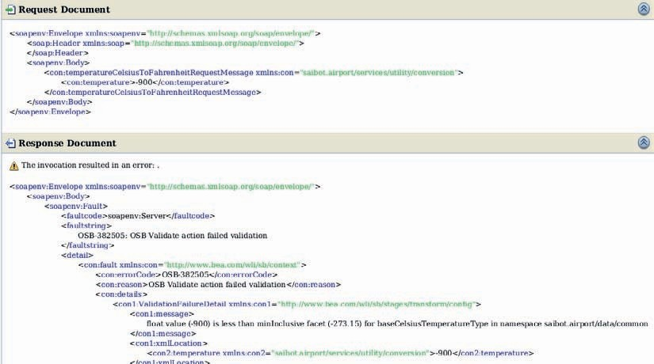

**FIGURE 3-22.** *Example of a validation failure reported by the service bus*

#### Exception Handling in the Pipeline

Almost all programming languages provide a mechanism for catching exceptions and handling them. This also applies to Service Bus projects. An error handler can be configured at each of the following levels: message flow (global), pipeline, route node, and stage. An error is handled at the lowest possible level. If an exception occurs or is explicitly raised in a stage, the error handler at the stage level is invoked for handling the error. If no stage-level error handler exists or it is not able to definitively handle a given type of error, the next level error handler—at the pipeline level—is invoked. If the pipeline-level error handler does not exist or also fails to handle the error, the service-level error handler is invoked. If the service-level error handler also fails, the error is handled by the system (the Service Bus run time framework). An error handler makes short work of an error if it ends with either a resume (continue as if nothing happened) or a reply activity (send a response and immediately end pipeline processing altogether).

A predefined context variable—called $fault—is populated with information about the error that triggered execution of the error handler. The XML structure of the content of this variable depends on the type of error that occurred. The fault variable is defined only in error handler pipelines. We can build business logic in the error handler based on the content of the fault variable.

An error handler is a pipeline and is therefore configured like any other pipeline. For example, you can use the Publish action to send error notifications to other services, use the Assign action to modify the context variables, Report on whatever is troubling the service, or perform other common pipeline actions.

Three commonly used error actions are *Raise Error*, *Reply*, and *Resume*. These actions should be the last one in an error handler. If an error handler does not contain a Reply, Resume or Raise

Error activity, it will be treated as if the error that triggered its execution is re-raised—which is implicitly equivalent to Raise Error.

Raise Error is used to throw a selected exception with a specified error code and description.

This can be a form of preprocessing before a global error handler kicks in.

Reply is used to cease further processing and return the response. The response is composed using the contents of the $body, $header, and $attachments variables as they are at the time of executing the Reply action. This means, for example, that by replacing the contents of the body variable with a SOAP Fault element just prior to the Reply activity, we can ensure that a fault is returned by the pipeline with the exact structure and contents that we want it to have.

The Reply activity is configured with one of two options: Success or Failure. Depending on this setting, the result code in the transport header returned from the pipeline is set to 0 or 1, respectively. A proxy with an HTTP transport will derive the HTTP 200 or 500 response code from that value. Note that success or failure does not influence the contents of the returned message at all. Selecting the option *With Failure* for example does not make Reply return a SOAP Fault message. For that to happen, a SOAP message has to be assigned to $body before the reply. It is typically considered good practice to always use a reply with failure if the $body contains a Fault message. Otherwise it is not as clear for the consumer that a fault is returned by the service provider and it would depend on the client implementation if the occurrence of a Fault in the body triggers its fault handling. The interoperability standard for Web Services (WS-I) also states that a SOAP fault should be signaled by a HTTP status 500 response.

Resume is the third way to conclude an error handler—but only at the stage or pipeline level and not at service level. It instructs the Service Bus to continue processing the next container at the same level as the error handler’s current container (stage or pipeline). After the Resume is performed, there are no lasting effects from the fact that an error has occurred. Note that activities that come after the failed activity in the same container—the one that was interrupted by the error—are not executed.

In the *TemperatureConversionPipeline* we will add an error handler to take care of any validation errors. We will take the somewhat unsophisticated tit-for-tat approach of returning a SOAP Fault that has not been announced in the service interface to inform the invoker that the request message did not comply with the service interface.

Drag the *Error Handler* from the component palette to the pipeline editor and drop it on *stage1* in the request pipeline. This will create the stage level error handler. Next, drag the *Raise Error* activity from the component palette and drop it inside the just created error handler for *stage1*. Specify the error code this activity should report, for example SAIBOT-001, and potentially a message as well. The pipeline should now look as is shown in Figure 3-23.

###### NOTE

stage1 *contains both Validate and Replace activities, so errors from within Replace and the XSLT execution would also be handled by this error handler. In this example that might be okay, but in real life, validation should typically have its own stage so it can have a special error handler that only gets triggered in case of a Validation error.*

It is easy to see the effect of the error handler in action. Just run the Proxy Service to have the service with modified pipeline deployed and the tester opened. Invoke the service with a temperature value of less than −273.15. The result should be a SOAP Fault that contains the SAIBOT-001 code value—see Figure 3-24.

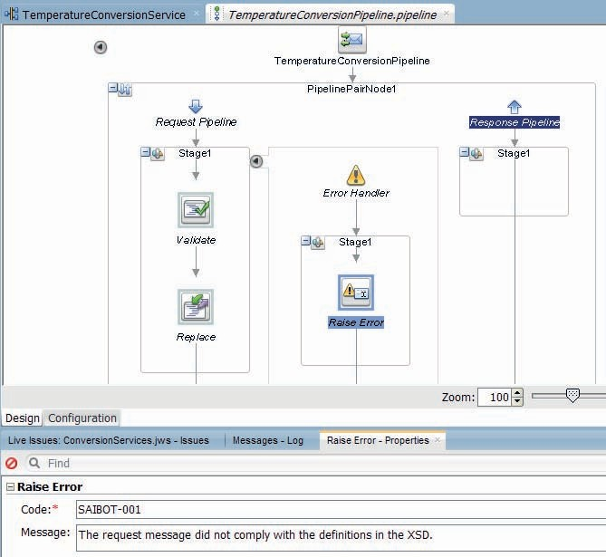

**FIGURE 3-23.** *The Error Handler at stage level will raise a generic error in case of an exception*

*in the stage*

To get a better insight in what exactly happens inside the pipeline, you can also run the pipeline itself. This gives us not just the response with the SOAP Fault from the pipeline: It also produces the trace of the activity inside the pipeline, as shown in Figure 3-25.

The trace in this case is pretty simple, because it only consists of stage 1—where validation takes place—and its stage-level error handler where the validation exception is handled. For more complex pipelines, this execution trace is very valuable.

#### Monitoring Service Bus Activity

The Service Bus is not built for comfort but for speed. Fast, stateless processing of messages, taking those messages as quickly as possible from reception to outbound routing (if applicable) and back to response is what it does in a highly optimized fashion. All overhead has been stripped from that process, including all forms of default reporting on the message processing.

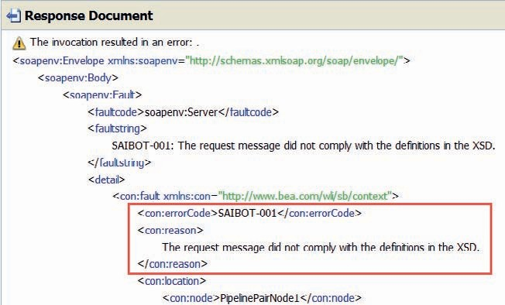

**FIGURE 3-24.** *The response from the Raise Error activity in the Error Handler*

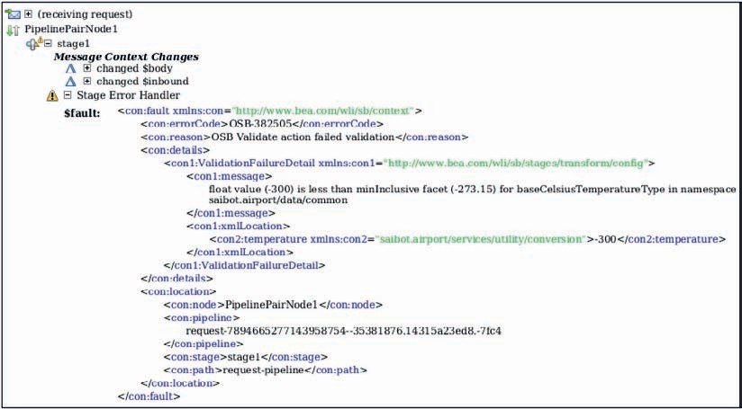

**FIGURE 3-25.** *The execution trace for the TemperatureConversionPipeline in case of*

*a validation error*

However, if so desired, we can make the Service Bus report on what it does, to help us get more insight in volume, performance metrics, and exceptions.

Open the Enterprise Manager Fusion Middleware Control for the Integrated WebLogic Server at http://localhost:7101/em. All of SOA Suite components including the Service Bus can be managed by administrators from this single unified console.

Login with the *weblogic* administrator account and the password that was set when the Integrated WLS was first created. Click on the SOA | service-bus node in the Target Navigation tree. On the right side, click on the Operations tab. Press the Search button, to show a list of all operations—pipelines, business services, and proxies. The list contains the proxy *TemperatureConversionService* and the pipeline *TemperatureConversionPipeline*. Click the check box in the header of the column Monitoring, to enable monitoring for all (two) operations listed. Enable Msg Tracking, Pipeline Alerts, Logging, Reports, and Exe Tracing as well. Press Apply.

Figure 3-26 shows what the page looks like.

If you now click on the link *TemperatureConversionService*, the dashboard with metrics for this proxy service is shown. Since no calls were made to the proxy since enabling all monitoring, tracing, and reporting settings, no meaningful metrics are presented at this point.

Make a number of calls to the *TemperatureConversionService*, including some with invalid values for temperature. Then refresh the dashboard page with proxy metrics to see some metrics reported—see Figure 3-27.

Through monitoring we can get an aggregate impression of the activity per service or pipeline in the Service Bus. However, we do not get to see information about individual service calls.

There are several reporting activities—Alert, Log, Report—that we can make use of in the pipeline to produce some operational information from within.

The *Log* activity is used to write information to the log files produced by Service Bus through the Web Logic logging framework.

*Report* publishes information to the built in reporting framework. The information is tagged with one or more search keys that help filtering and searching specific messages. Service Bus has an internal report handler that stores messages in a database (asynchronously, as to not add overhead to the request processing) and exposes them through the EM FMW Control console.

Custom report handlers can be plugged in as well.

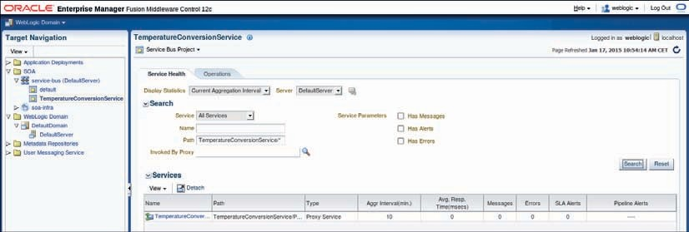

**FIGURE 3-26.** *The Service Bus Operations tab in the Enterprise Manager Fusion Middleware*

*Control 12*c *console*

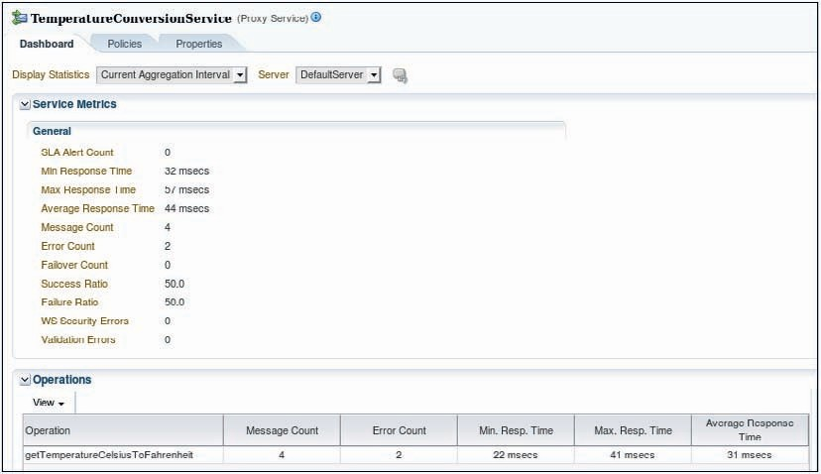

**FIGURE 3-27.** *The Dashboard for the Proxy Service TemperatureConversionService in EM*

*FMW Control*

*Alert* is used to publish messages associated with a certain severity level—ranging from *information* to *fatal—*to an alert destination. An alert destination captures a list of recipients that can receive alert notifications from the Service Bus. An alert destination can include one or more of the following types of destinations: Alert Logging (meaning the EM FMW Control), Reporting, SNMP trap, one or more email addresses, one or more JMS queues or topics. If you specify Reporting, alerts are sent to the Service Bus Reporting module and can be captured using a custom Reporting Provider that can be developed using the Reporting APIs. Note that the alert destination can be configured independent of the alert activities used in pipelines, even at run time.

##### Using Alerts to Provide Details about Validation Errors

We will now make use of an alert to make more details available in the administration console about any errors handled by the error handler in the *TemperatureConversionPipeline*.

As a first step, create a new folder called *Alerts*. From the context menu on this folder, select the option New | Alert Destination. A window appears that has you enter the name of the new alert destination, for example *PipelineAlertDestination*. When you press Finish, the alert destination is created and the editor appears to allow further editing of the destination’s properties. The default settings are fine, because Alert Logging is set. This means that we will be able to monitor the messages published to this destination in the EM FMW Control.

Return to the pipeline editor for the *TemperatureConversionPipeline*. Add an Alert activity from the component palette to the Error Handler, dropping it above the Raise Error activity.

Configure the activity in the property editor to report some fault details. Open the expression

editor for the *Content* property. Insert the errorCode and details elements from the $fault variable into the expression and use the concat function to combine them, like this:

 concat($fault/ctx:errorCode, ' ', $fault/ctx:details)

Close the expression editor. Set the Summary to *Validation Error*. The Severity Level is set to Warning in this case, to slightly elevate the alert above the level of least severity (Information). Select the Alert Destination you created a short while ago as the Destination. Figure 3-28 shows what the pipeline with the configured alert activity should now look like.

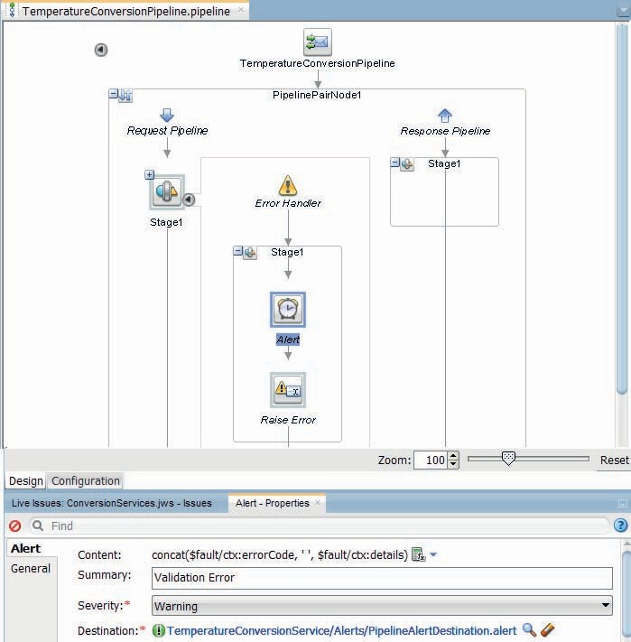

**FIGURE 3-28.** *The TemperatureConversionPipeline with the Alert activity and its properties*

Run the pipeline or the proxy. It will be redeployed, this time with the Alert activity that will report on validation errors. Make some service calls with incorrect temperature values. Then open the Alert History tab of the Service Bus dashboard in the EM FMW Control.

Set the Alert Type drop down to Pipeline Alerts. Then press the Search button. A list of recent pipeline alerts is shown, including instances resulting from the recently failed temperature conversion attempts. If you click on the link Validation Error in the Alert Summary column, a popup window appears with details for the pipeline alert, as is shown in Figure 3-29.

###### NOTE

*The Service Bus is configured per individual pipeline to keep track of pipeline alerts [or not] and starting at what severity level. In the EM FMW Control console, select the node SOA | service-bus |*

TemperatureConversionService*. Click on the Operations Tab. Click on Search. Then click on the link for the* TemperatureConversionPipeline*; this takes you to the dashboard for the pipeline. Finally, click on*

*the Properties tab—as shown in Figure 3-30. Here are the pipeline level operational properties that govern things like monitoring [level], logging, and reporting for this pipeline. The Pipeline Alerting Enabled checkbox should be checked and the Pipeline Severity should not be higher than Warning.*

##### Using Message Reporting

The Report action lets you extract information from each message handled by a pipeline and write it to the Service Bus Reporting Data Stream, from where they can be handled in various ways.

In the Report action, key value pairs are used to define key identifiers and values that can be extracted from any message context variable or message payload. The keys provide a convenient way to find and identify messages.

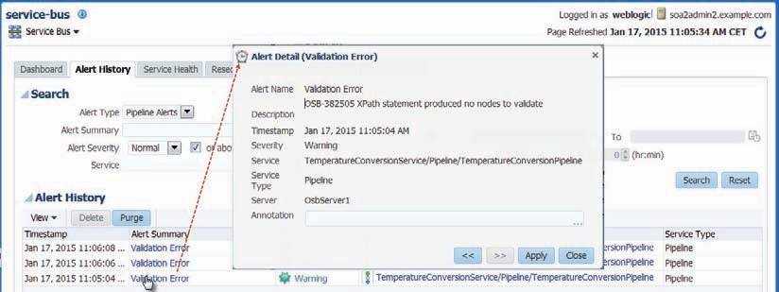

**FIGURE 3-29.** *Details for a Pipeline Alert published from the Error Handler in response to a*

*validation error*

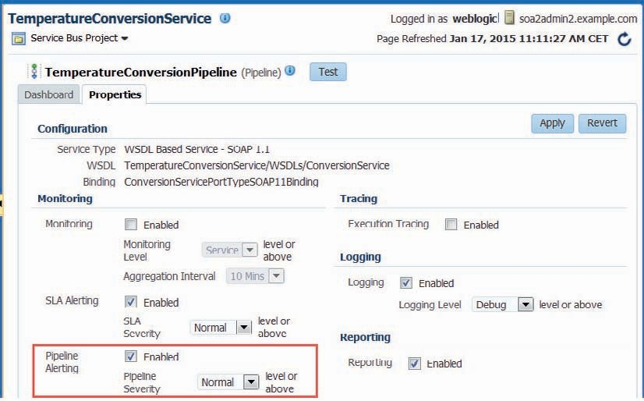

**FIGURE 3-30.** *Pipeline level properties for monitoring, reporting, logging and alerting*

Messages are published to a JMS Queue with little overhead to the reporting thread—the one processing the request. The default reporting provider consumes the messages from that queue and writes data to a database table. The messages stored in the database can be searched and reviewed through the Enterprise Manager FMW Control. When you use Message Reporting, a lot of internal information about (various stages of) message processing can be exposed. This comes at the cost of some overhead: preparing the information to publish adds some processing time and reporting actions on frequently invoked service will fill up the SOA INFRA database.

To get an idea of what the Report activity can do, add one for example to the Error Handler in the TemperatureConversionPipeline, before the Raise Error. See Figure 3-31 for details. Set the Content property for the activity using the expression editor to the entire request message in the body variable: $body/con:temperatureCelsiusToFahrenheitRequestMessage. Define one search key to use as a tag on instances of the service, to quickly identify the message report at runtime. Set the name to celsiusTemperature, the variable to body and the XPath expression to extract the temperature from the request message. Note that this is not a very useful example of a report search key. Common meaningful keys are based on business identifiers, such as flight number or airline code in the case of the airport industry.

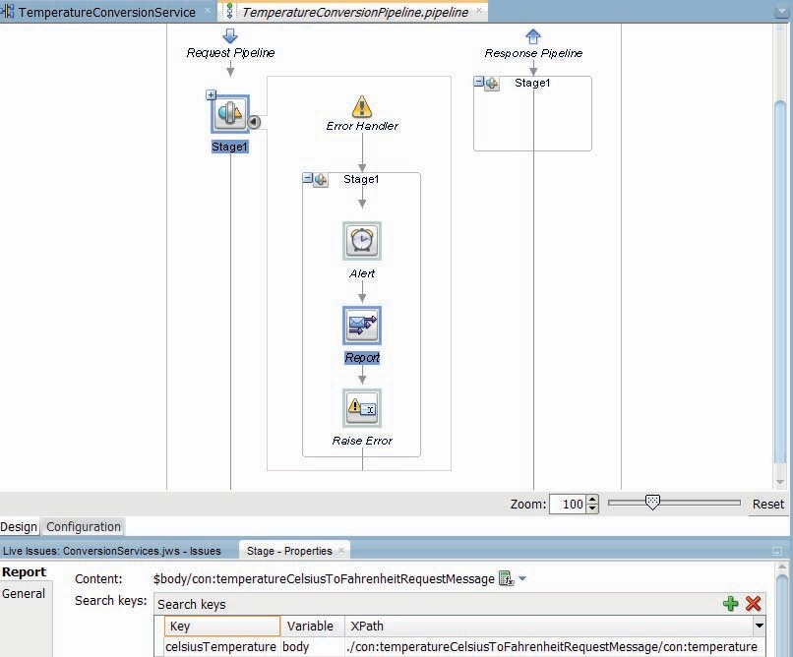

**FIGURE 3-31.** *Add and configure a Report action in the TemperatureConversionPipeline*

After adding the Report activity, run the *TemperatureConversionService*. Make some calls that include invalid temperature values, in order to trigger the error handler and thereby the Report activity. The Message Reports thus produced can be viewed in the EM FMW Control. Go to the console, select the node SOA | service-bus | TemperatureConversionService. From the drop-down menu labeled Service Bus Project (almost at the top of the right side of the page), select the option Message Reports (Figure 3-32).

Press the Search button on the page that appears next, to find all available message reports. An overview of the reports is presented. The search keys (aka report index) for each report are listed along with timestamp, origin of the report, and error code if applicable (Figure 3-33).

By clicking on the Report Index link you can navigate to the page with message details.

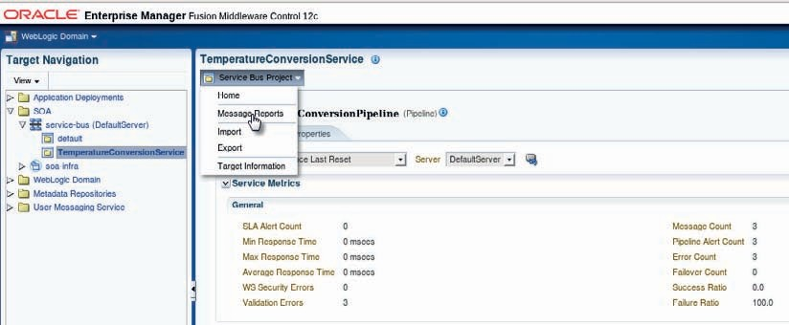

**FIGURE 3-32.** *Opening the Message Reports page for the TemperatureConversionService*

The extent of the message details available for each message is broad and deep. Information is available for example about the exact origin of the message, its time of processing, and the status and about the fault if one was thrown. The message details that were configured in the Report activity are available in a popup, as shown in Figure 3-34.

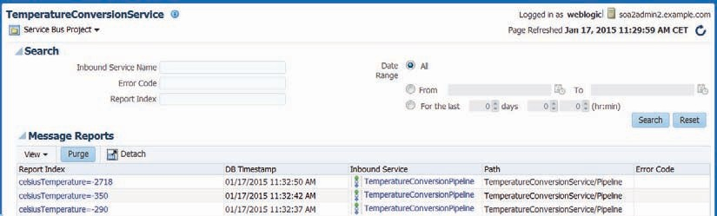

**FIGURE 3-33.** *Searching for Message Reports for the TemperatureConversionService*

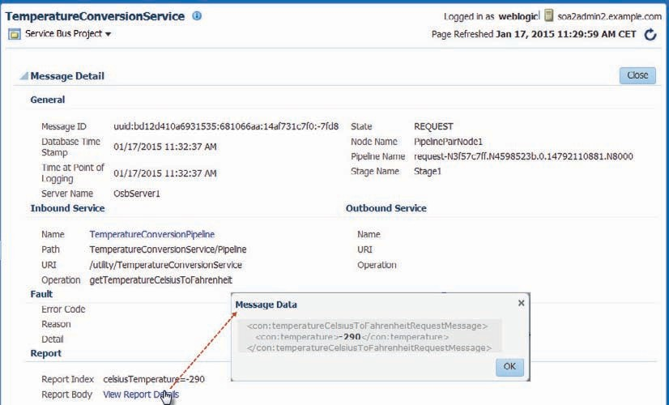

**FIGURE 3-34.** *Message details in the EM FMW Control as a result of a pipeline Report activity*

### Speed and Distance Conversions through Routing to External Services

The temperature conversion service we have discussed so far is about the simplest service imaginable. This service hides the encapsulations of the implementation of the business logic, but instead of invoking that business logic in the form of a business service, the temperature conversion service also implements the logic itself. In this section, we will move beyond that very simple case. We will develop another conversion service on the Service Bus, this time one that calls upon external services to do distance, height, and speed conversions. The pipeline will now implement both halves—the one leading up to the routing action calling the business service as well as the second half that deals with the response from the business service.

Additionally, the service that is preferably called to do the conversion, may not always be available. The business service will be configured to automatically fail-over to a local conversion service whenever the number one choice is not available. Note: The assumption here would be that the local conversion is not as accurate or quick as the preferred service, otherwise of course we would not need the external service.

#### Configure a Business Service for an External Conversion Service

The website [http://www.webservicex.net](http://www.webservicex.net/) offers a number of public SOAP web services. Some of these will support the unit conversions we are looking for. Conversions of height and distance for example are provided by the Length/Distance Unit Converter. In order to leverage this web service in a Service Bus project, there has to be a Business Service configured as the local stub representing the external service. In a pipeline we can call out to or—more commonly—route (a message) to a business service and hence to the external service.

##### Import the Web Service Contract

The WSDL for the external service has to be locally available. Under formal governance we would probably make use of an UDDI style service directory or the Fusion Middleware MetaData Services (MDS), but for now we will keep things simple. From the context menu on the WSDLs folder select the option Import. In the popup window that appears select the option *Service Bus Resources*.

The Import wizard opens. On the first page, select the option Resources from URL and press Next. On the second page (Figure 3-35) select WSDL as the Resource Type. Paste the URL for the WSDL of the external convertor service: <http://www.webservicex.net/length.asmx?WSDL>into the Source URL property. Enter the name for the resource as LengthDistanceUnitConvertorService. The WSDLs folder should already be selected. Press Next.

The wizard presents an overview of its intentions on the third page: creating a new WSDL resource with the specified name based on the document found at the URL for the external service. Press Finish to mandate this action.

The WSDL document is created in the WSDLs folder.

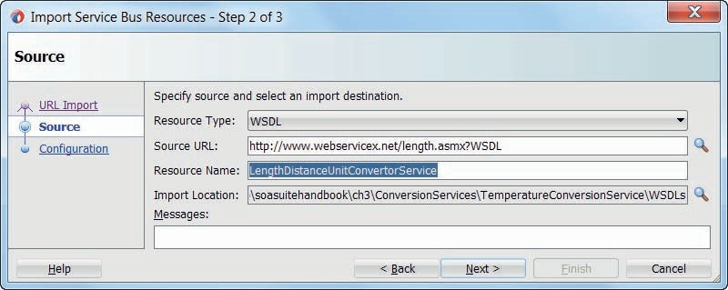

**FIGURE 3-35.** *Import an external WSDL (with associated resources such as imported XSD*

*documents)*

##### Create Business Service

Create a new folder called Business Service. Next, right click on the newly created WSDL document LengthDistanceUnitConvertorService to open its context menu. From the menu select Service Bus | Generate Business Service.

Another wizard appears to assist you in the creation of the business service based on the WSDL. Ensure that the Location field specifies the Business Service folder (Figure 3-36). Because this document contains four different port definitions, we have to make explicit which of these the business service will represent. Make sure that you select the *lengthUnitSoap* port. Then press Next.

Accept the default transport type and endpoint url on the second page and press finish to create the Business Service.

We can now test the business service. The option Run on the context menu for the new business service LengthDistanceUnitConvertorService will redeploy the entire ConversionService project and open the business service tester in JDeveloper, from which you can test make test calls to the Business Service that in turn means making test calls to the external service.

##### Business Service Fail-Over

The business service can be seen as the local representative of the external service. It takes care of relaying requests to the remote end point. It can, however, be more than a simple messenger boy. For example, it can be configured with multiple endpoints for the external service and employ a load balancing algorithm for distributing the requests over these endpoints. Various other aspects of the communication with the external service can be configured on the business service as well, including transport specific properties, security details, and result cache options.

When the business service is invoked from a pipeline and the remote service is not available at the endpoint that is invoked, then depending on the retry settings the business service will

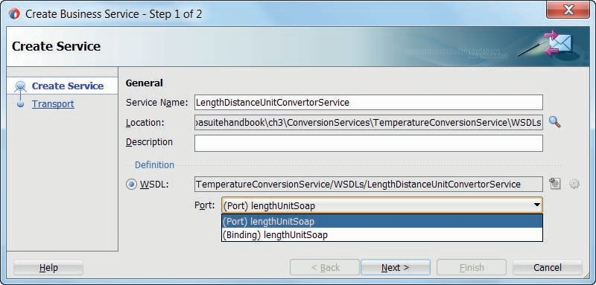

**FIGURE 3-36.** *Configuring the Business Service for the external SOAP Web Service*

attempt fail-over to other endpoints if these are configured—or it will retry the same endpoint again if no other endpoints are defined. Note that the alternative endpoints can refer to entirely different service instances on quite different locations, as long as they implement the same port or binding from the WSDL that the business service is referencing.

To see the fail-over in action, we will now create a local mock service that implements the same contract as the external *LengthDistanceUnitConvertorService*. We will then configure the business service to use the local service as a fail-over destination.

###### NOTE

*We only do this to see the fail-over mechanism in action. In actual practice it would be silly to have an external service and then implement a local equivalent that we use as a fail-over destination only.*

**Generate and Deploy Local Mock Conversion Service** Open the context menu for the WSDL document LengthDistanceUnitConvertorService.wsdl. Select the item Create Web Service. This will start a wizard that will generate a Java (JAX-WS) Web Service based on the same contract as the remote service. In the wizard go to step 2—Target Project—and press on the button New Project. Set the name of the new project to LocalLengthDistanceUnitConvertorService and accept the default target directory. Accept all defaults in all subsequent steps of the wizard and press Finish to start generation of the Java Web Service. The new project is created, with annotated Java classes to implement and publish the web service.

You can now test the local web service by running the class LengthUnitSoapImpl. This will deploy the web (service) application. The service can now be tested at http://localhost:7101/ ConversionServices-LocalLengthDistanceUnitConvertorService-context-root/lengthUnitSoap, for example using the HTTP Analyzer. All conversions will currently return 0.0, as we have not yet implemented any logic in the Java class to do any real conversion. You could enhance the Java code, but for our current purposes there is no real need to do so. Note: If you work with a

stand-alone WebLogic Server, you can deploy the Web Service using the WebServices deployment profile from the context menu on the project. The URL for testing will be the same, except for the hostname and port number.

**Configure Fail-Over for the Business Service** There is a second endpoint available now for the business service to fail-over to when the primary, remote web service is not available. To configure this fail-over option, open the business service editor for *LengthDistanceUnitConvertorService* (see Figure 3-37). Click the green plus icon in the area labeled *Endpoint URIs* . Enter the endpoint of the local Java Web Service as the URI. Change the Load Balancing Algorithm to none: under normal circumstances, the local convertor service should never be invoked.

Set property *Retry Count* to 2—to instruct the business service to immediately try the second end point (the local mock service) after the first one has failed. When the call to the second endpoint also fails, the first one should be attempted again, but only after waiting for as long as is indicated in the *Retry Iteration Interval*.

**Try Out Service Fail-Over** Run the business service *LengthDistanceUnitConvertorService*. Make a few calls to convert some distances. Now make the external service unavailable, either by disconnecting your computer from the network or by deliberately setting an incorrect value for the external service’s endpoint—for example, in the run time Service Bus Console. Verify if your

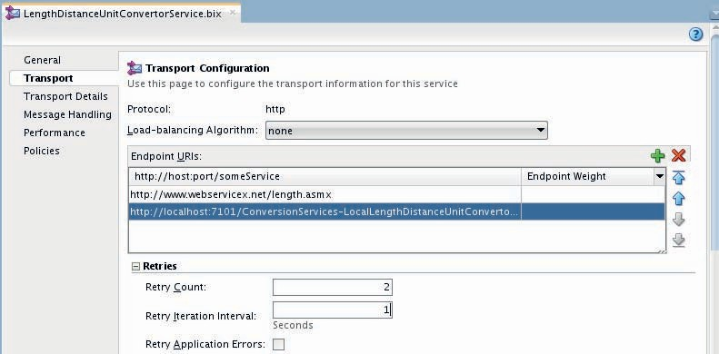

**FIGURE 3-37.** *Configuring the business service for fail-over to a local (mock) conversion service*

next service call returns successfully, even if with a value that is not to be trusted (0.0 if you have left the mock service above with the default implementation). If so, fail-over to the local service will have been performed upon the business service’s connection problem to the primary, remote end point.

#### Create Proxy ConversionService

The *ConversionService* as specified by Saibot’s designers in the WSDL document offers a range of specialized, frequently used conversion operations that will convert distance, height (just another form of distance), speed, weight, and temperature. The service will use a variety of local and external services for its implementation, but that of course is encapsulated—hidden from view for consumers of conversion functionality. A Service Bus Proxy Service is exposed for such consumers, based on the functional service interface and using a regular HTTP/SOAP transport.

Generate the Proxy Service using the menu item Service Bus | Generate Proxy Service on the context menu for the ConversionService.wsdl document.

The Create Proxy Service wizard opens—Figure 3-38. Set the Service Name to *ConversionServicePS—*following the standing naming convention of using the PS suffix for proxy services. Set the location to the Proxy folder. Ensure that this time the checkbox Generate Pipeline is checked. Set the name of the Pipeline to *ConversionPipeline*. Press Next.

On the second page of the wizard, change the endpoint to /utility/ConversionService. Press Finish to complete the wizard.

The proxy service and the pipeline are generated, both in the same folder Proxy, which for the pipeline is not the correct location. From the context menu on the *ConversionPipeline*, select the item Refactor | Move and relocate the pipeline to the Pipeline folder.

The default algorithm used by proxy services in the Service Bus to determine which of the operations defined in the service interface should be executed is by looking at the incoming

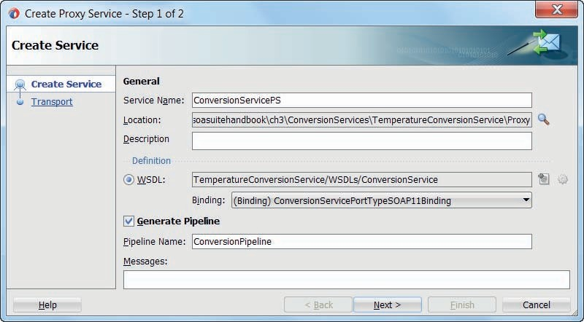

**FIGURE 3-38.** *Configure the Proxy Service for the Conversion Service*

message type. In this case, that approach will not do, because several operations expect the same message type. Therefore we have to open the Operation Selection tab in the proxy editor and set the Selection Algorithm to SOAP Action Header (see Figure 3-39). This means of course that service consumers will have to set that SOAP Action Header in their calls.

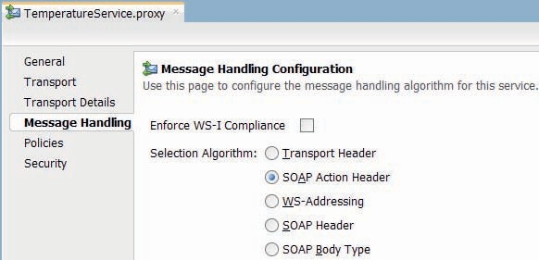

**FIGURE 3-39.** *Set the Operation Selection algorithm for the ConversionService proxy*

#### Implement the Generated ConversionPipeline

The *ConversionPipeline* is going to be a bit more interesting than the *TemperatureConversionPipeline*. Not only does the *ConversationPipeline* have to support multiple operations, it will also actually perform Routing to a business service and therefore have to cater for both the request and the response pipeline in the pipeline pair.

We will first focus on the operation *getDistanceFeetToMeter* that will be used to convert heights, typically expressed in either feet or meter. We need to be able to discern between different operations and implement activities to cater to each of them. Because the request message defined in the ConversionService’s interface for the *getDistanceFeetToMeter* operation does not have the same XML structure as the message we need to send to the *LengthDistanceUnitConvertorService* business service, we have to implement a transformation in the request pipeline. Similarly, the response from that business service is not based on the same XSD definition as the response expected from the proxy service, and therefore another transformation is needed to produce the required structure for the response message.

##### Configuring the Operational Branch

Open the designer for the *ConversionPipeline*. Drag the Operational Branch activity to the pipeline. This node is a minimal configuration branching node that contains branches and associated logic for selected operations defined in the WSDL. The Service Bus determines from the operation indicated in the request message which of the flows in the Operational Branch to execute. There is a *default* flow that will be executed if for the indicated action there is no operation-specific flow.

After adding the Operational Branch to the pipeline, configure the first (non-default) flow for the *getDistanceFeetToMeter* operation by selecting that operation from the drop-down list in the property editor (as is shown in Figure 3-40).

Add a Pipeline Pair to the *getDistanceFeetToMeter* flow and set its name to *VET*. In this pair we will add the transformations of the request to, and response from, the business service.

##### Configure Routing to the Business Service

Add a Route node to the flow for operation *getDistanceFeetToMeter*; drop it after the VET activity. Set the name of the Route node to RO. This container node will implement the call to the business service. For now, these names signify how the VETRO pattern is implemented in the pipeline. In the future, we will use more functional names for these nodes.

Drag the Routing component from the palette and move it to the Route node. Select the new Routing activity, as shown in Figure 3-41. Click on the magnifying glass for the *Service* property in the property editor. Browse to the business service *LengthDistanceUnitConvertorService* and select it as the target for the Routing activity. The only operation supported by the business service is *ChangeLengthUnit*; therefore this operation is automatically selected to be invoked by the Routing.

##### End-to-End Test of the ConversionService

Add this point we can try out the end to end chain, from proxy service to the pipeline all the way to the business service, the external service and back again. This flow is visualized in the overview editor, see Figure 3-42. Note that the link between the proxy service and the pipeline was established when we had the proxy service wizard also generate the pipeline.

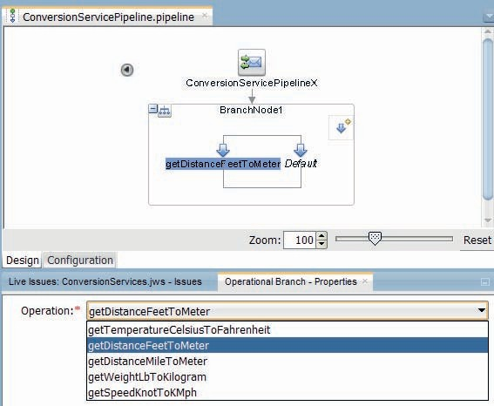

**FIGURE 3-40.** *Configuring the flow for operation getDistanceFeetToMeter in the*

*operational branch*

This will not yet result in meaningful responses with accurate converted values, because we have not yet added the transformations. However, the flow for a request message with its action set to *getDistanceFeetToMeter* should already be functioning.

Run the *ConversionServicePS* proxy and invoke the operation *getDistanceFeetToMeter*. The response, though meaningless, should contain an XML element called

*ChangeLengthUnitResponse* in the namespace [*http://www.webserviceX.NET/*.](http://www.webserviceX.NET/) This is proof that the end-to-end call succeeded; this XML element is returned by the external service invoked by the business service.

##### Add Request and Response Transformations

In order to produce a meaningful response we need to add a little processing in both request and response pipeline. The request message that arrives at the pipeline, held in the $body variable, is not of the XML type expected by the business service. Therefore, the $body variable’s contents should be replaced—using a transformation. Create a new XSL Map, called *distanceFeetToMeterRequestToChangeLengthUnit.xsl*. This map will transform from the source

element *distanceFeetToMeterRequestMessage* to the *ChangeLengthUnit* element that is the root of the request message to be sent to the business service.

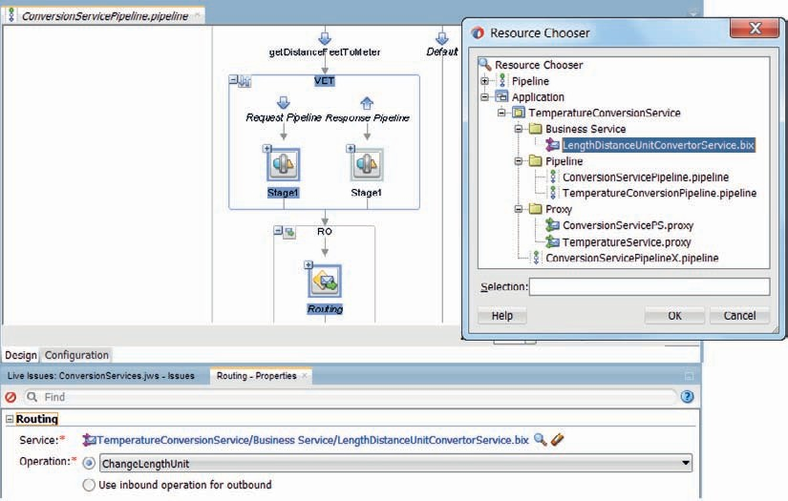

**FIGURE 3-41.** *The pipeline editor with the Routing activity in the operational branch*

The mapping simply copies the value of the *distanceFeetToMeterRequestMessage* element to the *LengthValue* element in the target structure. It also has to set the *fromLengthUnit* and *toLengthUnit* in the target message with text values *Feet* and *Meters* respectively, as shown in Figure 3-43.

A Replace activity should be added to the Stage in the Request pipeline, as is shown in Figure 3-44. The Replace activity is configured with Body as the Location, the XSL Map file

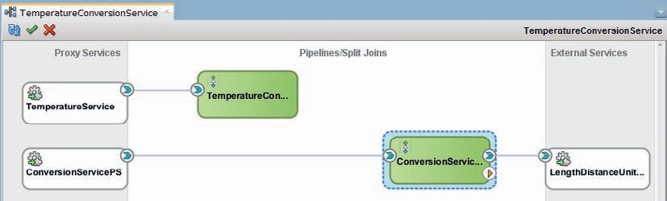

**FIGURE 3-42.** *Service Bus overview editor with the wires between proxy, pipeline, and business*

*service*

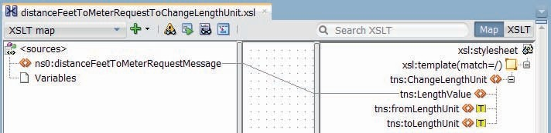

**FIGURE 3-43.** *The XSL Map for the transformation of the $body contents to produce the request*

*message for the business service*

*distanceFeetToMeterRequestToChangeLengthUnit.xsl* as the XSLT Expression to perform the transformation—with $body/con:distanceFeetToMeterRequestMessage for the Input Document Expression. The replace activity should replace the node contents.

The XSL Map to transform the response from the business service in the body variable to the appropriate structure is called *changeLengthUnitResponseTodistanceFeetToMeterResponse.xsl*.

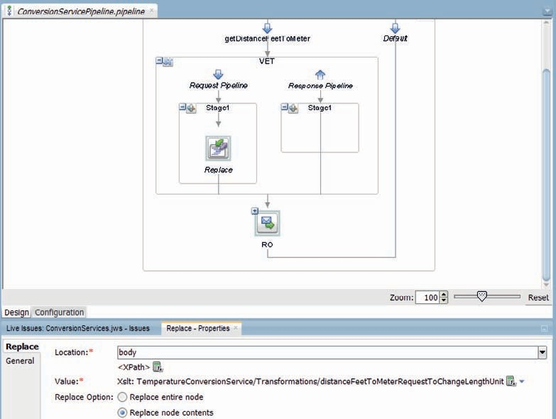

**FIGURE 3-44.** *The Replace activity turns the proxy service request message into the business*

*service input*

It maps the value from the *ChangeLengthUnitResult* element in the *ChangeLengthUnitResponse* root to the *distanceFeetToMeterResponseMessage* element. A replace activity is added to the stage in the Response pipeline to apply this transformation to the contents of $body—that holds the response from the business service at that point.

#### Run/Test Service

The *ConversionService* is now completely implemented—at least for the operation *getDistanceFeetToMeter*. The proxy receives the request and hands it to the pipeline to have it first transformed and then routed to the business service. The business service delivers to it the external service. The response is delivered by the business service to the pipeline, that processes it in the response pipeline by transforming it into the desired XML structure, before conveying it to proxy service. The proxy service will finally send the response over the current transport method to the consumer.

Try out the *ConversionService—*either by running it from within JDeveloper or using the HttpAnalyzer tool or SoapUI. Request the conversion from feet to meter for various values.

#### Routing Messages to the TemperatureConversionPipeline

The *ConversionPipeline* supports the ConversionService’s interface as defined in the WSDL document. The pipeline has an operational branch that determines from the operation indicated in the request message which of the branches in the pipeline to execute. At this point, the branch for the *getDistanceFeetToMeter* operation has been implemented. Calls to other operations are currently handled by the *default* branch—meaning that such calls would simply return the request message to the caller.

It should be simple to have the *ConversionPipeline* also provide support for the operation *getTemperatureCelsiusToFahrenheit*. After all, earlier in this chapter we developed the *TemperatureConversionService* that can be used as the implementation behind this operation.

To add a flow for this operation in the operational branch, click on the icon in the upper right hand corner. This will add a flow to the diagram. Ensure that the *Operation* property for this flow is set to *getTemperatureCelsiusToFahrenheit*. Add a Route component to the flow and drag a Routing activity inside this component.

Configure the Routing node to invoke the *TemperatureConversionPipeline*. Note: Pipelines can invoke other pipelines, just like they can route to business services. Pipelines are reusable building blocks that can not only serve multiple proxy services but other pipelines as well. In this case, we could also have wrapped the *TemperatureConversionService* in a business service that we can then invoke from the *ConversionPipeline*. However, it does not seem likely that we want to use any of the facilities business services provide in this current case—such as fail-over, result cache, security and transport settings—so the overhead is not justified.

Because the request and response messages exchanged with the *TemperatureConversionPipeline* are the same as those supported by operation *getTemperatureCelsiusToFahrenheit*, we do not have to perform transformative actions on the contents of the body variable, neither on the way to the *TemperatureConversionPipeline* nor on the way back.

The overview editor now visualizes the reference from the *ConversionPipeline* to the *TemperatureConversionPipeline—*as well as the external reference to the *LengthDistanceUnitConvertorService* business service (Figure 3-45). The project publishes two service endpoints—both based on SOAP—through two proxy services. Because the *ConversionService* also offers an operation to convert Celsius to Fahrenheit temperatures, we

could consider removing the almost redundant *TemperatureConversionService* proxy altogether.

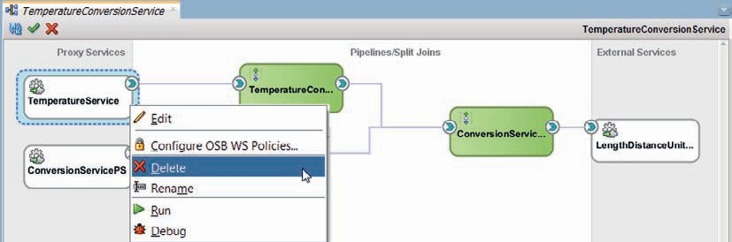

**FIGURE 3-45.** *Overview of the Service Bus project with the ConversionPipeline*

*invoking the TemperatureConversionPipeline to provide the implementation of the getTemperatureCelsiusToFahrenheit operation*

That would be as easy as activating the menu option Delete on the context menu for the Proxy Service in the overview diagram.

Now try out the conversion of Celsius temperatures by invoking the *getTemperatureCelsiusToFahrenheit* operation in the *ConversionService* proxy, to find out that you experience no difference whatsoever from having temperatures converted through calls to the *TemperatureConversionService* proxy.

### Exposing a REST/JSON Endpoint for the Temperature Conversion Service

An increasing number of service consumers—for example, applications running on mobile devices or HTML5 rich client/thin server web applications—have a desire to be able to consume services through a REST interface rather than the full blown SOAP protocol, frequently preferring JSON as the payload format over XML. SOA Suite provides native support to cater for these wishes: using the REST Adapter it is straightforward to provide REST/JSON endpoints in addition to or instead of SOAP/XML endpoints.

In this section, we will use this REST Adapter to expose the *ConversionService* as a REST-style service that accepts a simple HTTP GET request with a single URL parameter holding the Celsius temperature to convert and returns the calculated Fahrenheit temperature in a JSON message.

#### Creating a REST Conversion Service Interface with JSON Response

There are two approaches we can choose from:

* Top-down, where we start by defining a Proxy Service with a REST interface with the exact JSON or XML message structures that we require (potentially based on a predefined

WADL—the REST equivalent of the WSDL)

* + Bottom-up, where we have JDeveloper take an existing pipeline or business service and expose it as a REST service; we have control over the names of the resource and the

service itself, and over the names of URL parameters but we cannot specify the exact structure of the response messages because these are automatically derived (XML or JSON) from the response messages defined in the interface we are exposing

In this section, we will go for the bottom-up approach. It offers less refined control—but it is a lot faster. We do not have to create the transformations between the request and response definitions specified for the REST service and the corresponding messages used in the pipeline.

##### Expose the ConversionPipeline as REST Service

Right click on the *ConversionPipeline* that is to be exposed in a RESTful manner. Select the menu option Expose As REST (shown in Figure 3-46).

The REST Binding Adapter wizard appears, see Figure 3-47. Set the name to *RestService*, set Resource Path to /Temperature, remove all operations except *getTemperatureCelsiusToFahrenheit* and click on the icon to edit this operation binding.

In the REST Operating Binding editors, elect GET as the HTTP Verb, accept the request settings, and on the Response tab select [only] the JSON Payload checkbox for the response, as shown in Figure 3-48.

Click on OK (twice) to complete the configuration of the RestService.

##### Test the REST Interface of the ConversionService

The implementation of the REST-style interface of the ConversionService is complete—with currently only support for the temperature conversion and with an auto-derived payload format. This interface can easily be tested from any browser: the request message is as simple as a URL with a single parameter that is sent as an HTTP GET request by the browser to the endpoint operated by the RestService proxy.

Open a browser and type in the address bar the following URL: http://localhost:7101/TemperatureConversionService/RestService/Temperature?temperature=0

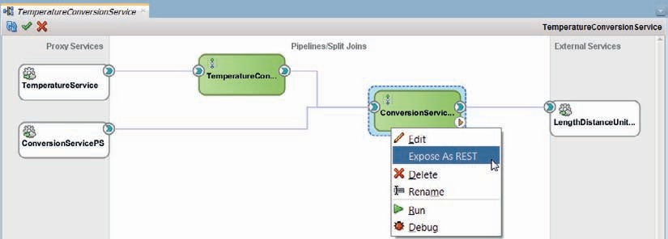

**FIGURE 3-46.** *Expose a Pipeline as a RESTful service—with limited control over the structure of the URL parameters and the JSON or XML response message*

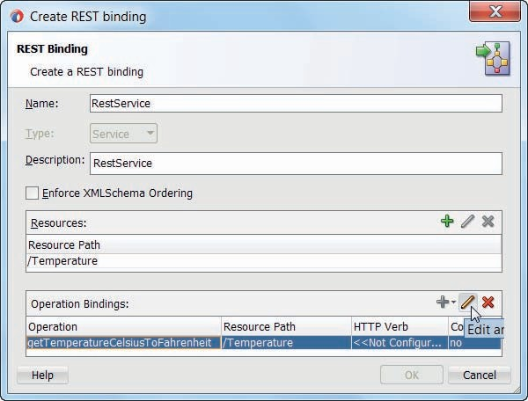

**FIGURE 3-47.** *Edit the REST binding—set Name and Resource [path], then edit one operation*

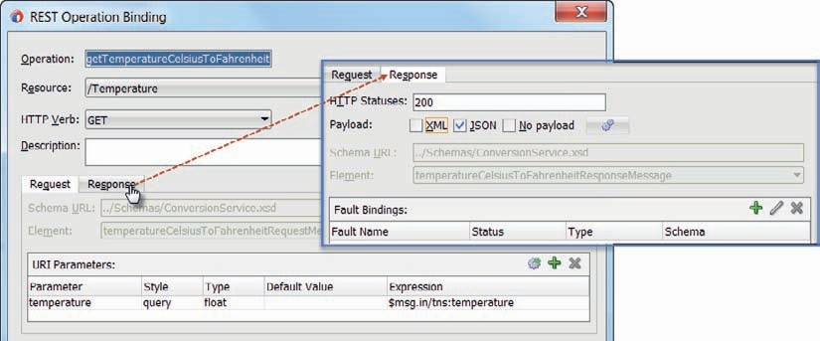

**FIGURE 3-48.** *Edit the getTemperatureCelsiusToFahrenheit operation binding—set HTTP Verb and configure Payload [type]*

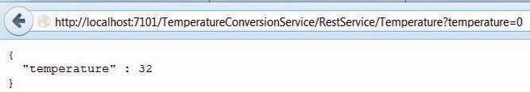

**FIGURE 3-49.** *Example of REST style call to the RestService to get the converted temperature*

*value and the resulting JSON response*

then press enter to make the browser send this request. See Figure 3-49 for the result.

The Service Bus receives the request. It derives the resource from the request—resource—and knows how to process the HTTP GET call: an XML document is constructed from the URL parameter temperature and the *ConversionPipeline* is invoked with this XML document set up in the $body variable. The response from that pipeline is transformed internally into the JSON message that is handed to the *RestService* Proxy that will return it.

The endpoint for the *RestService* (Proxy Service) is set to /TemperatureConversionService/ RestService—a combination of the name of the current project and the name of the service. We are free to set a different value for this endpoint though, by editing the Endpoint URI on the Transport tab of the Proxy Service editor.

###### NOTE

*You can also make test calls to REST services from the HTTP Analyzer in JDeveloper, SoapUI, and plugins for various browsers. The WADL address is: http://localhost:7101/sbresource?PROXY/ TemperatureConversionService/Proxy/RestService.*

### Summary

The Service Bus provides a platform for exposing all your services to (future) service consumers. It provides features such as protocol and data transformation, virtualization of the backend services and integration capabilities. To do this, the Service Bus is light-weight and capable of handling large volumes of service requests. The Service Bus is not meant as a platform to *implement* complex services, although for simple services you could use it.

#### More about the Service Bus

The Service Bus can obviously do much more than is discussed in this chapter. We have seen though what the core is of the Service Bus; receive requests over one of several transports like SOAP/XML or REST/JSON, perform selected aspects of VETRO on the request contents and after routing to the downstream component such as a pipeline or a business service do some VETRO on the response before return that response over the initial transport to the original caller. And do all of this really fast with very little overhead and even if we really want to, produce some operational data about what is going on.

In subsequent chapters, we will learn how the Service Bus will frequently be the front end of services whose implementations use various components, including Java classes, PL/SQL packages, 3rd party applications as well as SCA composite applications with BPEL and Business Rule components and Technology Adapters. We will see more in-depth information about additional functions and advanced facilities in the Service Bus for both developers and administrators.



CHAPTER

# 4

## Accessing Database and File System through Outbound Technology Adapters

any services require interaction with enterprise resources such as databases, legacy applications, file systems, and FTP servers as part of their implementation. The SOA Suite is shipped with a wide range of adapters that help the integration from Service Bus

**M**

projects (and the SOA composite applications we will first meet in Chapter 5) with these back-end systems. These adapters facilitate both inbound and outbound interactions. The former starts with an event in the enterprise resource that through the adapter triggers the service implementation. The latter is initiated in the Service Bus and goes out to the back-end system—to retrieve, publish, or push out data.

One of these adapters is the database adapter. This adapter allows integration from the Service Bus to relational databases to perform SQL queries, do data manipulation, and call stored procedures. We will do all of the above in this chapter with some of the Saibot Airport core databases.

The file adapter is used for outbound interactions such as to read files from and write them to the file system. These files can be in various formats such as delimited—like comma separated values (csv) -, fixed length, JSON, and XML. The files to be processed can contain multiple records, even of different types. In this chapter, we use the file adapter to create and update flight event log files and to expose the contents of an event log file in a service.

This chapter only demonstrates the outbound mode of the adapters. See Chapter 13 for examples of the inbound or polling mode of the technology adapters.

Note that the technology adapters are not only supported with Service Bus but also with SCA composite applications, as well as other Fusion Middleware components such as Oracle Data Integrator (ODI).

### Introducing Technology Adapters

The Oracle Technology Adapters are stand-alone applications, deployed in the J2CA container of WebLogic as a type of application called Resource Application. The adapters implement the Java EE JCA 1.5 standard. This standard describes a number of aspects of connecting to enterprise systems, including connection and transaction management, security, and lifecycle management and handling of events and incoming messages from the enterprise system. Any application running on the WebLogic platform can engage these adapters for enterprise integration purposes. The SOA Suite is one such application. Note that the JCA adapters can also be deployed on the JBoss and WebSphere platforms.

The collection of technology adapters includes (see Figure 4-1) Database, Advanced Queuing (AQ), MQ Series, JMS (Java Messaging System), File and FTP (File Transfer Protocol), Sockets, Coherence, LDAP *(Lightweight Directory Access Protocol*), and User Messaging Service (UMS) for email, VoIP, FAX, and text message. Custom JCA adapters can be used from the SOA Suite too. In addition to technology adapters, Oracle also offers Application Adapters (SAP, PeopleSoft, JD Edwards, Siebel, Oracle Applications for E-Business Suite), B2B Adapters (RosettaNet, EDI, Healthcare, and ebXML), Mainframe and TP-Monitor and Changed Data Capture Adapters. The technology adapters are included in the SOA Suite license; all other adapters are licensed separately.

Adapters provide the bridge to other technologies and communication protocols than those native to the SOA Suite. Note that other integrations—for example, to BAM, EJB, HTTP, and REST—are provided in the SOA Suite by special transports in the SOA Suite itself rather than through separate JCA adapters. These transports are listed in the component palette intermingled with the separately deployed adapters, which might be a little confusing.

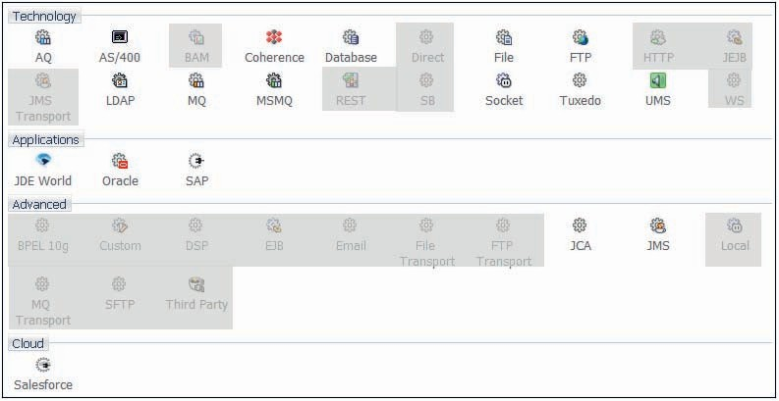

**FIGURE 4-1.** *Overview of Technology Adapters and other JCA adapters in SOA Suite 12c*

*(grayed out are the Service Bus transports)*

The initiative for an interaction with an enterprise system can come from within the SOA Suite. The SOA Suite composite application invokes the adapter and has it contact the external resource to read or perhaps manipulate data. This is called the outbound mode of the adapter.

From the perspective of the SOA Suite, the inbound mode is the situation where the composite application is invoked by the JCA adapter, at which point a new instance of the service is created in the SOA Suite. The JCA adapter can be registered as a listener for events in enterprise systems or it can be configured to periodically poll an enterprise resource for specific changes.

When the adapter receives an event or identifies a relevant change through polling, it calls the proxy service (Service Bus) or service binding (SCA) over the JCA transport and thus triggers

a new instance.

#### Design Time

The SOA Suite design time in JDeveloper has extensive support for the technology adapters as well as the B2B and Applications Adapters. That means that the configuration of adapters is supported through developer friendly wizards and that integration of the adapter configuration as proxy service or business service (in Service Bus projects) or as service binding or reference binding (in SCA composites) is seamless. The operation performed by the technology adapter is exposed in terms of a regular service using a WSDL interface definition and an XSD to describe the data input and output. Using technology adapters requires a service developer to configure the design time settings of the adapter; when that has been done, there is no adapter specific knowledge required because the adapter looks like any other service in the composite. Note, however, that this adapter-derived service is only to be used as a private contract inside the service. Also note that some run-time configuration is necessary to make the adapter connection to the enterprise resource.

The adapter configuration wizard generates a number of files. These largely fall into three categories:

* Adapter metadata files that instruct the Resource Adapter application at run time on what exactly to do (which SQL to execute, which JMS Queue to publish to, which file to read)
* XSD that describes the XML data structure for the data that is passed into and/or is received from the adapter; a crucial aspect of the adapters is their ability to communicate

in XML terms with the SOA Suite, regardless of the format used for interacting with enterprise systems. For many adapters, the configuration wizard will invoke the Native Format Builder. This wizard gathers some details from the developer on the native data format the adapter will have to deal with (e.g., in its dealings with the file system or the JMS queue or the User Messaging Service) and then creates the NXSD document that contains the mapping definition between the native data format (delimited text, fixed length text, JSON, XML, COBOL Copybook) and an XML representation thereof.

* WSDL that describes the operations performed by the adapter in web service terms that can easily be interpreted by the SOA Suite design time and run time; this definition

references the relevant elements in the XSD documents.

The design time configurations of adapters contain a reference to the JNDI name of a Resource Adapter connection in the target deployment WebLogic platform—as shown in Figure 4-3. This connection describes exactly which physical endpoint the adapter will interact with—which database, JMS queue or Socket it connects to. The design time definition of the adapter does not contain such physical, environment specific run-time aspects. This makes it easier to promote applications using Resource Adapters through your development, test, and production environments.

#### Run Time

The run-time component of Oracle technology adapters is the J2CA 1.5 resource adapter for the specific type of back-end application. The technology adapters are deployed into the J2CA container of the Oracle WebLogic Server. Oracle Fusion Middleware integrates with these J2CA

1.5 adapters through the JCA Binding Component, which converts web service messages into J2CA interactions and back.

Each binding of an adapter to a Service Bus project or a SOA composite involves the configuration of a specific adapter action and the connection factory entry whose JNDI name is included in the configuration. These connections are managed through the WebLogic administration console.

Note that these run-time adapter connections not only specify the connection details for an enterprise resource to interact with—for example, using a reference to a JDBC Data Source or a JMS Destination. They can also govern specific aspects of the behavior of the adapter. For example, high availability requirements on specific adapter operations can be configured on these connections, as well as thread management, transaction, and throttling details.

### Saibot Airport and Its Data

Data is an important asset for any business in the 21st century. It is certainly an essential aspect in many applications running in the SOA Suite. Carefully structuring and organizing data is essential. This starts with the metadata: the description of the data itself in terms of structure and relations,

integrity constraints, and interpretation. Next are designing the logical storage of the data along with ownership, information life cycle management and security.

Some data will live for a very short time—such as the temperature registration in a waiting area or the clicks by a visitor of the website—and other records may be retained for many years. These differences obviously impact the way such data is stored, processed, and managed.

Data used at Saibot Airport may not be owned or managed by the airport itself. Examples are the IATA registrations of airports, air carriers, air craft models, and individual air crafts. The list of countries and cities, nor the weather information (both local and worldwide) is owned by Saibot Airport. Yet the airport has a need for that data and it may or may not be feasible or practical to rely on real-time access of such data from their respective owners.

Data quality is an important challenge for the airport. For historical and sometimes still valid practical reasons, some data sets are replicated across the organization. This means there is a risk at data inconsistency through incomplete replication. The consequences range from mild embarrassment to substantial business costs and even safety threats.

As part of the enterprise architecture effort at Saibot Airport, a number of relatively independent business domains have been identified. Each domain covers clusters of business processes that provide an important function to the organization. Associated with each business domain is a data domain that contains the data processed, recorded, and managed by the functions in the domain. Ownership of each domain is clearly identified.

Within the data domain, the owner decides how to organize, store, manage, and enforce the integrity of the data. There is certainly no one to one mapping between logical domains and physical databases. While implementing services, we assume that every data domain is a stand- alone logical data store. Data from the domain is exposed through services that communicate in terms of the canonical Enterprise Data Model. These services cater for the required data aggregation and historical perspective. Services in other domains can only access data from a domain through these data services—never directly in the underlying data store. This decoupling means that integrity can be enforced anywhere from the data service level to the data store and that whenever the underlying implementation of (part of) a domain changes, there will be no impact on consumers outside the domain unless of course the change itself needs to be exposed.

Sometimes even though joins would be possible in a query that spans across tables that are in the same physical database but in different domains, we cannot use the table joins because we work from the assumption that these tables are actually in separate databases. And one day they may indeed be in different databases. Or one data domain may be implemented through a third party system or a remote web service. When that happens, the impact on Saibot’s service architecture will be limited. Only the implementation of the elementary data services will have to change—from accessing one database to integrating with another or to invoking a third party API or remote service interface. Nothing changes for the consumers of these elementary services.

There is therefore a price to pay for the increased control over the data: Logical references from data records in one domain to entities in a different domain cannot be implemented at database level through meaningless, system-derived identifiers and foreign key constraints, as was customary in the past. Joins in SQL queries cannot be used either, to enrich data from one domain with information from another. Filtering records from a large database table based on attributes of related records in other domains is not possible. Composite services, first discussed in Chapter 7, will deal with such cross domain relations. In the long term, this will turn out to be a fairly small consequence considering the rewards.

###### NOTE

*Several service design patterns have evolved that help further alleviate the burden. Examples are the use of business identifiers instead of the meaningless keys often used in relational databases, Domain Value Mapping and Cross Referencing (features in the SOA Suite, introduced in Chapter 5), service call outs to gather lookup details to use in the main routing call.*

The data domains identified by the IT staff at Saibot Airport include equipment, property, concessions, finance, HR, flights, reference, see Figure 4-2. Many of these domains have been subdivided in more fine grained components. The domains or these more refined components also shine through in the XML namespaces used in the canonical data model XSD definitions and in the namespaces used for domain level services.

The Flights domain is one we will have many dealings with in this chapter and the remainder of the book. This domain contains information regarding the slots that have been registered for air carriers—the future flights. It also holds the flights that are scheduled for the next 24–48 hours— the present—and flights that took place in the recent past. The implementation of the data domains is done through various mechanisms for storing and processing data, including NoSQL storage and data grids, content management systems and relational databases. The Flights domain at Saibot uses among others three distinct relational databases for future (slots), present, and past. Over the course of the book, we will investigate if for the live data regarding the present it could be useful and attainable to use a Coherence data grid to increase performance and availability.

### Retrieving Information from the Database

One important requirement in service implementations with regard to databases is the need to retrieve data from them. Services frequently expose search operations, making relevant data available in canonical data formats to various consumers. In order to actually deliver the goods, these services require database interaction, and a straightforward way of achieving that in the Oracle SOA Suite is through the use of the database adapter.

In this section, we will create the AirportService that exposes reference data regarding airports. All flights coming into Saibot Airport or leaving from it connect with a remote airport. There are many details about all these connecting airports that are relevant to invoking systems. The database in the Common data domain contains a table CMN_AIRPORTS with stores details about airports. The AirportService will expose the data from this table, as well as the

*Next days/weeks/months Last 24 – Next 24 hours*



FUTURE

(Plans)

COMMON

PAST

(Current History)

PRESENT

(Operations)

*Last 3 Years*

**FIGURE 4-2.** *Overview of Saibot’s core data domains*

**FIGURE 4-3.** *The anatomy of an outbound Database Adapter binding—configured with JCA, WSDL, and XSD files referencing a runtime Database Adapter connection that uses a JDBC Data Source to connect to a database schema*

Service Bus Project

WebLogic Server

XML

Database Adapter Binding

Database Adapter

XML

DB Adapter Connection eis/DB/SaibotCommon DB

Eclipse Link

JDBC Data Source jdbc/SaibotCommonDS

PL/SQL

wsdl jca

View

Table

saibot

CMN_COUNTRIES table that provides lookup data about the host country of the airport. The database adapter will provide the translation from SOAP to JDBC, from WSDL to SQL, and from relational data to XML, as shown in Figure 4-3.

#### Get Going with Application and Service Bus Project

Create a new application in JDeveloper using the New Gallery (CTRL + N). Select Category General | Applications and then the item *Service Bus application with Service Bus project*.

Name the application *ReferenceDataServices*. Call the Service Bus project *AirportService*. Create the familiar folder structure: schemas, business service, proxy, WSDLs, pipeline,

transformations. Also add a folder Adapters. Import the resources AirportService.xsd, common.xsd, reference.xsd (into folder Schemas), and AirportService.wsdl (into folder WSDLs) from the jar file AirportServiceInitialResources.jar, to make it look like Figure 4-4.

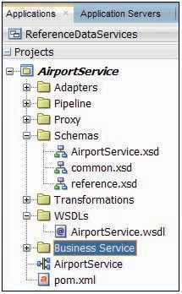

**FIGURE 4-4.** *The AirportService project with the imported resources*

The WSDL document—supported by the XSD definitions—describes the interface of the *AirportService*. Take a moment to familiarize yourself with the *findAirports* operation that we are about to bring to life.

#### Database Adapter—Read SQL Query Airports

Open the overview editor for the *AirportService*. From the component palette, drag the Database [Adapter] from the Technology section and drop it in the External References lane, see Figure 4-5.

The editor for configuring the Database Adapter reference appears. It will gather details from us on what exactly is the nature of the database interaction we desire. It will generate the configuration files that drive the database adapter’s operation at run time as well as WSDL and XSD documents that describe in normalized format the service the database adapter is to provide.

Set the name of the Database Adapter Reference to *QueryAirportsDB*. Press Next.

The Service Connection step in the configuration wizard (Figure 4-6) has a double purpose. It can be a little confusing to have both these purposes handled on the same page. The first one is to provide the database connection that is used at design time to gather metadata about the database and the objects we want to interact with. This database connection is used only by the wizard at design time. It is not relevant in any way to what will happen at run time. Select or create a database connection that connects to the database schema that holds the Saibot Common tables.

The second purpose is to provide the JNDI Name of the Database Adapter connection to be used at runtime, which we will configure in the target WebLogic platform—more details in the next section. It is common for this JNDI Name to start with eis/DB/ and to be followed by a descriptive name that indicates which logical database environment (database, schema, role) it is associated with. Note that this is *not* the JDBC Data Source name. Set the JNDI Name to eis/DB/ SaibotCommonDB.

Press Next.

On the next page (Figure 4-7) we set the Operation Type. This is obviously quite important: do we want the adapter to operate in inbound (polling) mode or in outbound mode. And in outbound mode, do we want it to manipulate data, to invoke a stored procedure or to query data.

And if—as in our case—we want to query data, what exact data retrieval method do we want to employ.

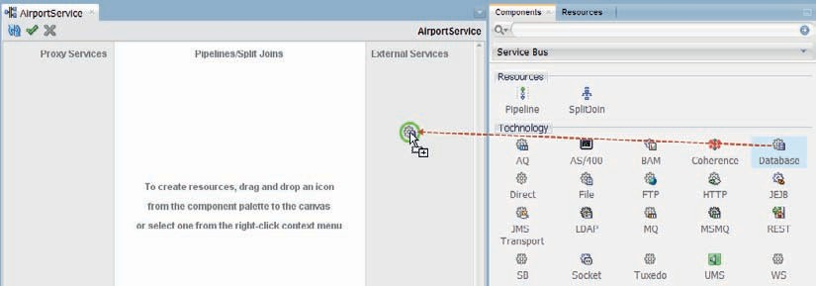

**FIGURE 4-5.** *Drag the Database Adapter to the External References lane*

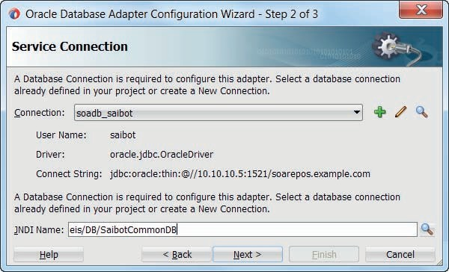

**FIGURE 4-6.** *Configure the design time database connection and the run-time JNDI Name of*

*the DB Adapter connection*

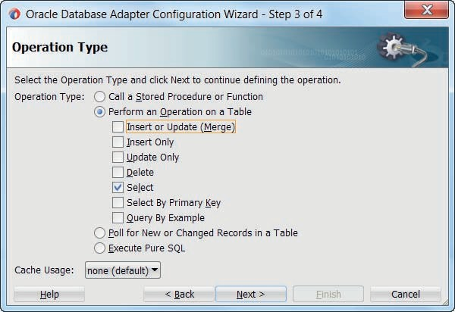

**FIGURE 4-7.** *Selecting the operation type for the Database Adapter Reference*

The retrieval options are:

* Select—we define a SQL query that typically contains one or more bind parameters; the input to the adapter at run time consists of the values for these parameters and based on

these values, the query will return a specific result set.

* Select By Primary Key—similar to the previous option, except that only one parameter is used: the primary key; this operation benefits from use of the Coherence integration with

the database adapter, available only on Exalogic systems.

* Query by Example—a sample XML record in the structure of the query results provides values that all produced query results should have in the corresponding columns; this

operation provides a lot of flexibility, that comes at a performance cost, because a new SELECT statement must be prepared and hard parsed by the database for each execution.

* Execute Pure SQL—provide the exact SQL statement that should be executed, including bind parameters to use; this type is especially useful when dealing with arbitrarily

complex statements, aggregate queries, and XMLType columns or other database types.

Additionally, and frequently quite valuable, a call to stored procedure or function can be used to retrieve a result set. This makes it possible to encapsulate the SQL inside the stored program.

On an Oracle database, this also allows us to prepare arbitrarily complex, multilevel data structures—using objects and collections—that can be returned in a single round trip. We will see this mechanism in action later in this chapter.

In this case, pick operation type Select.

In step 4, import tables CMN_AIRPORTS and CMN_COUNTRIES. Click the button Import Tables, press query to bring up a list of all tables available in the database connection you defined earlier on and shuttle these two tables to the right side.

It will take a little time for the wizard to process all metadata associated with these tables.

When you can again operate the buttons, press Next. This will take you to the Relationships page. This is where we have to specify how the two tables hang together.

The situation is that table CMN_AIRPORTS has a foreign key to CMN_COUNTRIES, based on column cty_id that references the id column in CMN_AIRPORTS. We want to be able to search for airports based on the country code—which is a column in the countries lookup table. And the search results should contain the lookup country information for each airport.

Click on button Create to specify the relationship between the two tables. A lookup relation like the one we have here is specified with the first radio button: CMN_AIRPORTS has a 1:1 Relationship with CMN_COUNTRIES. The Parent Table is CMN_AIRPORTS and the Child Table is CMN_COUNTRIES. The linking columns—CMN_AIRPORTS.cty_id and CMN_COUNTRIES. id—must be specified in the table, as is shown in Figure 4-8.

Press OK to complete the definition of the relationship. Then Next to go to the next step in the wizard.

The step Attribute Filtering lists all attributes that the query can produce, based on the columns in all tables involved. If column values are not required in the result set and are not involved in the search criteria, then you should uncheck the corresponding attributes for reasons of design time simplicity and run-time performance: fewer attributes means simpler transformations at design time and smaller data sets at run time.

Press Next when you have determined which attributes to include and exclude.

The next step is Define Selection Criteria (Figure 4-9), which really means composing the where clause for the SQL query. The wizard allows you to declaratively construct the selection criteria. However, you can also manually edit the SQL statement on this page.

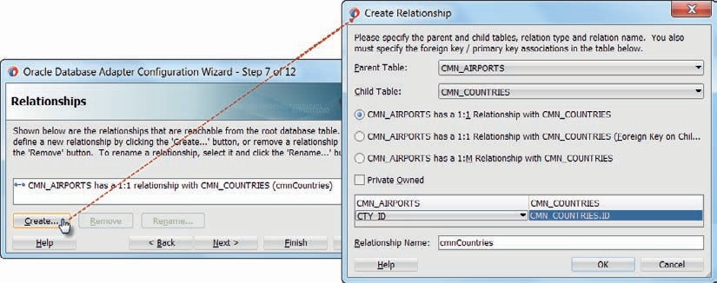

**FIGURE 4-8.** *Configuring the relationship between tables CMN_AIRPORTS and*

*CMN_COUNTRIES*

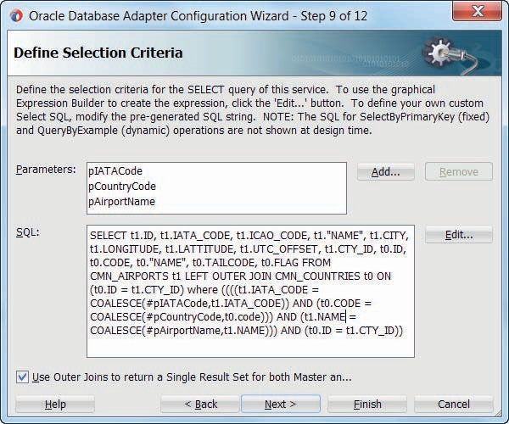

**FIGURE 4-9.** *Configuring the Query Selection Criteria*

When you manually edit the statement, then you are introducing hard-coded SQL that may result in maintenance overhead at a later stage and you may lose database platform independence by using vendor specific SQL. As long as you stay in declarative mode, the database adapter will translate the declarative search definition into platform specific SQL for the run-time target database, using relevant capabilities in TopLink. A preferred method of using advanced platform specific SQL capabilities without losing platform independence would be to encapsulate such SQL in database views that can be queried against by the database adapter using standard SQL, or use stored procedures to encapsulate the SQL.

Because Saibot Airport is hooked on Oracle Databases and is fictitious to boot, we will have no qualms in this book to edit SQL statements as we see fit.

First, press button Add thrice to create three parameters, called pIATACode, pCountryCode, and pAirportName. These parameters represent the run-time input to the database adapter reference. They can be used as bind parameters in the SQL query.

Check the checkbox to use outer joins to return a single result set. The effect of this setting is that TopLink will use a single SQL query to return results from both tables, instead of one query per table or even one query for the master table and one query on the lookup table for each master record.

When you press the Edit button you can declaratively compose the where condition, using the three parameters. The editor does not have built in facilities to deal with optional parameters not having a value. After using the declarative editor, you will have to manually refine the SQL condition to deal with that. The easiest way is using the Oracle specific NVL function; the platform independent way would be with the COALESCE function.

When the SQL statement is complete, press Next. The following two steps are for configuring advanced options (JDBC settings such as timeout and maximum number of rows) and JCA properties (retry strategy). Finally, press Finish to complete the wizard and have the adapter configuration files generated (see Figure 4-10).

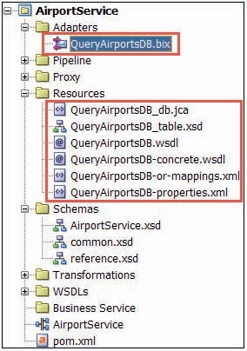

**FIGURE 4-10.** *The files generated by the Database Adapter configuration wizard*

The generated file QueryAirportsDB_db.jca is the root of the database adapter configuration for this service. It contains references to the other files that were generated as well as the core properties required at run time by the database adapter to do the job. Crucial among these is the location attribute (the JNDI name) in the connection-factory element that refers to the DB Adapter connection defined in the runtime WLS platform (see next section).

The generated QueryAirportsDB.wsdl file contains the normalized, web service representation of the functionality offered by this (database) adapter reference: it makes the database adapter reference look like an ordinary web service. The corresponding concrete WSDL adds a binding of type JCA transport and a port at the endpoint that was specified through the JNDI name entered in the wizard. The generated QueryAirportsDB_table.xsd is imported from the wsdl document. It contains the definition of the XML structure for the input—the parameters—and output—the query results—of the adapter operation. The files QueryAirportsDB-properties.xml and QueryAirportsDB-or-mappings.xml contain definitions used by TopLink, including the actual SQL query and details about the parameters and columns involved. Any advanced TopLink specific refinements that are not supported in the adapter configuration wizard can be made in these files. Note: re-running the wizard can overwrite such changes.

The wizard will also generate a Service Bus business service QueryAirportsDB, configured for this database adapter reference (using the JCA transport and referencing the QueryAirportsDB

_db.jca file). See how these files hang together in the dependency overview in Figure 4-11.

###### NOTE

*A business service can also be generated from the context menu on any JCA adapter configuration file, in this case by right clicking on QueryAirportsDB_db.jca.*

#### Configuration of Run-Time Server

The WebLogic Server on which the Service Bus engine runs needs to be prepared for the use of the database adapter, or at least for using the adapter to access a new target database. Typically this will be a two-step process that requires us to configure a JDBC Data Source—that describes the connection to the database account—and a Database Adapter Connection that defines specific adapter behavior and references the JDBC Data Source. Both steps are done from the WebLogic Server Administration console. You access this console at http://localhost:7101/console for the Integrated WLS or from the context menu on the Integrated WebLogicServer connection in the Application Servers window in JDeveloper.

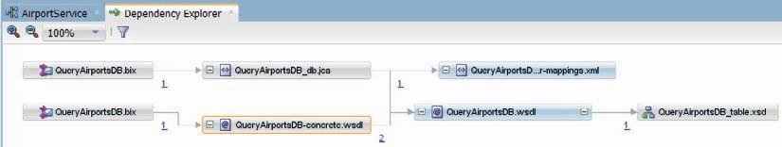

**FIGURE 4-11.** *Explore dependencies for the JCA Adapter specific WSDL file*

*QueryAirportsDB.wsdl*

##### Configure JDBC Data Source

To configure the JDBC Data Source, click on Data Sources on the home page in the console. Click on the New button and select the option Generic Data Source, to create a new JDBC Data Source. See Figure 4-12.

Define the Name as SaibotCommonDS and the JNDI Name as jdbc/SaibotCommonDS. Press Next—assuming the Database Type is indeed Oracle.

Following up on that assumption, accept the default driver on the second page of this wizard.

Click Next again. Provide the Database Name (the SID of the target database), the Host Name, and the Port. Then provide the name of the database account to which the Data Source should connect and the associated password (twice). Press Next. Press the button Test Configuration to verify if the connection was configured correctly. If not, return and correct the settings.

Otherwise, press Next again. We now need to associate the Data Source definition with the managed server(s) we want to deploy it to. For the Integrated WebLogic Server, check the box in front of DefaultServer. Then press Finish.

This will create the Data Source and deploy it to the DefaultServer, making it available for applications that want to use it.

##### Configure Database Adapter

The database adapter is deployed as an application to WebLogic where it runs independently from the SOA Suite. Any Java EE application running on the WebLogic Server can enlist the help of the database adapter or any other of the JCA adapters to integrate with enterprise resources.

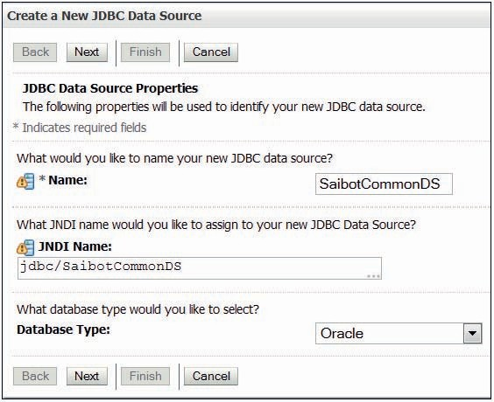

**FIGURE 4-12.** *Configure JDBC Data Source, name and JNDI name*

In order to invoke the adapter successfully, it requires a set of JCA properties that instructs the adapter on what action it should execute. Among the properties used by the database adapter is a reference to the JNDI name of a connection that should be used. This connection is configured for the database adapter through the WebLogic Administration Console. The configuration includes some settings regarding the use of database sequences for generating unique numbers and some other specific JDBC operations. The most important property is the reference to the JDBC Data Source that should be used by this DB Adapter connection to access the target database.

To configure the DB Adapter connection, go to the home page of the WLS console and list the deployments. Locate the DB Adapter deployment and click on it. Open the Configuration tab and then the sub-tab labeled Outbound Connection Pools. Click on the New button.

A wizard page appears on which you can specify the JNDI name for the new DB Adapter connection. This is the same name used in the JNDI name field in the Database Adapter configuration wizard in JDeveloper (that was saved in the location attribute of the connection- factory element in the .jca properties file). Set the JNDI Name to eis/DB/SaibotCommonDB and press Finish to create the new connection. When this is your first change to the database adapter deployment, WebLogic will prompt you to create a deployment plan file to save this and future configuration changes to. This file should be called Plan.xml and is commonly located in a directory called Middleware Home/SOA Suite home/soa/DBPlan, although you are free to choose any location on the server that runs the WebLogic platform.

The console will take you to a page that assures you that all changes have been activated and no restarts are necessary. Let’s make a few refinements to the connection definition.

Return to the tab Configuration | Outbound Connection Pools and click on the connection eis/DB/SaibotCommonDB you have just added. Click on the property value for the property XADataSourceName. The field is editable now. Type the JNDI name of the JDBC Data Source that you created earlier on: jdbc/SaibotCommonDS. Then press enter to set the value. Then press the Save button. This completes the configuration of the Database Adapter connection configuration.

###### NOTE

*In general, if a data source is used for nontransactional database access—read only—or will not be used for operations to participate in global transactions, it is best to configure it as “Non XA” (by selecting a database driver that does not do XA) to avoid the overhead associated with the XA transaction. In the Database Adapter configuration, you should then set the DataSourceName property instead of XADataSourceName. For the purpose of the Saibot Airport case in this book, working with an XADataSource at all times will be the simplest approach.*

#### Test Business Service

When the Database Adapter binding is configured in JDeveloper and a Service Bus business service is created for it, we can test it without first having to create a pipeline and a proxy service. One provision is that the configuration of the Database Adapter connection has been completed, as described in the previous section.

To test the database interaction, select the option Run on the context menu for the QueryAirportsDB business service in the Service Bus overview.

The Service Bus project will be deployed to the Integrated WLS. The Business Service tester appears, which allows us to enter values for the search parameters used in the query against the Airports and Countries tables.

When you press Execute, the XML document is handed to the DB Adapter by the Service Bus along with the JCA properties that tell it which connection to use and thereby indirectly which JDBC Data Source to leverage. The Database Adapter uses TopLink to construct the SQL query that is executed over the JDBC connection against the Saibot Common database (schema) and to return the results in XML format as described by the XSD document QueryAirportsDB_table.xsd. This XML document is returned to the Business Service Tester in the Response, as is shown in Figure 4-13.

###### TIP

*If instead you get a response message that contains a Missing Property Exception, the name used in the location property of the connection- factory element in the QueryAirportsDB_db.jca file may not exactly correspond to the JNDI name assigned to the DB Adapter connection in the WLS Console; alternatively you may have to restart the WebLogic Server after all.*

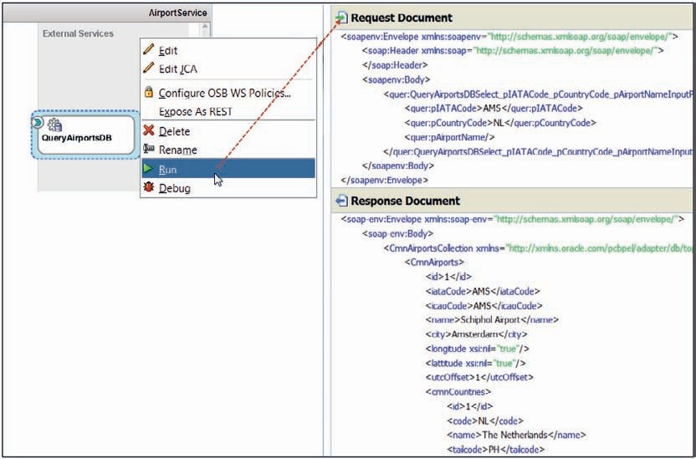

**FIGURE 4-13.** *Results from testing the QueryAirportsDB binding service*

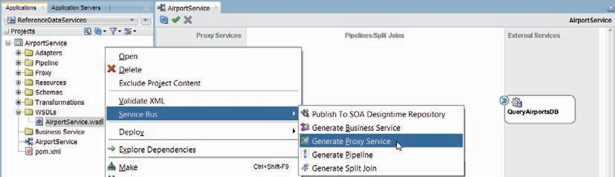

**FIGURE 4-14.** *Generate the Proxy for the Airport Service based on the AirportService.wsdl*

*document*

#### Implement Proxy Service and Pipeline

The next step on our way to the implementation of the *AirportService* is the implementation of the Proxy Service and Pipeline in the Service Bus project.

##### Generate Proxy Service

The *AirportService* that we are implementing here is described by the AirportService.wsdl document. Based on that document, we can let JDeveloper generate the proxy service as well as the pipeline. Bring up the context menu on the wsdl document and activate Service Bus | Generate Proxy Service, as shown in Figure 4-14.

In the Create Proxy Service editor, set the name to *AirportServicePS*, following the naming convention that Saibot have chosen for proxy services. Have the Pipeline generated as well by checking the relevant checkbox; call the Pipeline *AirportPipeline*.

Press Next. Set the Endpoint URI to /reference/AirportService.

Press Finish. The proxy service and the pipeline are generated, both in the WSDLs folder. Use the Refactor | Move option on the context menu for both definitions to relocate them to the appropriate folders.

The AirportService overview shows the new AirportServicePS wired to the equally new AirportPipeline. Create a wire from the AirportPipeline to the QueryAirportsDB business service, as shown in Figure 4-15.

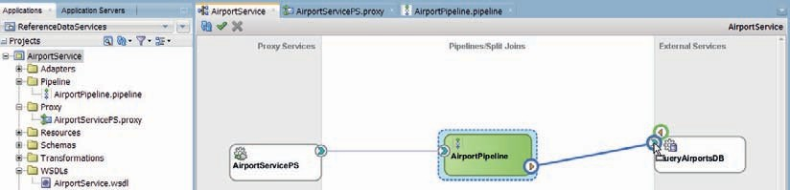

**FIGURE 4-15.** *Wiring the AirportPipeline to the QueryAirportsDB business service in the*

*AirportService project*

Then double click the *AirportPipeline* to bring up the pipeline editor.

##### Implement Pipeline

The *AirportPipeline* already contains a Route node with a Routing activity that calls out to the QueryAirportsDB business service. This is the result from wiring the pipeline to the business service. Ensure that the right operation is invoked from the routing activity: *QueryAirportDBSelect*.

All that is required now is that the request received from the proxy service is transformed to the XML technical format expected by the business service, as described in QueryAirportsDB_ table.xsd. Likewise, the technical response from the business service has to be transformed to the message format defined in the interface of the *AirportService*.

Create the XSL Maps for these transformations in the same way as in the previous chapter. In the mapping of the response from the Database Adapter to the response message format,

you will have to deal with a repeating set of nodes using the XSLT for-each operator. Every node represents a result row of the select statement. When the XSL Map editor first opens: click on the tns:airport node in the target tree and from the context menu select Insert Parent | XSL | for-each (see Figure 4-16). This will add a for-each node to the tree.

Map the node ns0:CmnAirports to the xsl:for-each node. Subsequently, map all child nodes to their respective counterparts—optionally using the *auto map* feature that you can engage by dragging node ns0:CmnAirports to node tns:airport. Figure 4-17 shows part of the mapping result.

In the pipeline’s Routing node, add Replace activities to both the Request and Response actions, using the two XSL Maps you have just created (as shown in Figure 4-18). Both replace the node contents of the body using an XSLT resource and feeding $body/*[1] as the input document expression into the transformation.

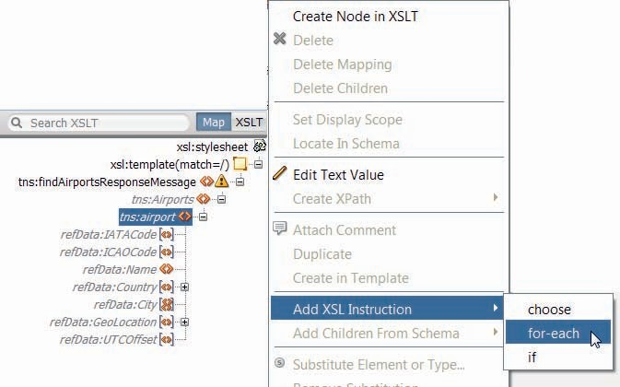

**FIGURE 4-16.** *Add a for-each node to the XSL Map to map multiple airports*

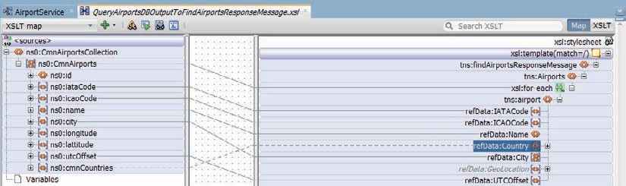

**FIGURE 4-17.** *Mapping multiple airports queried from the database to the response message*

*format*

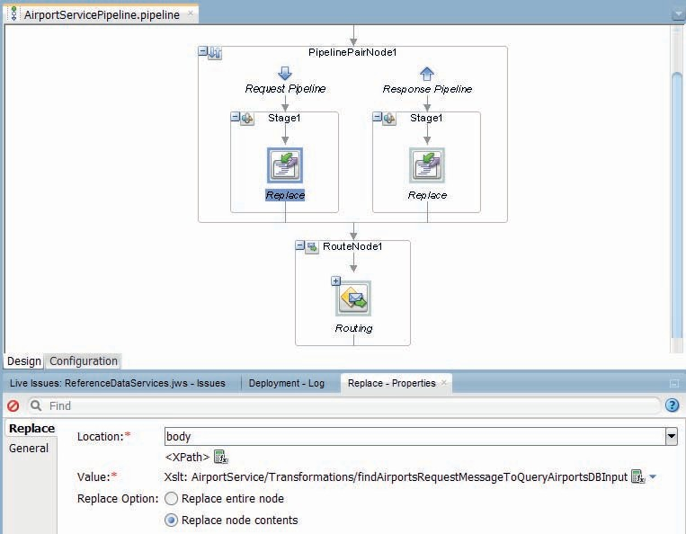

**FIGURE 4-18.** *The AirportPipeline with the Routing Node and two Replace activities—on the way in and on the way out*

#### Test the AirportServicePS Proxy Service

The complete *AirportService* can now be tested by running the *AirportServicePS* proxy. The Service Bus project is deployed and the Proxy Service Tester is displayed. Provide input in the format prescribed by the interface of the *AirportService*.

Press Execute to invoke the service. Through a transformation of our request message followed by an SQL query against the Saibot Common database and finally a transformation of the query results to the required response format, the output will be produced.

The end-to-end chain is complete—allowing us to expose services that use a database for most of their implementation.

### Using the Database Adapter to Insert Records

In addition to querying data, the database adapter is well suited to support data manipulation. It can do Insert, Update, Delete, and Merge operations—and it performs the manipulation(s) as part of the same transaction that was started for handling the service request by the Service Bus if we want it do (or alternatively create a dedicated transaction for the database operation).

More complex data manipulations—such as those involving multiple tables—can be implemented using stored procedures. Calls to stored procedures made by the database adapter are included in the global transaction too when an XA Data Source is used. Stored procedures should not perform Commit operations: any data manipulations they perform are committed or rolled back along with the (global or dedicated) transaction, orchestrated from the Service Bus.

In this section, we will look at both types of data manipulation with the database adapter: straightforward DML and calls to stored procedures that indirectly perform DML.

#### Simple Database Record Insert or Update

In the case of Saibot Airport, reference data is not only exposed through reference services, it is also managed through these services. For example, countries: the *CountryService* is used to search countries, retrieve country details as well as manage the data. Even though reference data for countries does not change a whole lot, still there are regular changes—34 new countries since 1990, such as the recent birth of South Sudan, the break-up of the Netherlands Antilles, the new flags of Paraguay and Malawi and several areas around the world where relevant changes may be the result of animosities.

The *CountryService* is defined through a WSDL document—CountryService.wsdl—with an associated XSD definition. The country data is held in table CMN_COUNTRIES in the Saibot Common domain. The table has columns for the country code, its name, the tail code assigned to aircrafts registered in the country and a BLOB column to hold a picture of the flag. We will now create the service to maintain country records, using the database adapter and the Service Bus.

##### Prepare the Service Bus Project

Back in the JDeveloper application *ReferenceDataServices*, create a new Service Bus project using the New Gallery—Category: General | Projects, Item: Service Bus Project.

Call the new project *CountryService*. Optionally, create folders WSDLs, Schemas, Proxy, Adapters, Pipeline, Transformations, and Business Service. Import the resources CountryService. wsdl and CountryService.xsd and also reference.xsd and common.xsd from the JAR file *CountryServiceInitialResources.jar*.

##### Create the Proxy Service and a Pipeline

From the context menu on the file CountryService.wsdl, generate a proxy service and associated pipeline.

The proxy service should be called *CountryServicePS* and the pipeline *CountryPipeline*. The location for the proxy service is the Proxy folder.

On the Transport page, set the Endpoint URI for the proxy service to /reference/ CountryService.

Finish the wizard and have the proxy service and the pipeline generated in the project. In the Service Bus overview editor, the result—an exposed proxy service wired to the

CountryPipeline—is displayed. What we need next is the business service based on a Database Adapter reference, wired to the pipeline.

##### Configure a Database Adapter Reference for Inserting Country Records

In the Service Bus overview editor, drag the Database Adapter from the component palette to the External References lane, to bring up the wizard that will configure the outbound DB Adapter reference, and create the business service on top of it.

Set the name of the Database Adapter Reference to *CreateCountryDB*.

On page 2, use the IDE database connection to the Saibot Common database. The Database Adapter connection that we used for the AirportService can be used again, because the current DB Adapter reference will access the same target database in a similar fashion. Either type the JNDI name of that connection—eis/DB/SaibotCommonDB—or browse this connection using the JNDI Browser against the Integrated WLS, provided it is actually running (as shown in Figure 4-19).

Select Insert Only as the Operation Type in step 3.

Import table CMN_COUNTRIES in the next step. Press Next. There are no relationships to add, so press Next again. Accept all attributes based on table columns to be included in the insert operation, and press Next.

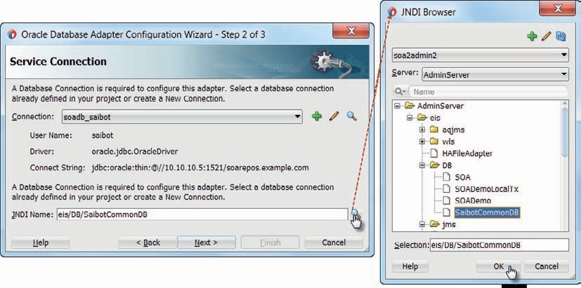

**FIGURE 4-19.** *Browsing the JNDI name for the DB Adapter connection in the Integrated WLS*

In step 7, we specify how for each new COUNTRY record, the next value from a database sequence CMN_CTY_SEQ will be used to set the value of the ID column—which is the primary key. If this sequence does not yet exist, it will not be in the drop-down list in this page. In that case simply type the name of the sequence in the Sequence field—and it will be created by the wizard in the database schema linked to by the IDE Database Connection, see Figure 4-20.

Complete the wizard, accepting all default settings after this step.

The Database Adapter configuration files are generated, as is the *CreateCountryDB* business service that is based on the JCA transport defined by the adapter configuration.

###### NOTE

*One of the properties of the Database Adapter connection defined in the WebLogic console is the SequencePreAllocationSize. It is necessary for this value to be equal to the increment by property of the database sequence. The default setting in the adapter connection is 50.*

##### Test the Business Service

At this point, even though the pipeline is not implemented nor is it wired to the business service, we can already test the business service and thereby the configuration of the database adapter. Because the DB Adapter connection is already set up in the Integrated WebLogic Server (or the stand-alone managed server you are using) earlier in this chapter, we can now simply activate Run on the context menu for the business service in the Service Bus editor and have the Service Bus project deployed and the business service tester console launched.

The request document is of course not of the XML structure *createCountryRequestMessage* that we need for the proxy service, but of the technical structure generated by the Database Adapter configuration wizard, corresponding to the SQL operation insert into CMN_COUNTRIES. Provide details, for example for the UK (tail code is G) and execute the business service.

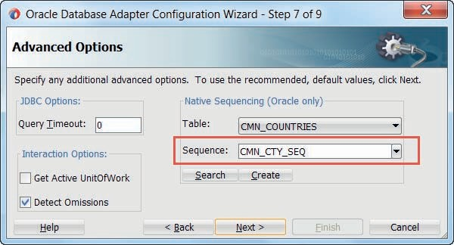

**FIGURE 4-20.** *Identifying (and Creating) the sequence to derive the primary key values from for*

*newly inserted records*

The Response document shows the country record as it was created, including the value derived from the sequence and assigned to the ID column.

You can verify in the database if the new Country record was indeed created. Later in this section we will use SoapUI to test the *CountryService* and also submit binary data for a picture of a flag that will be stored in the BLOB column in the CMN_COUNTRIES table.

##### Complete the Pipeline

In the Service Bus overview editor, wire the pipeline to the CreateCountryDB business service. This will add a Route node and Routing activity (linked to the business service) to the pipeline.

All we need to do now is to add transformations to the Routing activity, to transform the request message based on the XSD element *createCountryRequestMessage* to the input for the *CreateCountryDB* business service (== Database Adapter) and the response from the latter into the *createCountryResponseMessage* structure. Create the necessary XSL Maps and add Replace operations to the Routing node. You can test the proxy service as soon as the Replace for the request action is in place: the response will not have the correct XML structure, but the request does and the country should be added to the database table.

Note that the *CountryService* defines three operations in its interface specification. There is no distinction in the pipeline between these operations. That means that the pipeline will always do the same thing—invoke the *CreateCountryDB* business service—regardless of what operation was actually invoked. We need to add an operational branch node to add support for all three operations when we get round to completing the pipeline.

##### Test the Create Country Operation in the CountryService

When the pipeline is complete, with transformations in both request and response action, then run-the Proxy Service and create a request message, for example, to add France with tail code F. This time, we compose a *createCountryRequestMessage* XML element, according to the interface definition of the service.

After executing the service, the response message will be of the specified type— *createCountryResponseMessage—*containing a *resultCode* element with the assigned id value for the new country.

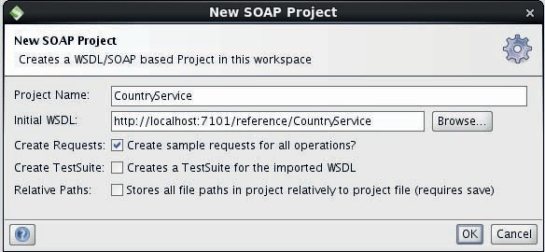

**FIGURE 4-21.** *Create new SOAP UI Test Project configured for the CountryService*

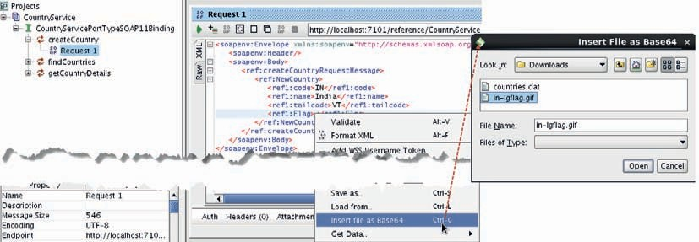

**FIGURE 4-22.** *Add the binary content from a file as Base64 encoded data to a request message*

##### Create a SoapUI Test Project for the CountryService

SoapUI [(http://www.soapui.org/)](http://www.soapui.org/)) is a valuable tool for testing services—so valuable it has become the de facto standard among developers. We can use SoapUI to see whether the CountryService handles images well. With SoapUI it is very easy to include, for example, the contents from image files as base64 encoded content in the XML request message.

Start SoapUI and create a new Soap project for the CountryService—its WSDL is exposed at http://localhost:7101/reference/CountryService?wsdl (see Figure 4-21).

Have sample requests created for all operations. Then open the test request for the createCountry operation. Enter the NewCountry record for India (IN, India, VT). Then remove the random data for the Flag element. Open the context menu for the Flag element and select the option Insert file as Base64 that allows us to add the contents from a binary file as base64 encoded content to the request message, as shown in Figure 4-22.

A file browser dialog window opens. Select an image file that holds the flag of India, such as in-lgflag.gif, downloaded from [https://www](http://www.cia.gov/library/publications/the-world-factbook/docs/).cia.go[v/library/publications/the-world-factbook/docs/](http://www.cia.gov/library/publications/the-world-factbook/docs/) flagsoftheworld.html.

SoapUI adds the base64 equivalent of the binary file to the request message. Press the Run icon to send the request message to the CountryService. The response should indicate that a new Country record was created (Figure 4-23).

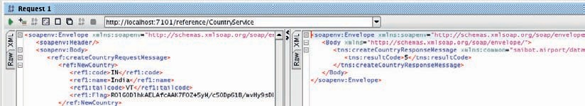

**FIGURE 4-23.** *Request to and Response from the CountryServie*

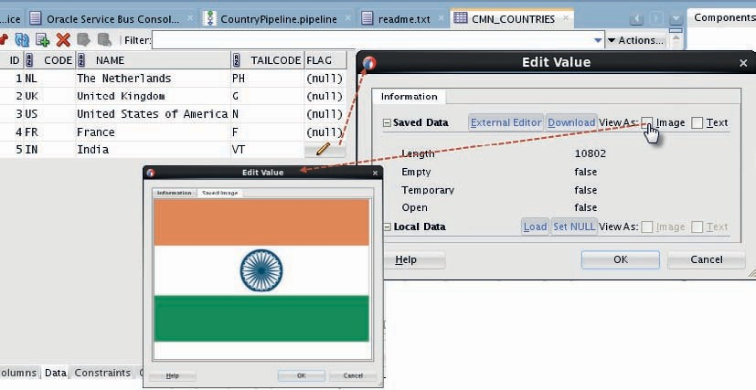

**FIGURE 4-24.** *Inspecting the new Country record including the BLOB column with the flag*

*contents*

In JDeveloper, in the Databases Window, when we open the connection to the Saibot Common database schema and list the tables, we can easily verify the data in the CMN_ COUNTRIES table. This reveals that the test from SoapUI created the country record for India, including a value for the FLAG column of type BLOB (Figure 4-24). We can inspect the value of the BLOB column and display that value as an image, by checking the Image checkbox in the Edit Value window.

#### Invoke Stored Procedure

The simple SQL data manipulations and select operations can be quite powerful, but they are limited. Data manipulations access only a single table—unless that table actually is a multitable view with an instead of trigger to handle multitable manipulation from PL/SQL—and do not handle multiple records of different types. The select operation can return records multiple types—for example, nested master-detail structures, such as countries with all their airports.

However, because we have to perform all data gathering in a single SQL statement, we still are somewhat limited in bringing in data from various tables.

One common way and even best practice to work around these limitations is through the use of stored procedures. The database adapter is equally good at invoking these database program units as it is as performing SQL. The DB Adapter also knows how to deal with stored functions or procedures that return a (ref) cursor; using a cursor is an elegant way of encapsulating the SQL required to gather data while still making the data available in an efficient manner. PL/SQL programs in an Oracle Database can use complex parameters, defined on top of Object and Collection definitions, that make it possible to transfer multilevel and heterogeneous record

**FIGURE 4-25.** *The DB Adapter can easily expose complex PL/SQL program units and nested data structures*



Type

Type

DB

Adapter Binding

Type

PL/SQL

Package

XML

Table

XML

Table

Table

structures—composed through simple or highly ingenious PL/SQL logic—in a single round trip, as Figure 4-25 visualizes.

The stored procedure can perform multiple queries and DML statements, against multiple tables, allowing for arbitrarily complex data manipulations. As a bonus, all database actions are encapsulated in the stored procedure; the only dependency between the database adapter and the Service Bus project using it on the one hand and the database on the other is the interface specification of the stored procedure.

In this section, we will use a PL/SQL package to take care of the database actions required for allocating one or more slots to an air carrier in the Saibot Future database with mid-term plans and forecasts. The *SlotService* is invoked to record and retrieve details about allocated slots as agreed in contracts between air carriers and Saibot Airport. This PL/SQL package provides the implementation for the *allocateSlots* operation in the *SlotService*. The response from that operation indicates for each slot if the registration of the allocation was successful.

##### Create Stored Procedure to Create Slot Allocations

The PL/SQL package FUT_FLIGHT_API contains procedure ALLOCATE_SLOTS. This procedure’s interface has two parameters:

* Input: p_slots based on database type slot_tbl_t, defined as a table of slot_t
* Output: p_slot_allocations of type slot_allocation_tbl_t, a table of slot_allocation_t

These types are defined as objects—similar to XML elements or Java Classes—with DDL statements such as:

 create or replace type slot_t force as object (

aircarrier_code varchar2(3)

, timeblock timeunit_t

, arrival_or_departure varchar2(1)

, aircraft_model_iata_code varchar2(3)

, aircraft_model_iaco_code varchar2(4)

)

where timeunit_t is a nested object type that itself references the collection type weekday_ tbl_t (see Figure 4-26). Obviously, these types support the definition of complex, nested data structures. These types can be used as the data type for database columns, for column expressions in select statements and for PL/SQL variables. When used as the foundation for input and output parameter as is the case here, quite large and complex data packets can be transferred into and from PL/SQL procedures and functions. That fact, and the ability of the Database Adapter to work well with such parameters, make them very suitable for use in the interaction between the SOA Suite and the database.

The PL/SQL code in procedure ALLOCATE_SLOTS takes care of some simple validations, lookups and finally record creation in table FUT_SLOTS.

##### Prepare Application FlightFuture

Create a new JDeveloper application called *FlightFuture* of type Service Bus application with Service Bus project. Call the Service Bus project *SlotService*.

Create folders Adapter, Schemas, Transformations, and WSDLs in the *SlotService* project.

Import the resources SlotService.wsdl, SlotService.xsd, common.xsd, and reference.xsd from the file SlotServiceInitialResources.jar.

##### Configure Database Adapter

Drag the Database Adapter to the lane with external reference. Configure a database adapter reference called *AllocateSlotsDB*, using the same IDE database connection as before, to the Saibot Common database, and using the same JNDI name eis/DB/SaibotCommonDB to use the same Database Adapter connection as before. Select Operation Type *Call a Stored Procedure or Function* in step 3 of the wizard.

Select procedure ALLOCATE_SLOTS in package FUT_SLOT_API in step 4 of the wizard, labeled Specify Stored Procedure (Figure 4-27).

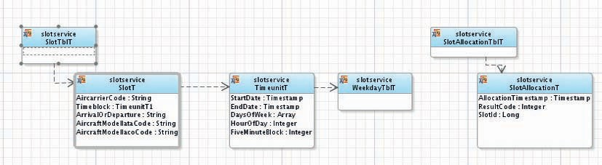

**FIGURE 4-26.** *Database types (Objects and Nested Table Collections) for Slot Allocation details*

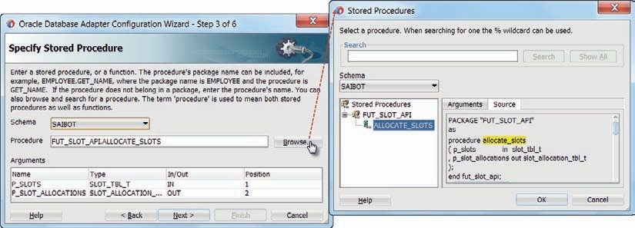

**FIGURE 4-27.** *Specify a stored procedure to have invoked by the DB Adapter*

The wizard inspects the signature of the procedure—deriving metadata about the parameters.

Later on, it will generate an XSD document that represents the structure of the parameters. The ability to map these parameters defined in terms of database objects and collection to and from XML is an extremely powerful and frequently undervalued capability of the database adapter.

Accept all further defaults in the wizard and press Finish on the first opportunity. The adapter configuration files are generated, as is the business service *AllocateSlotsDB* that links to it.

If you feel like it, you can test the business service to verify if the configuration of the database adapter was successful; just right click on the business service in the overview editor and select the run option.

##### Implement Proxy and Pipeline

Generate the Proxy Service *SlotServicePS* from the context menu on the SlotService.wsdl document.

Also let the wizard generate the pipeline for this Proxy Service, called *SlotPipeline*. Set the Endpoint URI for the proxy service to /flight/SlotService.

In the overview editor for the *SlotService*, wire the pipeline to the business service

*AllocateSlotsDB*.

Create the XSL Map transformation that maps from the *allocateSlotRequestMessage* to the *InputParameters* element generated for the database adapter binding (see Figure 4-28). Also create the mapping from the *OutputParameters* element defined in AllocateSlotDB_sp.xsd document to the *allocateSlotResponseMessage* to be returned by the Proxy Service.

Add Replace operations to the routing node in the *SlotPipeline* and have them operate on the

$body on the way in and on the way out respectively (Figure 4-29 shows the latter).

This completes the implementation of pipeline *SlotPipeline*. Save all sources.

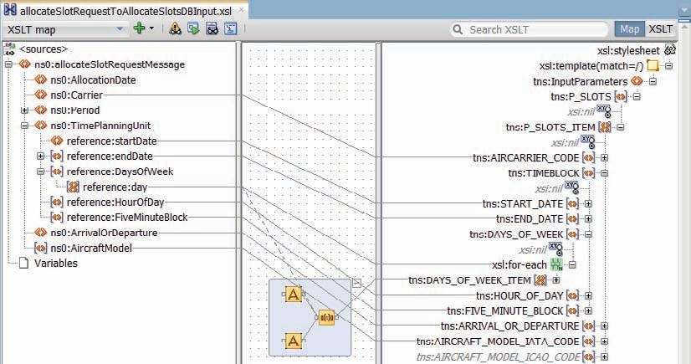

**FIGURE 4-28.** *Mapping the request message to the InputParameters element generated by the*

*DB Adapter wizard based on the Objects and Nested Table definitions in the database*

##### Test the Allocation of Slots through the SlotService

The *SlotService* is now completely implemented and is ready for testing. Run the *SlotServicePS* proxy service. Provide the details for a slot allocation in the request message, including one or more weekdays and the IATA code for an air carrier (see Figure 4-30). Press Execute to invoke the *SlotService*.

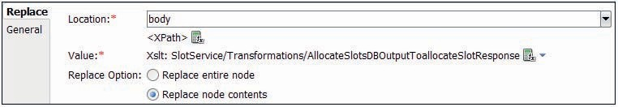

**FIGURE 4-29.** *Replace activity in the Response flow to transform the contents of $body based*

*on the AllocateSlotsDBOutputToAllocationSlotResponse.xsl map*

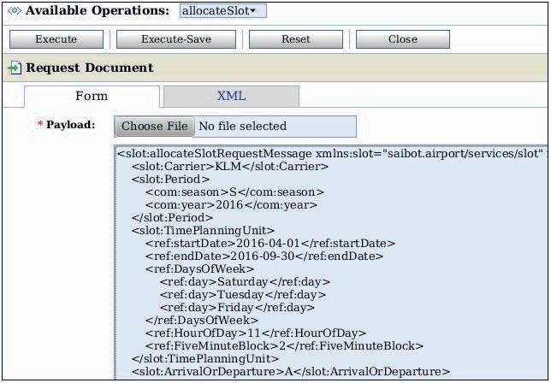

**FIGURE 4-30.** *Example of a Slot Allocation request message destined for the SlotService*

The response message will indicate if the registration of the slot allocation succeeded with a Result code (0 means success, > 0 indicates an error of some sort). In case of success, the identifier value for the registered slot is returned as well. Querying the FUT_SLOTS table will then produce the newly created SLOT record, as shown in Figure 4-31.

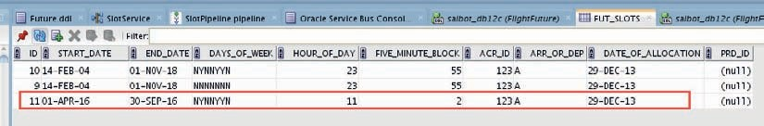

**FIGURE 4-31.** *New Slot record in FUT_SLOTS table, created by the SlotService through the*

*PL/SQL Package*

##### Alternative Way: Invoking Database through REST

Database can be invoked in various ways from the SOA Suite, that not all involve the database adapter.

From the SOA Suite we can call out an intermediary component—such as an Enterprise Java Bean (EJB) or a JAX-WS or JAX-RS-based Java Web Service—that in turn interacts with databases. This database interaction could be implemented using JPA (e.g., with EclipseLink, TopLink, or Hibernate), Oracle ADF Business Components (ADF BC), or plain JDBC.

Another example is simple HTTP Requests from the SOA Suite directly to the HTTP port of an Oracle Database. Such calls are handled by stored PL/SQL units registered with the Embedded PL/SQL Gateway (the same mechanism that facilitates the Oracle APEX product). These calls cannot participate in a global transaction: they are a transaction of their own.

This type of interaction does not require a Database Adapter connection or JDBC Data Source to be configured, or even the ability to establish a connection at all; the requests travel through firewalls and into clouds.

Using the dbms_epg package to create a Database Access Descriptor (DAD) and configuration of the path-alias and path-alias-procedure attributes for that DAD with a PL/SQL program unit that handles HTTP requests for specific URLs, we can construct a REST style service that can be invoked using typical REST URLs, such as http://DBhost:DB_HTTP_port/ saibotapi/rest/flights/10-10-2016/flight/KL103/ to request the flight details for flight KL 103 on the 10th of October 2016.

We can implement a PL/SQL package that prepares flight information based on the parameters—date and flight number—passed through this type of URL, and returns that data constructed as a JSON message. A Service Bus business service can use the REST adapter to construct the URL to invoke this REST service and to retrieve the flight information from the database and convert from JSON to XML (or have the database return XML if that is more convenient).

Alternatively, we can use the ORDS (Oracle REST Data Services) product to expose REST services directly from the database.

### File Adapter for Updating Files

One of the enterprise resources that can be integrated into the SOA Suite by a JCA Technology Adapter is the File System adapter. Through the File Adapter, Service Bus projects and SCA Composite applications can interact with a file system (that is accessible from the host of the SOA Suite run time) to read files and directories and write new or append to existing files. Additionally, the file adapter can be used in inbound or polling mode, where the adapter will trigger the execution of a service upon the detection of a new file. The File Adapter is also integrated with Oracle Data Integrator (ODI), where it is typically used to handle large batches.

The file contents handled by the file adapter can be both XML and non-XML data formats. When the file adapter is configured at design time, a mapping is created between the file format and a corresponding XML structure. This results in a Native XSD (NXSD) document that describes the XML structure to be used by the Service Bus (or SOA composite) for interacting with the file adapter. The NXSD document also provides instructions to the file adapter itself for converting the native file contents into XML and vice versa.

The FTP adapter has largely the same functionality as the file adapter, interacting with remote file systems through use of the File Transfer Protocol (FTP). For the transfer of large files to and from remote locations, the SOA Suite interacts with MFT (Managed File Transfer). MFT is a Fusion Middleware component to process (potentially very large) documents that can be passed to SOA, B2B, or Service Bus. It uses its own embedded FTP server to receive files onto before further processing and routing them. Its operations can be scheduled as batch jobs.

In this section, we will use the file adapter to write an event log file with all status changes and events with regard to the flights that are scheduled to arrive and depart from Saibot Airport. The file adapter is used in the implementation of the *FlightReportService* that exposes an operation for updating that flight event log with new flight information.

Initially, all flight events are written (or appended) to a single file. In a second iteration, the file adapter is instructed to write events to a flight specific file located in a date specific directory.

#### Prepare Service Bus Project for FlightReportService

Create a new JDeveloper application *FlightPresent* with a Service Bus project called *FlightReportService*. Create folders Schemas, WSDLs, and Transformations. Import the sources FlightReportService.wsdl, FlightReportService.xsd, and the canonical XSD documents common.xsd, reference.xsd, and flight.xsd from the file FlightReportServiceInitialResources.jar.

Create a new file—sampleFlightEventLog.txt—with some sample data in the intended format of the flight event log file that the file adapter is going to create. You can use any of a number of format styles, including COBOL Copybook, Binary, Fixed Position, JSON, XML, and delimited such as comma separated. For the flight event log file, we will use a CSV file format, with event entries composed like this:

 FlightDate,Aircarrier,FlightNumber,StatusTimestamp,NewStatus,Action,Terminal,P ier,Gate,Runway,CheckinCounter,BagageLocation

13-11-2015,UA,2031,12-11-2015T23:48:23,Open,GateOpen,3,F,45,,12-15,

12-11-2015,QA,15,12-11-2015T23:48:25,Closed,Taxiing,,,,3W,,

#### Configure Outbound File Adapter

Open the editor for the FlightReportService project. Drag the File Adapter to the External References lane (see Figure 4-32).

The File Adapter configuration wizard opens. Set the name to *FlightEventLogFileWriter*.

Press Next.

In step 2, choose Define [Interface] from operation and schema (specified later). In step 3 accept the default for the File Server JNDI Name (eis/FileAdapter).

In step 4, select the operation *Write File*. On this page (Figure 4-33) you see all other supported operations: Read File (polling, inbound), Synchronous Read File, List Files and Chunked Read (to process large files in chunks, only available from within a BPEL process). Set the operation name to *WriteFlightEventLogEntry*.

In step 5 (Figure 4-33), set the directory to be specified as a logical name. This means that the real [physical] directory name is not hard coded in the adapter configuration but instead will be provided via a property that is typically set at deployment time (as it depends on the target deployment environment which directory should be used).

Set the logical name to FLIGHT_EVENTLOG_DIRECTORY. Set the file name of the file to which the adapter will write messages to *flightEventLog.txt*. Check the check box *Append to File*.

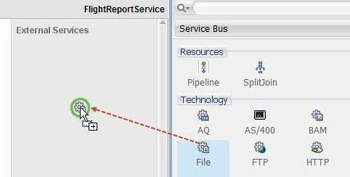

**FIGURE 4-32.** *Add outbound File Adapter to the FlightReportService Service Bus project*

This means that instead of creating a new file every time the adapter is executed, the file adapter will now add new messages to the end of the existing file. Only when the file adapter finds that the file specified does not yet exist, will it create the file.

The name of the file that is written to can be determined by dynamically using wild cards that either resolve to a unique sequential number (%SEQ%) or to a string based on the timestamp at the moment of writing (%yyyy% or %dd.mm.yyyy’T’HH:mm%). Examples of valid file names with wild cards are eventsFor%yyyy.mm.dd%.txt and uniqueLogFile%SEQ%.log). In this case, use the fixed file name flightEventLog.txt.

Press Next to go to the Messages definition page.

When you check the box “Native format translation is not required (Schema is Opaque),” the file adapter will not attempt to translate the contents read from or written to the file, from or to a native format. Instead, the contents are passed without interpretation as Base64 Encoded. This allows binary content such as image files or PDF documents to be read and written, without content parsing thereby increasing performance.

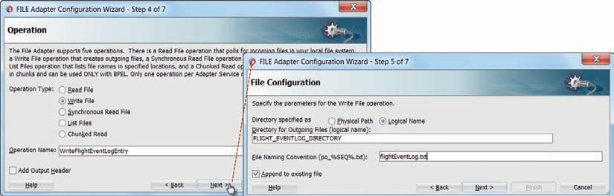

**FIGURE 4-33.** *Operations available with the File Adapter*

In this case, we do want native format translation—to CSV format—so click on the little gears icon to start the Native Format Builder that will help create an NXSD file that maps the native file format to an XML representation that we can deal with in the Service Bus pipeline.

Set the file name of the NXSD file to be created to nxsd_FlightEventLogFile.xsd in step one of the Native Format Builder. Select the Delimited file type, because we will create a file with comma delimited values. Note the variety in file formats that the file adapter can create for us, including JSON, XML, Fixed Length, and Complex (multi record).

In step 3 (Figure 4-34), specify the file with sample data that you created earlier. Accept all other settings—most of which are relevant only for file reading.

In step 4, accept the default configuration of *multiple records, all of the same type*. In step 5 you can provide some instructions for creating an easier-to-use XSD definition. Set the namespace to saibot.airport/data/flight/FlightEventLogFileWriter, the root element name to *FlightEventLog* and the record level element name to *FlightEventLogEntry*.

The delimiters to use to identify fields and records, and the rules for filtering records, are defined in step 6 (Figure 4-35). These rules can be quite complex when the native format is to be used for *reading* files (with not straightforward structures). In our case, we can accept all default settings that stipulate that fields are delimited by commas and that records are delimited by an EOL (end of line).

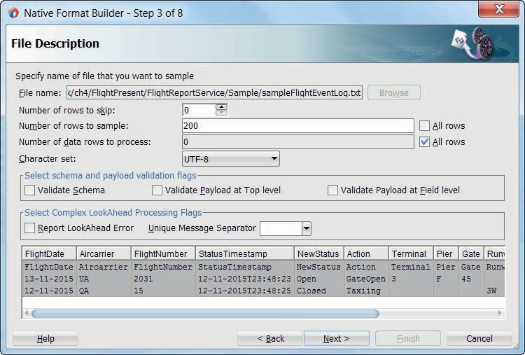

**FIGURE 4-34.** *Configuring the Native Format for the delimited file type*

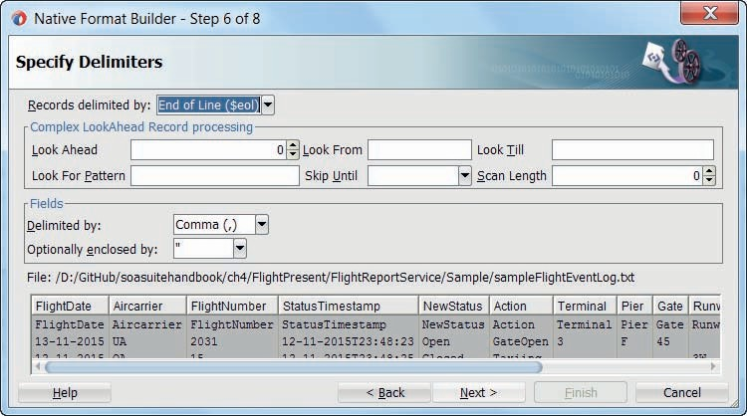

**FIGURE 4-35.** *Specify the delimiters to use to separate fields and records when writing the file*

In step 7, we can specify the names of the XML elements that the wizard will create in the NXSD file. In this case, we can derive the names from the field names in the first record (the header) in the sample data file.

In step 8, the wizard presents the NXSD source it is about to generate. You can inspect, modify, and accept or go back to previous wizard steps or cancel the wizard. Press Finish to complete the wizard and generate the NXSD file.

You are returned to step 6 of the File Adapter configuration wizard where the link is set to the *FlightEventLog* element in the generated NXSD document. Press Next. Then press Finish to complete the file adapter configuration and the associated business service.

#### Implement Proxy and Pipeline

Generate a proxy service *FlightReportServicePS* and associated pipeline *FlightReportPipeline* from the FlightReportService.wsdl document. Set the Endpoint URI for the proxy service to /flight/ FlightReportService. In the overview editor, wire the pipeline to the business service *FlightEventLogFileWriter*.

Create an XSL Map, for example, called reportFlightStatusUpdateRequestToNXSDFlightEventLog.xsl. In this map, transform from the *reportFlightStatusUpdateRequestMessage* to the *FlightEventLog* element that was generated in the NXSD definition.

Open the pipeline. Add a Replace activity to the request action in the routing activity. Configure the replace to transform the contents of the $body variable using the XSL Map to provide the NXSD formatted input for the request message sent to the business service and mapped onwards to a csv-style record entry in the log file.

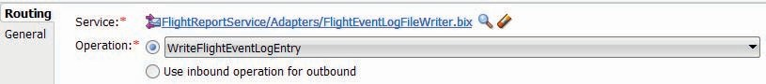

**FIGURE 4-36.** *Configuration of the Routing activity to the File Adapter Business Service*

Edit the Routing node: set the operation to *WriteFlightEventLogEntry* (instead of the default setting of *Use inbound operation for outbound*). This is necessary because the operation name *reportFlightStatusUpdate* exposed by the FlightReportService is different from the name of the operation *WriteFlightEventLogEntry* generated by the file adapter wizard (Figure 4-36).

At this point, the request message is received by the proxy service, handed to the pipeline and transformed into the format specified by the Native XSD schema. The pipeline routes to the business service that hands the XML document to the file adapter that converts it into the native comma separated values record. When it next tries to write the record to the flightEventLog.txt file, it will fail.

Remember how in the file adapter configuration we specified a Logical Name for the target directory, in order to prevent hard coded values to enter into the adapter configuration for settings that are environment specific. In Chapter 22, we will discuss environment specific deployment. For now, we will set the value for the FLIGHT_EVENTLOG_DIRECTORY property on the Transport Details tab of the business service editor for the *FlightEventLogFileWriter* (Figure 4-37). Set the property to a directory on the local file system of the runtime SOA Suite platform. Note: The directory—and its parents if necessary—will be created at run time by the file adapter, if it does not already exist. This requires that the operating system account, under which the SOA Suite runs, has the required privileges to do so.

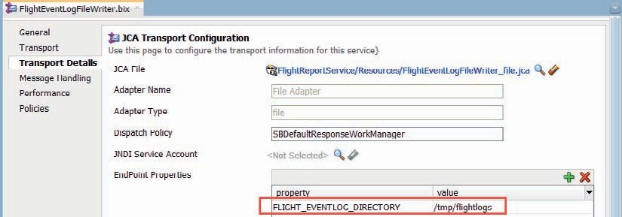

**FIGURE 4-37.** *Set the value for the logical directory property FLIGHT_EVENT_DIRECTORY on*

*the Transport Details tab of the business service*

#### Test the FlightReportService

Run the *FlightReportServicePS* proxy. Select operation *reportFlightStatusUpdate* to invoke and provide some sensible data for the *reportFlightStatusUpdateRequestMessage*. Press the Execute button to invoke the service.

The response message is the raw output from the file adapter—because we did not yet implement any manipulation of the body variable in the response pipeline.

When you check the file system, you should find a file called flightEventLog.txt with the data from the *reportFlightStatusUpdateRequestMessage*. This file is located in the directory specified in the FLIGHT_EVENTLOG_DIRECTORY property; this directory is created by the file adapter if it did not already exist beforehand.

#### Enhance FlightReportService to Use Dynamic Directory and File Names

A single flight event log file soon will become unwieldy. It would be far more convenient to create separate log files per date and flight. We will change the configuration of the file adapter to achieve the following: flight event log files are created per flight per date. They are created in a directory that is dedicated to the date on which the flight was scheduled to take place, for example, 12-25 for Christmas Day. The log files will be called <Air Carrier><Flightnumber>FlightEventLog.txt.

##### Compose the Name for the Flight Event Log File

Add an Assign activity to the Request pipeline, before the Replace activity that manipulates the

$body contents. Configure the activity to assign the name of the log file to write to. This name should be assigned to a local pipeline variable *flightEventLogFileName*. Use a concatenation of the month and day of the flight—with the XQuery functions fn:month-from-date and fn:day-from- date—followed by the / separator, followed by the air carrier code and the flight number, concluding with the string FlightEventLog.txt. Note that the first part of this value—anything leading up to the directory separator—determines the target directory within the directory specified using the FLIGHT_EVENTLOG_DIRECTORY property.

The complete XQuery expression is:

 concat(fn:month-from-date($body/flig:reportFlightStatusUpdateRequestMess age/flig:flightStatusEvent/flig:FlightDate),'-',fn:day-from-date($body/ flig:reportFlightStatusUpdateRequestMessage/flig:flightStatusEvent/ flig:FlightDate),'/',$body/flig:reportFlightStatusUpdateRequestMessage/ flig:flightStatusEvent/flig:Carrier,$body/flig:reportFlightStatusUpdateRequest Message/flig:flightStatusEvent/flig:FlightNumber, ‘FlightEventLog.txt')

##### Set Filename through Transport Header

Many JCA properties can be manipulated at run time. That means that within the pipeline, we can dynamically derive values that steer the behavior of the JCA adapter. One of these properties is jca.file.FileName that is interpreted by the File Adapter as the name of the file that should

be processed.

JCA properties can be set in a Service Bus pipeline with the Transport Header activity. Add this activity to the request pipeline, under the Replace activity (Figure 4-38). Make sure that the Direction property on this activity is set to Outbound.

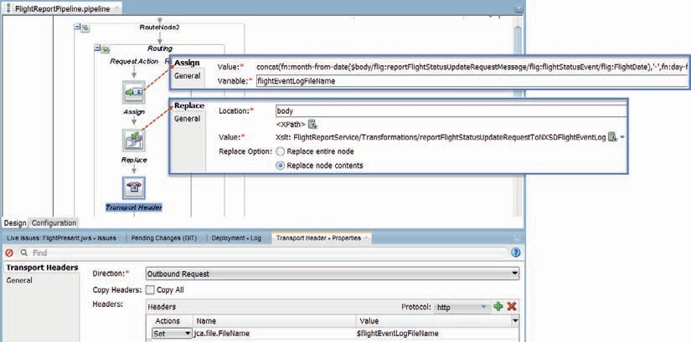

**FIGURE 4-38.** *Transport Header activity to set the name of the file to write to at run time*

Set the protocol dropdown in the Headers table to JCA. Click on the green plus icon to add a header. The action for this new entry should be Set. Click on the field in the Name column. A dropdown becomes available with a listing of all known outbound JCA properties. You can either select or simply type property name jca.file.FileName. The Value expression should be set to

$flightEventLogFileName.

##### Run the Enhanced Service

With these changes, you can run and test the *FlightReportService*. However, with file names that are dynamically set, the file adapter does not create the target directories if they do not already exist. That means that you will have to create date specific directories inside the directory indicated by property FLIGHT_EVENTLOG_DIRECTORY for each day for which event log files will be generated.

###### TIP

*The File Adapter may sometimes have to deal with files that require pre or post processing. For example, when files are compressed or encrypted or both, the mapping of native file content to an XML document can only be done when decompression and decryption have been performed after reading the file. Or in the outbound case the data mapped from XML to the native file format should be encrypted and/or compressed before the file can be written and perhaps a target directory has to be created. For such intermediate processing of file contents, the File Adapter has a feature called File Valves. With this feature, we can hook custom Java code into the*

*processing pipeline of the File Adapter—to inspect and manipulate the data after having been read or just before being written.*

### Reading from the File System Using the File Adapter

The File Adapter can read files in two different modes. One is the inbound, polling mode where the adapter periodically inspects specific directories on the file system for new files and starts reading and processing them when they are found. The other is the synchronous read mode where the adapter is engaged to retrieve the contents from one or more files and deliver them to the invoker, which is typically a Service Bus business service or an SCA composite.

We will now use this second mode to read data from flight event log files created through the *FlightReportService* as discussed in the previous section. This file adapter configuration is integrated into the *FlightReportService* to provide all event information available on a certain flight to satisfy the need of the *getFlightReport* operation.

#### Configure File Adapter for Synchronous Read

The first step is the configuration of a second file adapter configuration in the *FlightReportService* project. Open the editor and drag the file adapter to the external references lane. In the file adapter configuration wizard, set the name to *FlightEventLogFileReader*. Accept the defaults in steps 2 and 3. In step 4, select operation type *Synchronous Read File*. This means that the file adapter will read the contents from an existing file, typically convert it to an XML representation and make it available to the invoker.

Set the operation name to *ReadFlightEventLogHistory*. Do not check the box to *read the file as an attachment*, because we want to use the file contents as the body of the response from the business service that wraps the file adapter configuration.

Specify the same logical directory name as previously mentioned in step 5, using the logical name FLIGHT_EVENTLOG_DIRECTORY. The logical name is exposed as a property on the business service’s transport details tab. Ensure that the check box for deleting files after reading them is unchecked, as well as the option to archive the files. Both actions are primarily intended for use with the inbound polling mode of the file adapter. Note: If the checkbox is read only, you will have to set the corresponding property DeleteFile to false in the JCA file FlightEventLogFileReader_file.jca in the text editor in source mode.

Specify a random file name—for example, UNSPECIFIED—in step 6 of the wizard. We will dynamically determine the name of the file to read—because it depends on the flight for which the event history is requested.

The Native XSD nxsd_FlightEventLogFile.xsd that was created when we configured the file adapter to write the flight event log file can be reused in step 7. For reading the log file, the same mapping from comma separated values to XML can be reused. Select the *FlightEventLog* element in that XSD document, to instruct the file adapter on how to make the data from the log file available.

Note that in the NXSD definition, we can include special reading instructions for the file adapter to skip records from the source file or map records in different ways depending on conditions regarding the data in specific fields.

Complete the wizard.

Open the Transport Details tab for the business service *FlightEventLogFileReader* that has been created by the wizard. Set property FLIGHT_EVENTLOG_DIRECTORY to the appropriate value for your environment.

#### Implement Operational Branch for getFlightHistory

The interface of the *FlightReportService* defines a second operation, next to *reportFlightStatusUpdate*. The pipeline should therefore have an operational branch activity with branches for each of these operations. Open the *FlightReportPipeline* (Figure 4-39). Add the operational branch with branches for the operations *reportFlightStatusUpdate* and *getFlightReport*. Move the routing node previously implemented to implement the *reportFlightStatusUpdate—*to the appropriate branch. Add a new routing node to the branch for *getFlightReport*. Add a routing activity and configure it to invoke the *FlightEventLogFileReader* business service’s *ReadFlightEventLogHistory* operation.

Add an assign activity in the request pipeline of the routing node. This derives the name of the file to read the requested flight event log entries from and assigns it to a new variable *flightEventLogFileName*. The file to read can be found in a flight date specific directory, named according to the <month number>-<day number> pattern. The request message sent to the getFlightReport operation contains a FlightDate element from which the directory name is derived. The filename itself is composed from the IATA code of the air carrier and the number of the flightboth elements in the request messagefollowed by the fixed string FlightEventLog.txt. The following XQuery expression is used in the assign activity to concatenate all pieces together:

 concat(fn:month-from-date($body/flig:getFlightReportRequestMessage/ flig:FlightDate),'-',fn:day-from-date($body/flig:getFlightReportRequest Message/flig:FlightDate),'/',$body/flig:getFlightReportRequestMessage/ flig:Carrier,$body/flig:getFlightReportRequestMessage/flig:FlightNumber,'Fligh tEventLog.txt')

The name of the file to read, set by the assign activity in $flightEventLogFileName, should be passed to the file adapter as a transport header property. Add a transport header to the request pipeline, after the assign. With direction is Outbound Request, add a header for jca.file.FileName that takes its value from this variable, as shown in Figure 4-39.

To complete the pipeline, the response from the file adapter needs to be transformed into the proper format. To that end, create an XSL Map called nxsdFlightEventLogTogetFlightReportResponse.

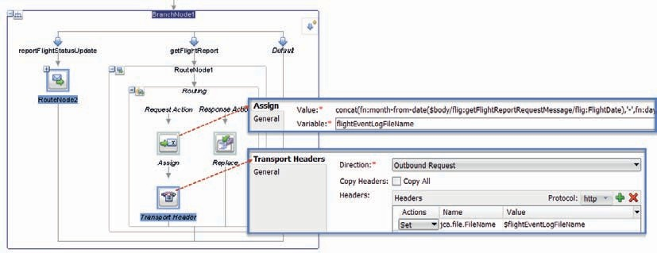

**FIGURE 4-39.** *Pipeline with Operational Branch and Routing activity for the getFlightReport*

*operation*

xsl that maps from the *FlightEventLog* element in the Native XSD created for the file adapter to the

*FlightReportResponseMessage* element in FlightService.xsd.

Add a replace activity to the response pipeline of the branch for *getFlightReport*. Have it replace the $body contents using the new XSL stylesheet acting on $body/*[1].

#### Run getFlightReport in FlightReportService

At this point we can run the FlightReportService and invoke the getFlightReport operation to retrieve all events regarding a specific flight.

If we provide a combination of flight date, air carrier code, and flight number for which earlier on flight events were reported, we will get an overview of such events in the response message. If no event log file exists for the flight indicated, the file adapter will not find the requested file and instead of a proper response message, the service will return a soap fault. We could add an error handler to the pipeline for that situation and if we were really developing the production systems for the good people of Saibot Airport in Lexville, then of course we would.

### Remote File Adapter—Retrieving Data from Internet Resources

Data offered as internet resource in a structured XML or non-XML format (such as JSON, CSV, or fixed position)cannot be retrieved by the File Adapter, but it can be read by the Service Bus. Using a combination of an HTTP transport style Business Service, a Service Callout, and a Native XSD mapping, it turns out to be fairly easy to implement what is best described as a *remote file adapter*. This section describes the implementation of a *findCountries* operation that reads a comma separated values file with countries, accessed with a simple HTTP GET request to the website OurAirports.com.

The FTP adapter can be used to access remote files, if these are located on an FTP server. SOA Suite does not contain an out of the box WEBDAV adapter that could be used for a similar operation. One could be implemented as Custom JCA adapter.

#### Create Business Service to Retrieve File Contents

Open the *ReferenceDataServices* application and the *CountryService* project. Create a business service *OurAirportsCountriesBS*, with transport set to http.

On the second page of the wizard, pick the option Messaging with both Request and Response set to Text as the content type (Figure 4-40).

On the third page of the wizard, set the Endpoint URI for this business service to the URL at which the comma separated countries file can be accessed: <http://www.ourairports.com/data/> countries.csv.

Press Finish to close the wizard and complete the creation of the business service.

#### Create the Native XML Schema Definition

The SOA Suite has the capability to come up with an XML representation of data in all kinds for formats that are not XML. Native XML Schema Definitions—indicated with NXSD—are created that describe both the XML structure that best represents the native data format and provide mapping instructions on how to convert from the native format to that XML structure and vice

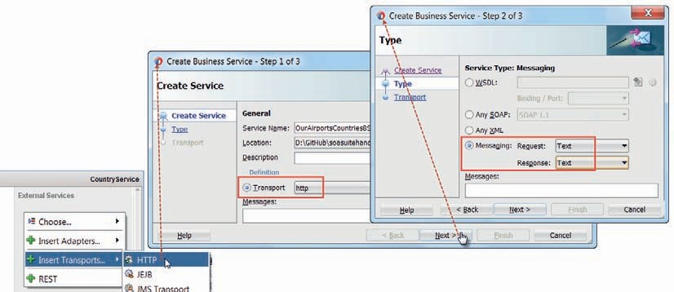

**FIGURE 4-40.** *Create business service with HTTP transport, Service Type set to Messaging and*

*the content type as Text for request and response*

versa. This capability is used in various adapters, as we already have seen with the File Adapter and the REST Adapterand can be used in Service Pipelines as well.

In our current implementation, we need to convert the countries.csv file into an XML structure that we can filter for the countries that should be returned. To that end, first create a sample file of the data in the CSV file. You can do this by downloading the file to your local file system or creating a new file in the *CountryService* project, opening the countries.csv file and copying a few records to the new project file.

From the New Gallery, select General | XML | NXSD Schema. This will bring up the Native Format Builder Wizard that introspects a sample of the data in native format and with your guidance creates the native schema that represents it.

Create an NXSD schema for the sample file—in the same way as we created the NXSD schema for the sampleFlightEventLog.txt file.

#### Update Pipeline to Retrieve Remote Data into a Local XML Variable

Open the *CountryPipeline*. Add an operational branch to enable the pipeline to handle requests for different operations. Create a branch for operation *createCountry* and move the existing pipeline pair and route node to this branch. Add a branch in the operational branch for the *findCountries* operation. Add a pipeline pair to this new branch.

Add a service callout activity to the request pipeline (Figure 4-41). This type of activity is used in pipelines to help perform enrichment or validation prior to and after routing takes place. We use it here to take over from the routing node, to make the call that brings in the remote CVS document and loads it into a pipeline variable.

Configure the Service Callout to invoke the business service *OurAirportsCountriesBS*. Check the radio button marked *Configure Payload Document*. Set the *Body* field to body in the request

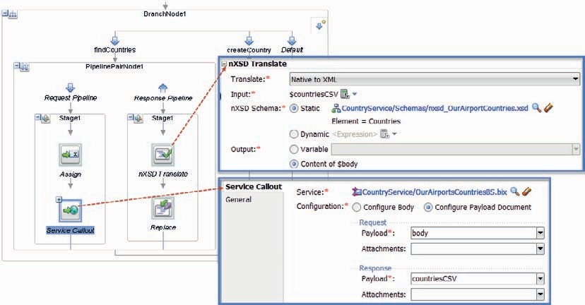

**FIGURE 4-41.** *Configuring the Service Call out to fetch the file returned from the remote website*

*into the custom variable countriesCSV and the nXSD Translate to process the contents in*

*$countriesCSV*

document indicating that the request should use the content of the $body variable as its payload (which is irrelevant since the callout does an HTTP GET request that carries no payload). Set the *Response Body* to *countriesCSV*. This means that the body from the response returned by this callout should be used to populate the custom pipeline variable *countriesCSV*. Subsequent activities in the pipeline can access the contents of this variable using the familiar $countriesCSV notation.

Add an NXSD Translation activity to the Response Pipeline. This activity is used in general to use a Native XSD to map data in native format into the corresponding XML representation, or vice versa. In this case, it maps the contents of the $countriesCSV variable as XML to the $body variable, using the Native XSD that was created earlier based on the sample countries file.

Configure the NXSD Translation as is shown in Figure 4-41: *Apply Translation* should be configured as *Native to XML*. The input is variable $countriesCSV, populated by the Service Callout. The NXSD Schema to use for this mapping is the *Countries* element in nxsd_ OurAirportsCountries.xsd. The result of the translation should be set as the content of the $body variable.

The *CountryService* project is shown in Figure 4-42. The Service Callout has introduced a new wire from the pipeline to the business service *OurAirportsCountriesBS*.

At this point, you can test the CountryService’s *findCountries* operation by running the *CountryService*. The search criteria you pass in the request message will be completely ignored and the response message will not be according to the service’s interface definition, but you should get an XML representation of all countries provided by OurAirports.com.

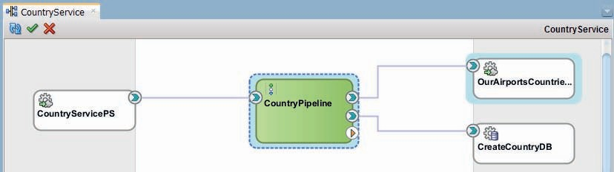

**FIGURE 4-42.** *Service Bus project CountryService with doubly wired pipeline*

#### Add Country Filtering to the Pipeline

It is not convenient to always receive *all* countries in the world when invoking the *findCountries* operation and it is definitely not what the service interface suggests with its *findCountriesRequestMessage* input. Besides, at this point the response is not even according to the XSD definition of the response message. Let’s kill two birds with one stone by using an XSLT transformation to map the response into the right format and filter for only those countries that satisfy the search condition.

Create an XSL Map—nxsdOurAirportsCountriesTofindCountriesResponse.xsl—that maps from the Countries element in the Native XSD to the *findCountriesResponseMessage* in the CountryService.xsd. Define three parameters, simple without Schema reference, called *continent*, *countryName,* and *countryCode*, as shown in Figure 4-43.

Map the source to target as shown in Figure 4-44 using a for-each node as parent for the tns:Country element to which the *Country* element from the source is mapped. Map the code and name fields from the source to the their counterparts. Note the three source nodes available for mapping, created for the three input parameters. Then open the source mode tab to add the filter condition to the for-each node.

Add the following expression to the select attribute of the for-each node:

 /ns0:Countries/ns0:Country[(($countryName='*') or starts- with(ns0:name,$countryName)) and (($countryCode='*') or starts-with(ns0:code,$countryCode)) and (($continent='*') or (ns0:continent,$continent))]

This results in only countries whose name starts with the value passed in the $countryName parameter are returned, unless that parameter is set to the * wildcard. And only countries whose code starts with the value passed in the $countryCode parameter are returned, unless that parameter is set to the * wildcard. And finally, only those countries whose continent is set to the value in the $continent parameter are returned, unless that parameter is set to the * wildcard.

###### NOTE

*When you have to resort to filter expressions like this, it may be a reason for considering the use of XQuery mapping, with its quite powerful FLOWR expressions.*

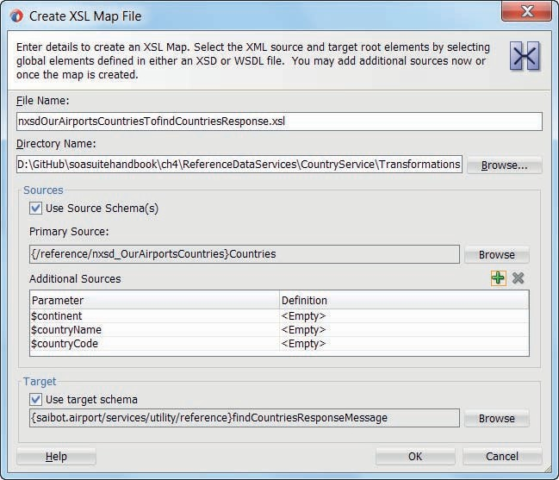

**FIGURE 4-43.** *Create XML Map with input parameters besides the Primary Source*

This mapping can be applied to the $countriesCSV variable—provided we have the values for the three parameters. These values are taken from the request message sent to the *findCountries* operation, so initially they can be found in the contents of the $body variable. We should save this initial message into a custom variable early on in the pipeline. If we do not, manipulation of

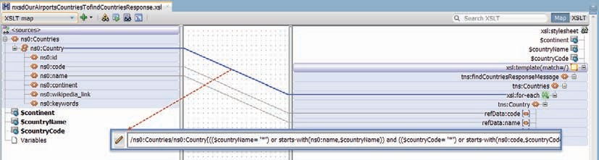

**FIGURE 4-44.** *Mapping the countries read from the remote countries file to the response format*

the $body variable—as is done by the NXSD Translation that writes its result to $body—would overwrite the data, before we get to the replace activity.

Add an Assign activity before the Service Callout. Configure the Assign action to use the *findCountriesRequestMessage* element in the $body variable to set the value of the custom variable *findCountriesRequest*.

At this point we have made all the necessary preparations and we can add the Replace activity in the response pipeline, right after the NXSD Translation. Configure the replace activity (Figure 4-45) with the location set to body, the XPath expression empty, and the replace option set to Replace node contents. Configure the Value using an XSLT Resource. Select the nxsdOurAirportsCountriesTofindCountriesResponse.xsl map we have just created as the resource to perform the transformation with. Set the Input Document Expression to $body/*[1]. Then also set the values for the three parameters, using XPath expressions to retrieve the relevant element value from the $findCountriesRequest variable: $findCountriesRequest/ref:continent/ text(),$findCountriesRequest/ref:code/text() and $findCountriesRequest/ref:name/text().

This completes the *findCountries* branch in the *CountryPipeline*. You can now again test the *findCountries* operation in the *CountryService* and this time you should get a response in the proper XML format and containing only the countries you actually asked for.

###### NOTE

*Retrieving the countries.csv file from the remote website can take fairly long. Additionally, the site may not always be available. And the data in the file is relatively stable. These are indications that we should consider the use of the Service Result cache for the*

*OurAirportsCountriesBS business service. The result cache is a facility that keeps a local, in-memory (actually in Coherence grid) copy of the data returned by the business service. This copy can be used by*

*the business services instead of the remote data, for as long as was specified as retention time. The Service Result Cache is discussed in more detail in Chapter 9.*

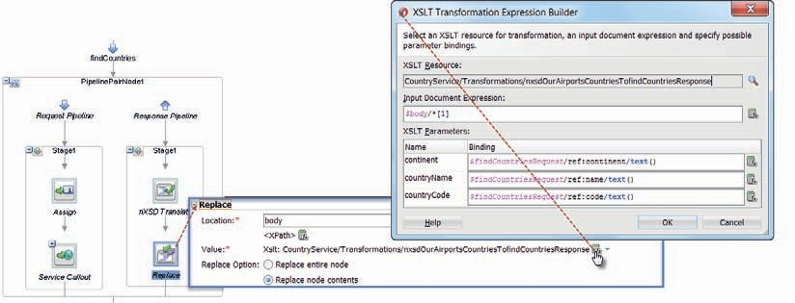

**FIGURE 4-45.** *Configure the Replace activity to transform and filter the country records*

### Summary

It is quite common for services to rely on enterprise resources to provide (part of) their implementation. Such resources—like database, file system, queue, ERP system, SaaS application—are usually accessed in other ways and with other technologies than HTTP and SOAP or REST. Frequently they handle data in different formats than XML. The SOA Suite works with Technology Adapters to cross the gap between the world of the Service Bus (and SOA) composite and the enterprise resources. Through these adapters, service developers in SOA Suite can interact with these resources on familiar web service terms and have the adapter do the translation from these terms to whatever native format and protocol the resource uses.

In this chapter, we have seen how outbound interactions—initiated from within the Service Bus use the File Adapter and Database Adapter to access external files and interact with tables and stored procedures in a relational database. An important part of that interaction is the translation of messages from the native format utilized by the enterprise resource and XML used by the Service Bus. The Native Format Builder and the Native Transformations are important tools to work with native formats such as relational data, JSON, and CSV. The translation from and to native formats can be done as part of the adapter operation or as activity in a Service Bus pipeline.

Apart from the File Adapter and the Database Adapter, the SOA Suite also works with technology adapters for Advanced Queuing, MQ Series, JMS, FTP, Sockets, Coherence, LDAP, and User Messaging Service (UMS) for email, VoIP, fax, and text message. Additionally, Custom JCA adapters can be used from the SOA Suite. Most of these adapters will be discussed in later chapters.

Many adapters can be used in an inbound interaction. This means that an event outside the SOA Suite is detected by a technology adapter and results in a service initiation by the adapter, based on that event. Examples are the file polling mode in the File and FTP adapter, incoming messages on a queue received by the JMS and AQ adapter, incoming emails and chat messages intercepted by the UMS adapter and new or updated records detected by the polling Database adapter. Inbound actions are discussed in Chapter 13.





CHAPTER

# 5

## Introducing SOA Composite Applications

he Service Bus is typically used to virtualize service implementations: to expose an end point and perhaps a normalized interface for services that are implemented using a choice of technologies. The implementation of services can be realized outside the organization,

**T**

inside the organization in legacy applications or platforms—exposed through technology adapters—or custom built using some programming language like Java (for example EJB or JAX- WS) or .NET technologies (e.g., Windows Communication Foundation or WCF and C#).

The SOA Suite offers another option for implementing services in the form of SOA composite applications, based on the SCA (Service Component Architecture) standard. These applications can leverage the service component engines in the SOA Suite—BPEL, Mediator, Business Rule, Human Task, Spring Java—to implement functionality, and they can easily integrate with external services and enterprise resources.

SOA composite applications expose a service interface. In many respects they are very similar to Service Bus composites. In this chapter, we will get started with these composite applications by implementing the ConversionService again. In Chapter 3, we did an implementation with the Service Bus, and this time we will use the SCA approach using the Mediator component to implement the same functionality. This should make it clear what the similarities are and where some differences lie between Service Bus projects and SOA composite applications.

We will add a composite sensor to achieve a little run-time monitoring support and we add validation and fault handling. The chapter concludes with the common pattern of publishing the SOA composite in the Service Bus, thereby virtualizing the service implementation.

### Service Component Architecture

SCA is the industry standard Service Component Architecture for composing applications in a service oriented way. In SCA, all business resources—web services, Enterprise Information System (EIS) service assets, workflows, databases, and so on—are presented in a service-oriented way, with a service interface. SCA aims at separating business integration logic from implementation so that an integration developer can focus on assembling an integrated, composite application rather than on the implementation details. Specialists create the service components using, for example, BPEL, Java, or Business Rules or whichever component technology is best suited for the job. They then make these components available for wiring together and assembly into composite applications. These composites hide their implementation—they only expose their service interface and their dependencies. Deployment of the bundled composites is easier and more efficient than deployment of every individual component would be.

Even though SCA is an industry standard, it does not provide portability of composite applications between SCA containers. An SCA application that has been developed for the Oracle SOA Suite will not run on Apache Tuscany or IBM WebSphere. Applications running on those platforms will have a similar structure, using the same SCA artifacts, but leveraging platform- specific service engines and bindings. The portability of developers and administrators across different vendors’ SCA containers is much enhanced, though, because of the common concepts.

#### Some Background on SCA

SCA is an industry standard that prescribes a structured approach for composing applications from service components. Service components are pieces of (potentially fairly coarse-grained) business logic that are used as building blocks when composite applications are assembled. The composite applications are the reusable functional units that provide meaningful business functionality, in the form of services.

The components, their assembly into composite applications, and their mutual dependencies and interaction within the composites are described in the SCA standard and defined by a series of XML files, created at design time and interpreted by the SCA container at run time. The core elements of an SCA composite are (also see Figure 5-1):

Service—how the composite is exposed (interface, protocol binding) References—on what other services the composite depends

Components—the internal components that provide the implementation of the service(s) (interface, binding and endpoint)

Wires (how the service components hang together and how they relate to the externally service interfaces and service references

The composite.xml file is the file that describes the composite application as a whole—in terms of these elements. It is from this file that all other files are directly or indirectly referenced, and it is also this file that an SCA container—such as the SOA Suite—will interpret first at deployment time.

##### Service Components

Each service component is described in the composite.xml file. It has a name, an implementation— a combination of an implementation type that references a service component engine such as BPEL or mediator—and a reference to an implementation file or the program that should be executed by the engine. The component definition contains a componentType element that specifies the service(s) exposed by the component—through references to portTypes in WSDL documents or alternatively with references to Java interfaces.

However, a service component not only explains what it can do for the world; it also indicates what it needs the world to do in return. Every service component can specify one or more references. A reference is a dependency from within the component that needs to be satisfied. It is similar to the power plug that comes with electrical devices: the device promises to deliver a service, but only when you provide it with an electricity service. For Java developers, this mechanism of advertising a dependency and relying on it to be fulfilled in order to properly function is well known as “dependency injection,” as performed by the Spring Bean Container or the JSF managed bean framework, for example.



Component

Component

Service

Reference

*Promote Wire Promote*

Composite.xml

**FIGURE 5-1.** *The core elements of an SCA composite application*

References are, like services, usually described in terms of a portType defined in WSDLs or a Java interface: The service component describes the interface it requires the injected service to implement in order to utilize it.

Additionally, a component can advertise the fact that it has properties that can be set by anyone who is including the component in a composite application or doing deployment, or even administering the composite at run time. A property has a name, type, and possibly a (default) value. Typically, the value of a property governs part of the behavior of the component.

##### Service Composites

Components cannot exist on their own—or at least not in the SCA run-time environment. They need to be part of a service composite (application) because that is the unit of deployment and invocation. Usually a composite will contain more than just a single component, but it does not have to.

Composites are described through the composite.xml file as per the SCA standard, which is rendered in JDeveloper in the visual composite editor. This composite.xml file includes entries for service components and the wires between these components.

A composite application usually exposes at least one service—a public interface for consumers of the composite. Note that a composite application could have as its only “interface” a component that consumes an event. In that case, there is no explicit public service interface that external consumers should invoke.

Multiple services containing multiple operations can be published by a single composite application. A public service exposed by a service composite application is a service published by one of the service components inside the composite that has been promoted to the composite level. Inbound adapter services are the special case in the SOA Suite—they provide entrance points into SOA composite applications, but frequently in a slightly indirect way that does not allow for direct invocation. Examples are the file system and database adapters that poll for new files or records and in response initiate a new composite instance with the new or modified data acting as the implicit request message. The JMS and AQ adapter do something similar with messages arriving on a topic or queue.

Components declare their dependencies through references. Some of these references are satisfied by other components within the composite. These references can therefore remain private, hidden from public view—an example of encapsulation. Compare this with a desktop computer that has a motherboard inside with a dependency on electricity—a fact that is not advertised externally because it can be satisfied internally with a wire (quite literally in this case) to the internal power adapter that itself is published as a reference through the power cord that we connect to the power socket.

References that cannot be resolved using other local components are exposed by the composite on behalf of those components that require them. These references are promoted—just like services—to the composite level and need to be satisfied when the composite is deployed. At that time, it should be indicated in the composite.xml how those references are to be resolved. Component-level references have to be wired to their provider—which is either another internal component or a composite-level reference that gets bound to an implementation.

Whether another component, another composite or some external provider fulfills the service is mostly determined by aspects such as reuse, encapsulation, and ownership.

##### Analyzing the Service Composite Definition—composite.xml

Next follows a simplified snippet from a composite.xml file that defines a service composite

*ConversionService* that exposes a service called *ConversionService* that is exposed with a SOAP

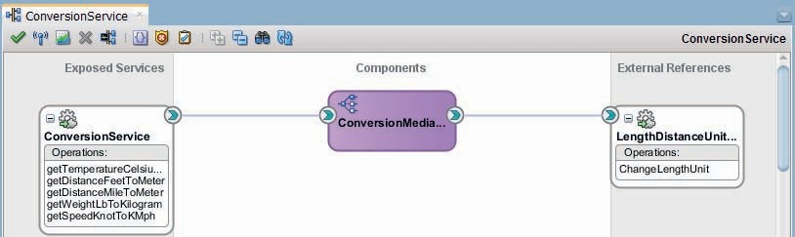

**FIGURE 5-2.** *The visualization of the ConversionService SCA composite*

Web Service binding according to the port and with the functional interface as specified in the associated WSDL and XSD documents.

The composite contains a single component, *ConversionMediator*, that implements the service interface we just discussed, described by the *ConversionServicePortType*. The component also exposes a reference—a need for some service injection—described by PortType *lengthUnitSoap*.

From the implementation element, we derive that this component is to be executed by the mediator service component engine and that this engine should execute the *ConversionMediator*

*.mplan* file.

The composite itself has a reference binding, which is component’s reference promoted to the composite’s level and satisfied with a binding (SOAP 1.1 Web Service) to the external *LengthDistanceUnitConvertorService*. This promotion is necessary in this case because there is no component available in the composite that can provide the service required by the *ConversionMediator*.

Figure 5-2 shows the visualization of this same service composite in the JDeveloper SOA composite editor.

 <composite name="ConversionService" revision="1.0">

<import namespace="saibot.airport/services/utility/conversion" location="WSDLs/ConversionService.wsdl"

importType="wsdl"/>

<import [namespace="http://www.webserviceX.NET/"](http://www.webserviceX.NET/) location="WSDLs/length.asmx. wsdl" importType="wsdl"/>

<service name="ConversionService" >

<interface.wsdl interface="saibot.airport/services/utility/ conversion#wsdl.interface(ConversionServicePortType)"/>

<binding.ws port="saibot.airport/services/utility/conversion#wsdl. endpoint(ConversionService/ConversionServicePort)">

</binding.ws>

</service>

<property name="someRunTimeProperty" type="xs:string" many="false">some value</property>

<component name="ConversionMediator">

<implementation.mediator src="Mediators/ConversionMediator.mplan"/>

<componentType>

<service name="ConversionMediator" >

<interface.wsdl interface="saibot.airport/services/utility/ conversion#wsdl.interface(ConversionServicePortType)"/>

</service>

<reference name="LengthDistanceUnitConvertorService" >

<interface.wsdl [interface="http://www.webserviceX.NET/#wsdl.](http://www.webserviceX.NET/#wsdl) interface(lengthUnitSoap)"/>

</reference>

</componentType>

</component>

<reference name="LengthDistanceUnitConvertorService" >

<interface.wsdl [interface="http://www.webserviceX.NET/#wsdl.interface(leng](http://www.webserviceX.NET/#wsdl.interface(leng) thUnitSoap)"/>

<binding.ws [port="http://www.webserviceX.NET/#wsdl.endpoint(lengthUnit/](http://www.webserviceX.NET/%23wsdl.endpoint(lengthUnit/) lengthUnitSoap)"

location=»WSDLs/length.asmx.wsdl» soapVersion=»1.1»>

</binding.ws>

</reference>

<wire>

<source.uri>ConversionService</source.uri>

<target.uri>ConversionMediator/ConversionMediator</target.uri>

</wire>

<wire>

<source.uri>ConversionMediator/LengthDistanceUnitConvertorService</source.

uri>

<target.uri>LengthDistanceUnitConvertorService</target.uri>

</wire>

</composite>

The two wire elements at the end of this snippet describe the link between the service exposed by the composite and the service provided by the *ConversionMediator* on the one hand and the relation between the reference published by the mediator and the composite level reference. This instructs the SCA engine to channel message received at the *ConversionService* to the *ConversionMediator* and to send messages from the *ConversionMediator* to the reference configured to invoke the external *LengthDistanceUnitConvertorService*.

#### SCA Composites in Oracle SOA Suite

The SOA Suite contains two run-time service engines. One is the Service Bus engine that we first met in Chapter 3 and the other one is the SCA engine that processes SOA composite application definitions. SOA composite applications are developed in JDeveloper. They can make use of several SCA service component engines—BPEL, Mediator, Human Task, Business Rule, Spring Java—that the SCA run time knows how to invoke.

The actual work done in a composite application takes place in these engines, based on the respective component implementations created by, for example, BPEL, Business Rule, or Java developers. The published interfaces of both the services and references at composite as well as component level are defined in one or more WSDL files with associated XSD documents. These interfaces and contracts are typically created before the implementation for each component is created; this approach is sometimes referred to as “contract first” development. The interface or contract provides the context within which the developer will create the implementation.

SOA Suite developers are usually not very aware of the fact that they are working on SCA artifacts. Most of the SCA specific terminology and configuration files are hidden from view by visual editors in JDeveloper.

###### NOTE

*In the context of SOA Suite, it is common to use the term SOA composite [application] instead of SCA composite application—and we will use the former in the remainder of this book.*

**Compare SOA Composite with Service Bus Project**

The core of the functionality offered by SOA composites is very close to what Service Bus provides. Both expose services, handle requests—frequently using call outs to other applications or third party services—and return responses. Some measure of XML validation and manipulation is involved and at run time some degree of fault handling and monitoring support is available. In fact, there are few things that Service Bus allows us to do that we cannot accomplish with an SOA composite (albeit not always in a very efficient or straightforward manner). Many of the things we can do in SOA composites can also be done with Service Bus, although there are areas that Service Bus does not touch; these include long running and stateful services (or processes).

Asynchronous interactions can be dealt with to a certain extent by Service Bus, but not as smoothly as with the BPEL component in an SOA composite. The special engines for business rules and human interaction (per definition asynchronous and long running) available for SOA composites can also not be embedded in Service Bus composites, although the service they expose can be invoked from a Service Bus project.

Because any organization that has acquired the SOA Suite has full access to both SOA composites and Service Bus projects, they are at liberty to pick the best option for a challenge, based on the respective strengths of the two engines for that particular task.

Service Bus is typically positioned as the lean mean business machine: very good at doing very little, extremely fast, and scalable. It is best used for its core qualities:

* + Receiving messages over a variety of transports as part of one way or synchronous two- way exchanges
  + Performing validation, transformation, enrichment, and routing over multiple transports to external systems
  + Processing responses through transformation, enrichment, and returning them to the calling party

The Service Bus is capable of thus processing high message volumes with short processing time per message. Additionally, the Service offers valuable run-time facilities for monitoring the message traffic and looming SLA violations, for applying security policies that govern access to services as well as message encryption/decryption, for dealing with peak volumes in message traffic, for load balancing outgoing requests and handling unavailability of external services and for transparently engaging a local cache for efficiently reproducing service responses without having to call the external system all the time.

The implementation of the functionality of a service, especially when it is getting more elaborate, is not ideally developed inside the Service Bus composite. It is preferable to create the implementation in a different component—which could be a SOA composite—and engage that

component from the Service Bus. A best practice has arisen among SOA Suite developers to have only lean Service Bus projects that can benefit from the core strengths of the Service Bus for message processing and for run-time operations and have these composites route to the actual implementation of the service.

It is also common to expose all services through the Service Bus and not access service implementations directly—or at least not allow such direct interactions across domains. Under that guideline, all SOA composites would be registered on and exposed by the Service Bus and only ever accessed through the Service Bus. In that way, all run-time goodies in the Service Bus are applicable to requests to the SOA composite. Additionally, consumers are insulated from changes in the implementation, including one so dramatic as a migration from an SOA composite to a standard application to provide the service functionality, because the Service Bus can still offer the same contract but routes to a different implementation.

### Your first composite application

In this section, we will create a SOA composite application. Such an application is created in a JDeveloper project. This project can be deployed to a SOA Suite run-time environment, either into the Integrated WebLogic Server or into a remote, stand-alone server. The service interfaces declared by the composite are exposed as service endpoints by the run time once the application has been deployed. In this case, the composite application will implement the temperature conversion in the *ConversionService*.

#### Prepare the JDeveloper Project

To get started, create a new JDeveloper application. Pick the application template *SOA Application*. Call the application *ConversionServices*. The application wizard will prompt you for the creation of an SOA Suite project. Call the project *ConversionService*. On the page *Configure SOA Settings* (see Figure 5-3), select the option *Composite with Mediator*. Press Finish to create the application, the project, and the mediator component.

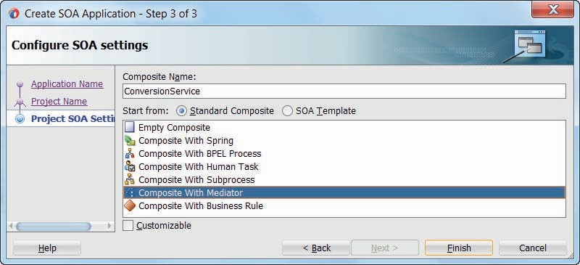

**FIGURE 5-3.** *Create SOA composite application with a Mediator component inside*

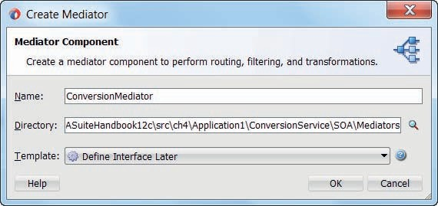

**FIGURE 5-4.** *Quick configuration of the ConversionMediator component*

A wizard opens (Figure 5-4) to have you configure the Mediator component that gets created.

Set its name to *ConversionMediator* and accept the default template *Define Interface Later*.

Press OK to create the Mediator.

The composite editor opens for the *ConversionService* composite, as shown in Figure 5-5. It visualizes the current structure of the SCA composite, that is specified through the file composite.xml. Note: The application navigator lists this file as *ConversionService*. Also note that in the project some predefined folders have been created, such as WSDLs, Transformations, and Schemas.

From the *ConversionService* project from Chapter 3, copy the XSD files common.xsd and ConversionService.xsd to the Schemas directory, the XSL files to the Transformations directory and the ConversionService.wsdl file to the WSDLs directory. Figure 5-6 shows what the project contents should now be.

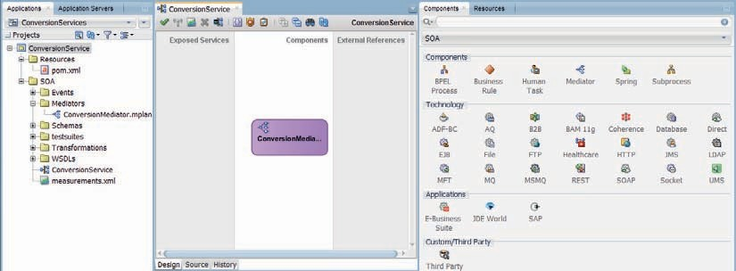

**FIGURE 5-5.** *Overview of the JDeveloper IDE after the initial configuration of the SOA*

*composite application*

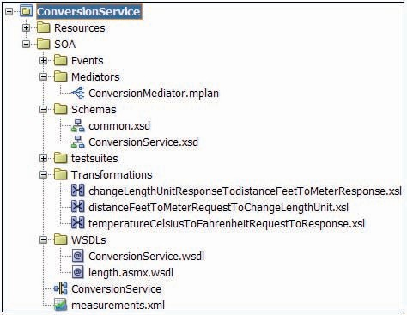

**FIGURE 5-6.** *Project navigator after copying the relevant files to the ConversionService project*

The project contains both the original service interface used for the Service Bus implementation, as well as the XSL Maps that were created for that implementation. We will be reusing these transformations in the SOA composite, from the Mediator component.

#### Configure the Service Binding

Right click in the Exposed Services lane. Select the option Insert | SOAP Service, to indicate that this composite should expose a SOAP web service. In the dialog that pops up (Figure 5-7), set the

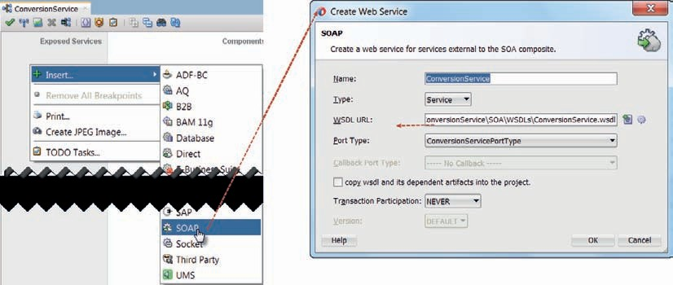

**FIGURE 5-7.** *Configure the ConversionService SOAP Web Service interface exposed by the SOA*

*composite*

name of the service to expose to *ConversionService*. Select the ConversionService.wsdl file that was copied into the WSDLs directory from the Service Bus implementation for the WSDL URL field. The ConversionServicePortType will automatically be set. Press the OK button to create the service binding.

The composite overview will display the *ConversionService* SOAP binding that the composite now exposes to external consumers. However, the service binding is not yet wired to any service component to provide the implementation.

The *ConversionMediator* will have to be the component implementing this *ConversionService*.

Wire the service binding to the Mediator to establish that fact, as shown in Figure 5-8.

#### Configure the ConversionMediator

At this point, the file composite.xml contains the wire definition that instructs the SOA Suite engine to pass any request messages received on the *ConversionService* SOAP binding to the *ConversionMediator*. At this moment, the Mediator has no clue as to what to do with such requests.

The mediator component is similar to the pipeline in Service Bus: it performs the core VETRO operations, typically routing transformed messages to the component delivering the actual functionality for a service operation. The mediator does not have the same rich support for error handling, message manipulation, use of variables, looping, and call out found in the pipeline. It is simple, straightforward and has some advanced features such as integration with Schematron for complex validation of messages, content based filtering, parallel routing, message resequencing, and hooks for Java Callouts to perform custom operations on messages before or after processing. The Mediator is configured with routing rules: instructions that specify for a specific service operation how an incoming message should be processed in terms of validation, transformation, and routing. The transformation can be implemented with both XSLT (XSL Map), XQuery of direct value assignments, and can leverage Domain Value Maps (DVM) and Cross References (XREFs) through advanced XPath functions.

Double click on the Mediator component. The editor opens and displays stubs for the creation of routing rules for each of the five operations specified in the ConversionService contract.

Messages arriving at the SOAP endpoint for this SOA composite application are handed to this

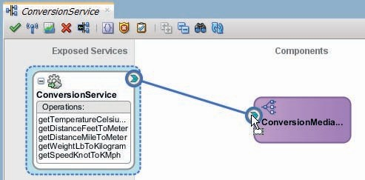

**FIGURE 5-8.** *Wiring the ConversionMediator to the ConversionService—to specify that the*

*former provides the implementation of the latter*

mediator. The mediator determines the required operation—from the SOAP action specified in the request message—and executes the routing rule(s) set up for that operation. For each routing rule, we can specify a boolean filter condition; only when the expression—that typically inspects the contents of the request message (content-based routing) —evaluates to true, is the routing rule executed. Note that multiple routing rules can be executed for an operation, resulting in the sequential or even parallel delivery of messages to multiple destinations.

Click on the green plus icon for the operation getTemperatureCelsiusToFahrenheit that we want to create routing rule for. This brings up a dialog—as shown in Figure 5-9—in which we can select the target type for the routing rule. The mediator can invoke an existing service or generate a new SCA reference to invoke, or it can publish an event to the Event Delivery Network when the rule is executed (see Chapter 15 for more on events) or it can simply Echo the request—after doing a transformation—back to the caller. In a Service Bus pipeline, when no Routing activity is executed, we also effectively do an echo of the request message—potentially after transformation.

Select the Echo Reply Target Type and click on OK.

The routing rule is created. No filter expression is required, nor do we need Schematron-based validation, transformation to native format or assignment of values to header variables. All we need is a simple transformation of the request message, using the XSL Map created in Chapter 3 for the *TemperatureConversionService*. Click on the icon behind the field labeled Transform Using. Select the temperatueCelsiusToFahrenheitRequestToResponse.xsl file in the Transformations folder, as shown in Figure 5-10.

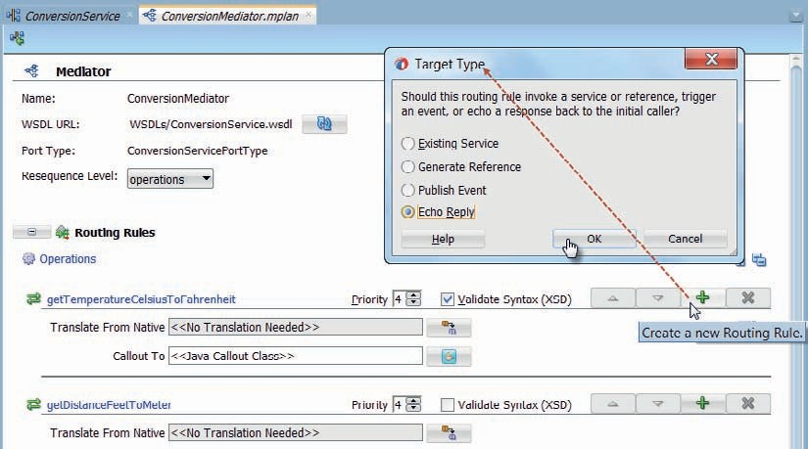

**FIGURE 5-9.** *Configure the routing rule for the getTemperaturCelsiusToFahrenheit operation to*

*be of type Echo Reply*

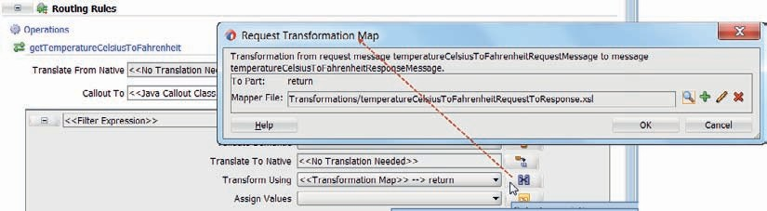

**FIGURE 5-10.** *Configure the transformation for the routing rule, using an XSL Map*

This map performs the Celsius to Fahrenheit conversion and creates the required response message format.

The mediator has similar support for mapping to and from native data formats as has the Service Bus pipeline through the NXSD Translation activity. Some selected section of the content of the request message that contains data in some special format such as CSV or JSON can be mapped to XML using an NXSD map—as is specified in the Translate from (or to) Native field in the operation. This XML is then taken as the input for the transformation configured in the routing rule. Similarly, a routing rule can be configured to produce a native output format that is routed to a target service or echoed back to the invoker.

Save all changes and close the mediator editor.

#### Deploy the SOA Composite and Test the Temperature Conversion

Right click the *ConversionService* project node and select the option Deploy. This deploys the SOA composite *ConversionService* to the SOA domain on the Integrated WebLogic Server. Note that the logging for the SOA build action, shown in the console, rightly displays warning messages, indicating that the mediator does not contain routing rules for four of the five operations in the *ConversionService* interface. Ignore these warnings—we will simply not invoke those operations.

When the deployment is complete, login to the Enterprise Manager FMW Control as user *weblogic*. Open the node SOA | soa-infra | default to see the SOA Composites that have been deployed to the default partition on the integrated server’s SOA domain. The *ConversionService* composite should be listed, as shown in Figure 5-11.

Click on the node for the *ConversionService*. Then click on the Test button that appears in the

*ConversionService* detail page.

A simple web service testing page opens (see Figure 5-12), similar to the Proxy Service tester used for the Service Bus. Select the operation *getTemperatureCelsiusToFahrenheit*—the only one currently implemented by the mediator. Enter a value for the temperature in Celsius and press the button Test Web Service.

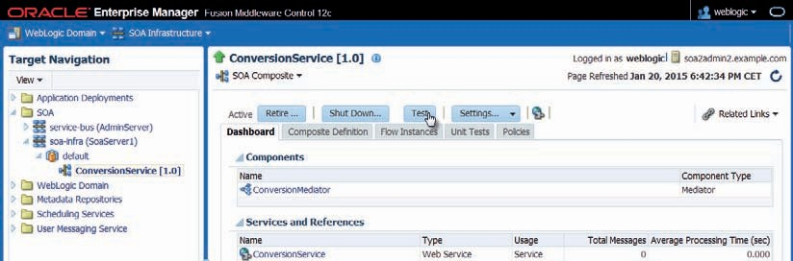

**FIGURE 5-11.** *Enterprise Manager Fusion Middleware Control with the freshly deployed*

*ConversionService composite*

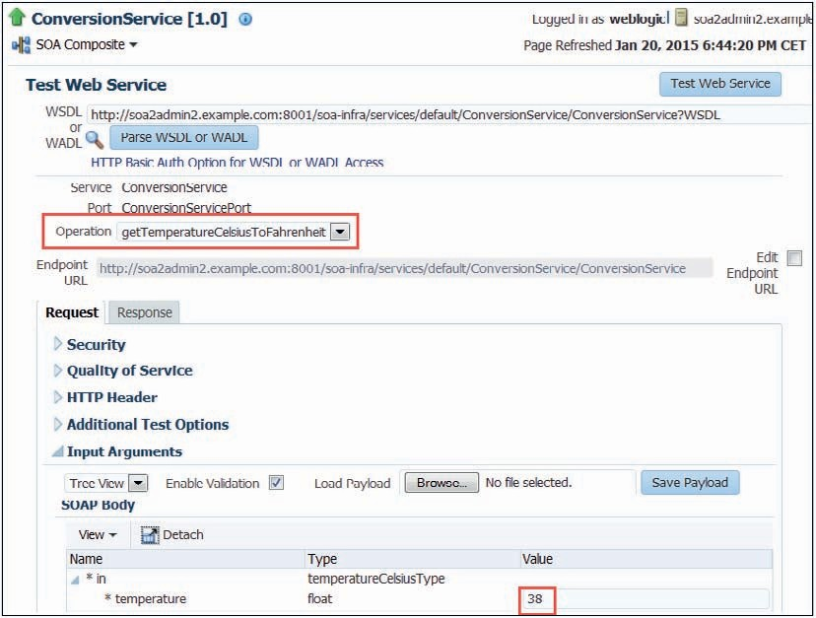

**FIGURE 5-12.** *Page in EM FMW Control to test the web service exposed by the SOA composite*

*ConversionService*

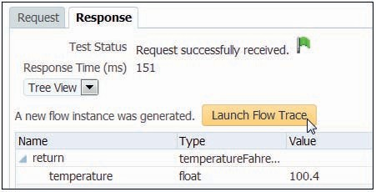

**FIGURE 5-13.** *The response to the test call to the web service*

After a short while, the response from the web service should be displayed, with the Fahrenheit equivalent of the Celsius temperature—as shown in Figure 5-13.

The first time you invoke the service, the response may take a little time because of various initializations going on. Perform the test again and you will probably experience a much faster reaction. You may also want to try out the other operations that are currently not yet implemented by a routing rule in the mediator, to see what will happen.

##### Detailed Execution Trace

The SOA Suite records and makes available quite a bit of detail about the execution of composite applications. This information can be very useful during development as well as for monitoring purposes in a production environment. Note that this information comes at the cost of performance overhead as well as potentially large storage requirements. The Audit Level settings govern how much trace details are recorded, and these should be set with some care in your production environment.

Click on the Launch Flow Trace button to get details about the internals of the execution that took place when the *ConversionService* SOA composite was invoked, as shown in Figure 5-14.

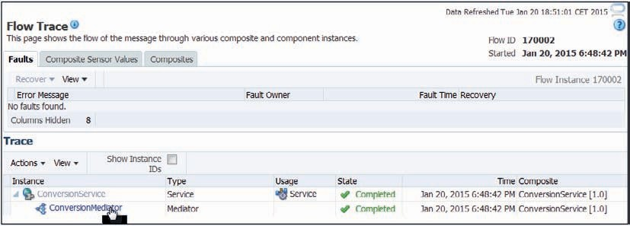

**FIGURE 5-14.** *The message flow trace through the SOA composite for the test call to the*

*ConversionService*

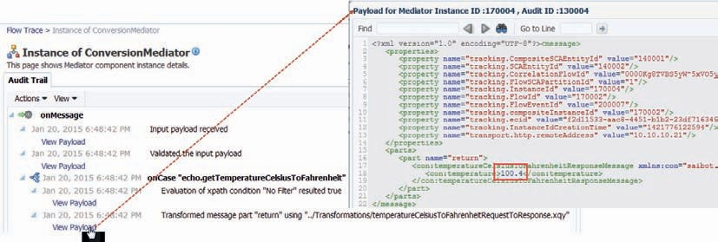

**FIGURE 5-15.** *Details on the ConversionMediator execution for the ConversionService*

*composite*

Clicking on the *ConversionMediator* link will reveal additional details about the actions taken by the mediator in this particular instance or execution of the *ConversionService* composite, as shown in Figure 5-15.

We can even check the message payload at each step of the execution of the mediator—both before and after transformation for example.

**Configuring the Audit Level**

The level of detail of the trace information recorded and retained for instances of SOA composite applications is configurable at run time. Three Audit Levels are available: Development (full record of payload and instance trace), Production (complete instance trace but no payload details), and Off. To set the Audit Level globally, select the soa-infra node and from the context menu click on SOA Administration | Common Properties (see Figure 5-16).

Alternatively, and especially valuable to administrators of a production environment that will typically have the global Audit Level set to Production or even Off, the audit level can be overridden per SOA composite. Open the details page for a composite by selecting the node for the composite in the target navigation tree, as shown in Figure 5-17. Click on Settings. The first option in the drop-down menu allows setting the audit level for the composite.

All audit information for SOA composite instances is captured in the SOA Suite run-time database infrastructure. It is important to implement some sort of regular purging scheme to prevent this database from getting too large. Simple, manual purging of instances can be done through the EM FMW Control console. More details in Chapter 23.

|  |
| --- |
|  |
|  |
| **FIGURE 5-16.** *Configuring the system wide auditing settings through the EM FMW Control* |
|  |
| **FIGURE 5-17.** *Define the audit level setting for the ConversionService composite (overriding the system wide setting)* |

### Extending the Initial SOA Composite Application

We have seen a complete iteration for the *ConversionService* composite application—from development through deployment and runtime execution. In this section, this application is extended—as is our understanding of SOA composite application development. Until this point, we have only used XSLT for transformation of XML data. XQuery is introduced as an alternative. Validation of request messages in the Mediator comes up next, either using the XSD Schema Definition or using the more advanced Schematron definitions. Fault handling in SOA composites is introduced—to deal with validation errors. And finally, to aid our run-time understanding of the instances of the SOA composite application, Composite Sensors are used to add metadata to these instances.

#### Using XQuery for XML Manipulation

Transforming XML data is an important aspect of what the SOA Suite does when it handles requests and produces responses. Until this point, we have used XSL Mapping (XSLT stylesheets) for the transformation of the XML, in the replace actions in the Service Bus pipeline and in the mapping in the SOA Composite mediator component. The SOA Suite—just like the Service Bus— also supports the use of XQuery functions to execute these transformations. Anywhere an XSLT resource can be engaged, we can use an XQuery resource instead. At design time, JDeveloper offers similar visual tooling for creating mappings in either XSLT or XQuery.

##### Comparing XSLT and XQuery

XSLT and XQuery are similar in many respects and quite different in some. Both work from an XML input and construct an XML result. They rely heavily on XPath 2.0 to retrieve and manipulate data from the XML sources. Both support variables, looping and if-then-else logic. XSLT works with templates as a program unit that can be called and applied. XSLT stylesheets can import other stylesheets and use imported templates. XQuery works with functions that can invoke

each other. An XQuery resource can import XQuery library files and make use of functions defined in such library modules. Recursion is supported in both XQuery and XSLT—and used frequently enough.

XSLT seems best suited for transforming a single source XML document in its entirety, the default approach of its built-in tree walking engine. XSLT is not a strongly typed language, because its origin lies in text processing. Based on the assumption that it would be used to generate documents in a markup language—such as XML, XSLT is written as an XML vocabulary. XQuery in contrast was designed to run a query in which you zoom into specific sections of one or multiple source documents. XQuery has no default behavior; it is more like a programming language in which the developer is in charge. XQuery is a strongly typed language, geared toward working with typed data. The XQuery syntax is not XML.

The support for XQuery and XSLT in SOA Suite is on par—there is no preference for either in the tooling. There is also no clear performance benefit of using one over the other—except when the streaming support in XQuery can be leveraged in Service Bus. So it is up to us to decide which of the two to use in any given situation. In general it seems that for transformation of entire messages, using XSLT is the easiest way to go. When specific sections of one or more XML sources are to be processed, inspected, or validated, XQuery probably offers more freedom to the developer to achieve the desired results. Additionally, XQuery expressions can readily be used in SOA Suite applications for simple evaluations or assignments.

##### Create the XQuery Transformation for the Celsius to Fahrenheit Conversion

We will now explore how a simple XQuery transformation can be created and integrated in the SOA composite application to do the temperature conversion. Open the context menu for

the Transformations folder and click on New | XQuery File ver 1.0 to create a new XQuery. The dialog window shown in Figure 5-18 opens, in which we have to specify the details for the XQuery file.

Set the name to temperatureCelsiusToFahrenheitRequestToResponse.xqy.

Check the box to generate a function. Specify the name of the function as *temperatureCelsiusToFahrenheitRequestToResponse*. Accept the defaults for namespace URI and prefix. An XQuery function can take from zero to many input parameters. Frequently it will have a single input parameter: the source document that is to be processed into some form of output.

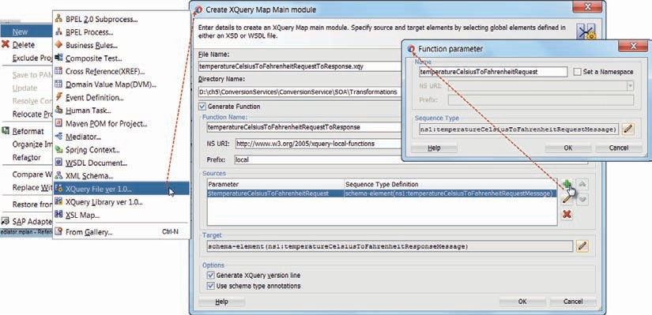

**FIGURE 5-18.** *Create the XQuery Map to transform from XSD type*

*temperatureCelsiusToFahrenheitRequestMessage to temperatureCelsiusToFahrenheitResponseMessage*

Add an input parameter called *temperatureCelsiusToFahrenheitRequest*, based on the XSD type

*temperatureCelsiusToFahrenheitRequestMessage*.

Set the type of the target—the outcome of the function—to the XSD type *temperatureCelsiusToFahrenheitResponseMessage*. Press OK to complete the setup of the XQuery Map Main module. JDeveloper will now create the xqy file and open the editor.

The mapping editor for XQuery is very similar to the mapper for XSLT, see Figure 5-19. The sources that were specified for the XQuery function are shown on the left. The target element’s structure is presented on the right. Through simple drag (from source) and drop (on target), we can create a straightforward mapping of sources values into the target XML structure. Drag the source temperature element to the target element. Then, click on the created line. The properties editor

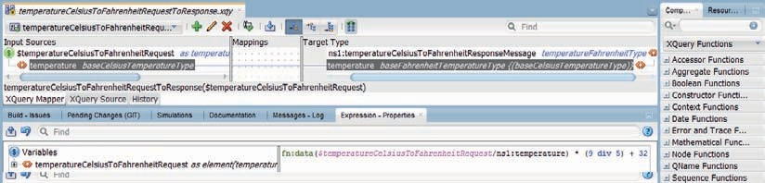

**FIGURE 5-19.** *Creating the XQuery mapping that converts the temperature*

will show the XQuery expression that the drag and drop operation produced— fn:data($temperat ureCelsiusToFahrenheitRequest/con:temperature). This expression will simply copy the temperature value from the source. That is not good enough, as we have to actually convert the temperature from the Celsius scale to Fahrenheit. Edit the expression in the property editor to:

 fn:data($temperatureCelsiusToFahrenheitRequest/con:temperature) * (9 div 5) + 32

Click on the commit icon to apply this change to the XQuery source.

Note that you can go straight to the XQuery Source view to directly edit the source instead of using the visual mapping tool and property editor.

Save the XQuery source. Note: Unlike the XSLT Mapper, this editor unfortunately does not offer the option to test the XQuery function from within the IDE.

**Replacing the XSL Map with an XQuery Transformation in the ConversionMediator** We now have two ways of transforming the request message for the temperature conversion. The routing rule in the mediator is currently set up to use the XSLT stylesheet for mapping the request message. Open the editor for the *ConversionMediator*. Click on the mapping icon for the routing rule for the *getTemperatureCelsiusToFahrenheit* operation. A dialog appears where the mapper file to be used for the Request Transformation can be set, as Figure 5-20 demonstrates. Click on the browse icon, set the File Type to XQuery Files (*.xqy) and select the temperatureCelsiusToFahrenheitRequestToResponse.xqy file that contains the XQuery function to perform the transformation.

Unlike an XSL map, that simply takes the entire request document as its input, we have to explicitly configure the values used for the input parameters of the XQuery function. Click on the row for *temperatureCelsiusToFahrenheitRequest* in the table with External Variables. Click on the edit icon. Derive the value for this parameter from an expression and set the expression to $in.in/ conversion:temperatureCelsiusToFahrenheitRequestMessage.

Click on OK to close the Request Transformation Map dialog. The routing rule has now been updated to engage the XQuery transformation to process the request message.

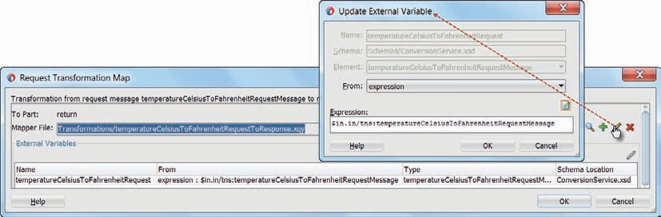

**FIGURE 5-20.** *Configure (how) to use the XQuery transformation for transforming the Celsius*

*temperature request message*

##### Deploy and Test the ConversionService with XQuery Inside

Deploy the ConversionService project to the Integrated WLS. Then test the web service from the Enterprise Manager FWM Control, using the HTTP Analyzer in JDeveloper or with an external tool such as SoapUI.

Obviously, you will not notice any change in the way the service is invoked or in the response. Only when you check the detailed flow trace will you notice that the Mediator did not do the XSL transformation but an XQuery manipulation instead did the honors.

#### Validation of Request Messages

The mediator supports two types of message validation. One is the straightforward validation of incoming messages against the XSD—similar to what the Validate action in a Service Bus pipeline does. The second type of validation is support for Schematron. These two options are shown in Figure 5-21, in the Mediator editor. Schematron is a validation language in which rules are specified that the contents of an XML document should comply with. These rules are expressed in XPath expressions that are used to inspect the existence or absence, number of occurrences, and values of XML elements and attributes. Schematron goes beyond XSD validation because of its ability to apply rules conditionally or work with rules that refer to multiple elements.

When validation is enabled for a particular routing rule, every request message arriving at the mediator and processed by that rule is validated and a fault is produced if the message contents violates the validation through either or both the XSD definition or the Schematron rules.

###### NOTE

*A service interface stipulates through an XSD definition what the structure should be of any message passed into it. However, the SOA Suite does not—for either Service Bus or for SOA*

*composites—actually enforce that the request messages comply. This validation has to be performed explicitly.*

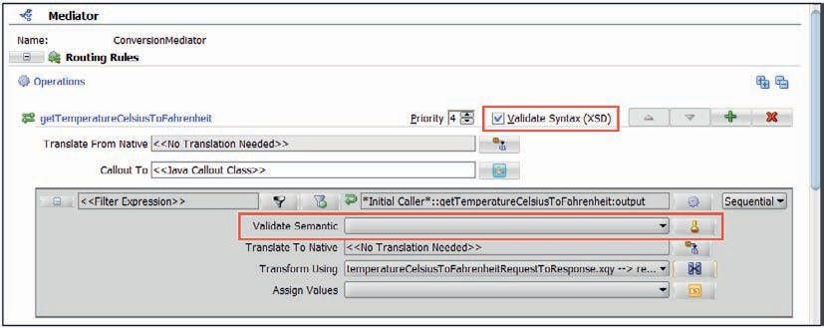

**FIGURE 5-21.** *Validation can be done by the Mediator based on the XSD Schema or a Schematron*

*rule library*

Even more advanced validation could be implemented using Java Callouts. We can specify a Java Class that will be invoked by the Mediator for a number of specific stages in the message processing—pre- and postvalidation, transformation, and routing of a message. In this class, we can implement validation logic through custom Java code that has full access to the message content. Note: Chapter 10 introduces the Spring component that will frequently the better option for message preprocessing in custom Java.

**Enabling XSD Validation**

To enable the validation of request messages against the XSD they are based on, all we need to do is check the checkbox *Validate Syntax (XSD)* at the operation level. This setting applies to all routing rules that may be created for the operation.

##### Schematron-Based Validation

Schematron validation rules are specified in an XML document created according to the 1.5 version of Schematron that uses the namespace <http://xml.ascc.net/schematron/>(which also happens to be the URL at which more information can be found).

Schematron-based validations can introduce substantial performance overhead because of potentially complex, fine grained rule evaluations. They are typically used to inspect messages originating from systems and entities outside the trusted enterprise landscape—including third party COTS applications, and not so much for the internal interactions between services running on the SOA Suite.

Any XPath condition can be used to specify the test condition of a Schematron rule, that is, the boolean expression that should evaluate to true in order for the document to be considered valid with respect to that rule.

Create a new XML document in the Schemas folder. Call it ConversionServiceValidationRules

.sch. The extension.sch is used to identify Schematron files.

Add the following content to ConversionServiceValidationRules.sch:

 <?xml version="1.0" encoding="UTF-8" ?>

<schema [xmlns="http://www.ascc.net/xml/schematron">](http://www.ascc.net/xml/schematron)

<ns uri="saibot.airport/services/utility/conversion" prefix="conversion" />

<pattern name="Celsius Temperature Values not under -100">

<rule context="//conversion:temperatureCelsiusToFahrenheitRequestMessage">

<assert test="conversion:temperature &gt; -100">Temperature should not be below -100</assert>

</rule>

</pattern>

</schema>

This defines a single rule that applies to the context of the temperatureCelsiusToFahrenheitRequestMessage node in the namespace saibot.airport/services/ utility/conversion (specified with the prefix conversion). The rule states that the temperature element in this context should have a value greater than −100. If that condition does not hold, a violation of this rule is reported.

We can use complex XPath expressions in the boolean test condition of the assert element, that may reference XPath functions as well as any element in the source XML document that is validated through the rule.

The Schematron document may contain many rules that apply to various context element. If an XML document is validated using a Schematron document, only those rules applicable to the elements in the XML are processed and all other are ignored.

To configure the routing rule to perform validation using this Schematron document, bring up the mediator editor. Click on the stamp like icon behind the Validate Semantic field in the routing rule for the getTemperatureCelsiusToFahrenheit operation. Select the ConversionServiceValidationRules.sch as the Schematron file to use to validate the request message, as shown as in Figure 5-22. Each message part can be associated with a different Schematron document. Note that Schematron validation is configured per routing rule—not at the operation level like is the case for XSD validation.

##### Validation in Action

Both types of Validation have now been configured—against XSD and according to Schematron. Deploy the project. Send a test message with the temperature value set to −300, which is invalid according both the XSD schema and the Schematron rule.

The result is a SOAP fault with a message that reads: “oracle.tip.mediator.infra.exception

.MediatorException: ORAMED-01303:[Payload default schema validation error]XSD schema validation fails with error “Invalid text ‘-300’ in element: ‘temperature’”.” This clearly is the outcome of the XSD validation, which is apparently the first—and in this case only—validation to take place.

When you send a second test message with a temperature value of −150, the XSD validation is passed. Now the Schematron rule kicks in and the result is again a SOAP Fault, with a payload stating “oracle.tip.mediator.infra.exception.MediatorException: ORAMED-01301:[Payload custom validation]Schematron validation fails with error “Temperature should not be below -100”.

Clearly these are not the faults we would like to return to the consumer of our service—if for no other reason than that the SOAP Fault betrays far too many details about the implementation to consider the service anywhere near encapsulated.

In the Enterprise Manager FMW control, details on the faulted instance can be found in the instances tab for the *ConversionService* (see Figure 5-23) and the flow trace for the faulted instance. The column *recovery* lists the fault as nonrecoverable—obviously, because in this synchronous service the fault has already been returned to the caller.

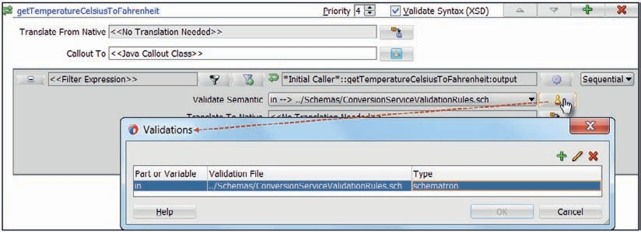

**FIGURE 5-22.** *Configuring validation according to a Schematron constraint definition file*

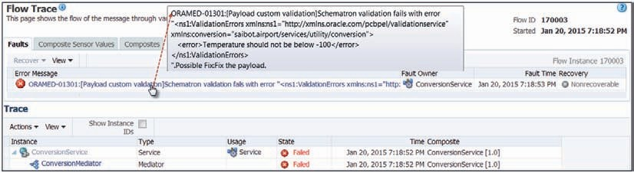

**FIGURE 5-23.** *Flow trace for a ConversionService instance that returned with a [Schematron*

*validation] fault*

#### Fault Handling

Fault handling in SOA Composite applications is to some extent handled inside components—for example in BPEL and to a lesser degree in Mediator. SOA Suite has a generic framework for handling faults in SOA composite applications, using fault policies and bindings that are configured and executed outside the components. The bindings associate the fairly generic policies with specific composites and components. The policies specify what should be done under which conditions.

##### Fault Policies

Fault policies are defined in the file fault-policies.xml in the root directory of the SOA composite project—or in a file with a different name in a different location (typically MDS, see Chapter 21) that is specified through the oracle.composite.faultPolicyFile in the composite.xml file. This file contains one or more fault-policies, identified through a unique id. These policies are typically reusable across composites.

A fault policy contains actions—*what* should be done—and conditions—*when* should one of the actions be executed. The actions in a fault policy can make use of the following operations that can be performed by the SCA container to handle a fault:

* Retry—retry the activity that caused the error, in a new thread and a new transaction; this action makes sense, for example, for calls to components that temporarily could

be unavailable; the retry action is configured with details on how often and with what delays a retry should be attempted. Additionally, we can specify another action in the fault policies file to execute when the maximum number of retries has failed as well as an action to perform when the retry was successful.

* Abort—the generic exception FabricInvocationException fault is thrown back to the caller, and the state of the composite instance is set to terminated.
* Human intervention—make the faulted instance available in the EM FWM Control console for manual recovery; this recovery could include payload manipulation and

restarting the instance at a suitable moment.

* + Custom Java Code—invoke a custom Java Class to execute custom logic to deal with the fault; for each possible return value from the class, we can configure a subsequent action

in the fault policy file to be invoked. Additionally, we can associate a property set with an action entry of type custom Java to pass context settings to the Java code. This class should implement the Java interface IFaultRecoveryJavaClass.

* + Rethrow—the final resort to simply rethrow the same SOAP fault that triggered the policy, when all else fails.

For synchronous interactions such as the one in the *ConversionService* composite, only Abort, Rethrow and Custom Java Code are appropriate operations to execute.

The conditions in the fault policy file identify an error or fault condition and then indicate the action to be taken when that particular condition occurs. The condition identifies a fault—either a predefined generic SOA Suite fault such as mediatorFault or remoteFault—or a specific custom fault. Note: Every Mediator fault is wrapped into the mediatorFault, which acts as a generic container for all the mediator faults. The condition can contain a test that inspects the fault details—for example, those inside mediatorFault—using a boolean XPath expression. When this expression evaluates to true, the condition applies and the action associated with the condition

is executed.

Mediator Error Groups can be used in test conditions while defining the Fault Policy. There are six mediator error groups: TYPE_ALL, TYPE_DATA, TYPE_METADATA, TYPE_FATAL, TYPE_ TRANSIENT and TYPE_INTERNAL. Each of these groups contains several error codes, that each start with the name of the group. Examples of these error codes that can be tested for are TYPE_ DATA_FILTERING, TYPE_DATA_TRANSFORMATION and TYPE_FATAL_DB. An example of a test condition that would trigger for a validation violation is given next

 contains($fault.mediatorErrorCode, "TYPE_DATA_VALIDATION")

Multiple conditions in a fault policy can evaluate to true for a fault occurrence. The first condition that applies is the one for which the action is executed. Other conditions are ignored. The order in which conditions are defined in the fault-policy is therefore meaningful.

##### Fault Bindings

Fault policies are defined in the file fault-bindings.xml in the root directory of the SOA composite project—or in a file with a different name in a different location that is specified through the oracle.composite.faultBindingFile in the composite.xml file.

The fault bindings file contains one or more entries that associate a fault policy with the entire composite, with a specific component or with a specific reference (to an adapter or other binding to an external service).

Such an association is very straightforward. To associate the entire SOA composite with a particular fault policy, the syntax is as follows

 <composite faultPolicy="SaibotFaultPolicy"/>

To associate one or more components in the composite with a fault policy, the syntax is:

 <component faultPolicy="SynchronousMediatorPolicy">

<name>ConversionMediator</name>

<name>SomeOtherComponent</name>

</component>

Specifying that a fault policy is associated with a reference is similarly straightforward:

 <reference faultPolicy="UsuallyReliableExternalServicePolicy">

<name>QueryAirportsDB</name>

<name>AllocateSlotsDB</name>

</reference>

When a fault occurs at runtime, the fault bindings are checked to determine the fault policy for the current component. If none is specifically associated with the component, the policy at composite level is picked. If a fault policy is found, then the conditions are inspected to find the action to execute. If no fault policy binding is located, then no action is performed and the behavior is the same as if the fault policies did not exist.

If there is no fault policy defined the error is thrown back to the caller for synchronous interactions. For parallel routing rules in the Mediator and other one-way or asynchronous interactions, the default action of human intervention is performed. Note: When fault handling has been implemented inside the component and the fault does not get published outside of it, then the fault handling framework does not get triggered at all.

##### Fault Handling in the ConversionService

In the context of the *ConversionService* SOA composite, open the New Gallery. Create a new SOA Tier | Faults—Fault Policy Document. A file fault-policies.xml is created and the fault policy editor opens, see Figure 5-24.

Set the name of the (first) fault policy to *SynchronousMediatorPolicy*. Click on the Actions tab. Here are the predefined actions—default-termination, default-manual, default-retry, and

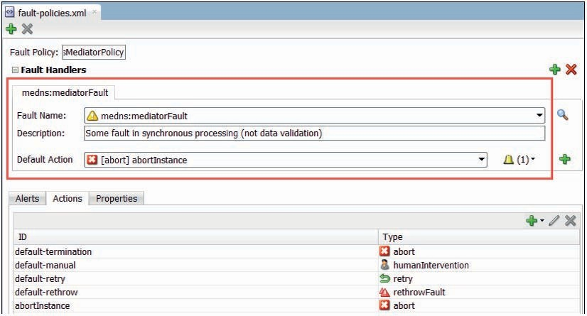

**FIGURE 5-24.** *Fault Policy editor showing a fault policy for the medns:mediatorFault*

default-rethrow. Each of these predefined actions is associated with one of the five action types available in fault policies. Add a new action with an ID of *abortInstance* and of type *abort*.

Add a fault condition by clicking the green plus icon. Select the medns:mediatorFault from the drop-down list. Provide a description that explains to the developers and administrators what this condition is for and then set the Default Action to *abortInstance*.

This fault policy now specifies that when the mediatorFault occurs, the abortInstance action should be executed. We have not yet specified to which composite or component this policy applies. That is what fault-bindings.xml file is for.

Open the composite overview for *ConversionService*. Click on the little icon for editing the composite fault policies. Figure 5-25 shows the popup that appears. Set the policy to *SynchronousMediatorPolicy* for the *ConversionMediator*. At this moment, binding the policy at composite level would have exactly the same effect.

Through these two editors, the fault-policies.xml and fault-bindings.xml files have been created. You may want to take a look at the source of these files, to get a good understanding of what was done behind the covers.

Deploy the composite. Test the temperature conversion operation in the service with a temperature value outside the valid range, which means under −100 degrees Celsius. The invocation will fail, like before. Only this time, the instance will abort because of the fault policy, as Figure 5-26 demonstrates. The SOAP Fault does not reveal detailed information. The end status of the *ConversionMediator* instance is now Terminated.

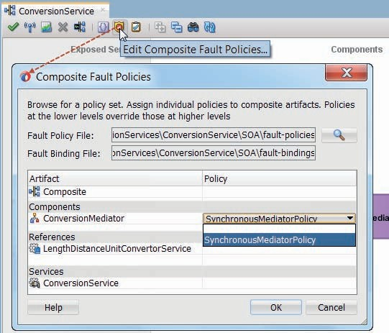

**FIGURE 5-25.** *Binding Fault Policy SynchronousMediatorPolicy to the ConversionMediator*

*component*

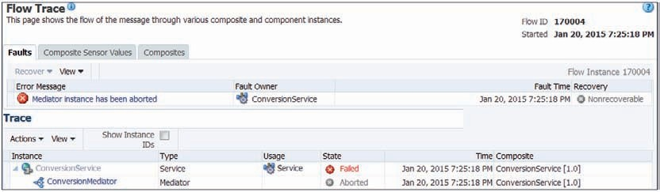

**FIGURE 5-26.** *Flow trace for an ConversionService instance that was aborted because of the*

*fault policy binding*

Return to JDeveloper and change the action for the one condition in the fault policy to *default-rethrow*, the predefined action to rethrow the fault. Deploy the composite again and execute the same test with the invalid temperature value. This time, the response will be the same SOAP Fault we saw in the previous section. The fault policy kicked in—and this time the action was to rethrow.

Return to the fault policy editor in JDeveloper. Add a new condition. Choose again the mediatorFault for the Fault Name. Next, set the *If* condition to

 contains($fault.mediatorErrorCode, "TYPE_DATA_VALIDATION")

This means that this condition only holds true in case of a validation exception from the Mediator. From any other type of fault, the other condition will kick in and execute the default-rethrow action. For validation faults however, set the *Then* action to *abortInstance*, as shown in

Figure 5-27.

Deploy the composite once more and invoke the temperature conversion again with an invalid value. Now the instance should abort again, because the fault condition we just added—to abort for validation errors—trumps the generic one that is defined below it in the fault-policies.xml file.

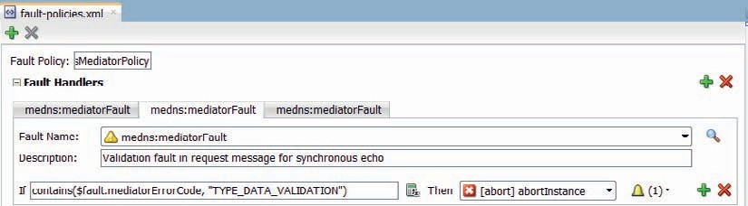

**FIGURE 5-27.** *Adding a conditional action for the mediatorFault*

##### More on Fault Handling

Compared with the error handling in a Service Pipeline, the Mediator lacks a number of important facilities. There is not the option to perform an alternative way of processing the faulted request and still return a valid response, nor can we change from the actual SOAP Fault to a fault of our own choosing. We cannot throw a business fault when neither the validation, the transformation, or the routing resulted in a technical exception or SOAP Fault, even if the contents of the request or response would suggest that we do so. Only by using Java callouts and/or a Custom Java Action to handle a fault do we get a little more grip. As we discuss later in this chapter, many organizations will decide to expose their SOA composites through the Service Bus—and not have any direct calls to the service exposed by the composite. The fault handling— including encapsulation and picking the appropriate fault—can then be done using the richer capabilities at that level, which is usually the preferred option over dabbling in custom Java Callouts.

###### TIP

*The BPEL component that we also can use in SOA composites has much richer fault handling capabilities (see Chapter 8).*

The fault-policies.xml file allows us to define fault alerts, configure them through a property set and associate these alerts with individual fault conditions. Alerts send notifications to a Logger, a JMS destination, or an email address. When an alert has been associated with a fault condition, whenever that condition is satisfied by a fault occurrence and it triggers an action, the alert is executed as well and a notification with fault details is sent to the alert destination.

#### Add Composite Sensors for Instance Identification

Instances of a SOA composite are identified through a rather meaningless technical numeric identifier, that is of little use when trying to find a particular instance. In SOA Suite, we have the option of associating other, more meaningful tags with instances of a composite through a feature called composite sensors. A sensor is defined at design time—or at run time—with a name, an XPath expression that derives the value for the sensor from the request message sent to the composite instance or the response returned from it and a filter that can be used to track the sensor value for selected instances only. In the Enterprise Manager FMW Control, composites instances display their sensor values and we can search for instances of SOA composites with specific values for the composite sensors. Additionally, the value of the sensor can be sent to a JMS destination, to allow external parties to keep track of specific activities. The composite sensor is quite similar to the message reports introduced for Service Bus pipelines in Chapter 3.

The ConversionService is not the most logical candidate to tag through a composite sensor, but in order to get a feel for the mechanism, we will apply one anyway.

##### Specifying a Composite Sensor for the ConversionService

A sensor is defined on a SOA composite through the dialog opened from the Composite Sensor icon above the SOA composite editor, as shown in Figure 5-28. Click on the icon. In the Composite Sensors window that appears, select the Service node ConversionService. Then click on the plus icon. The Create Composite Sensor window appears.

Set the name to celsiusTemperatureValue. Select the operation getTemperatureCelsiusToFahrenheit. Define an XPath expression using the expression builder. Have it return the temperature element

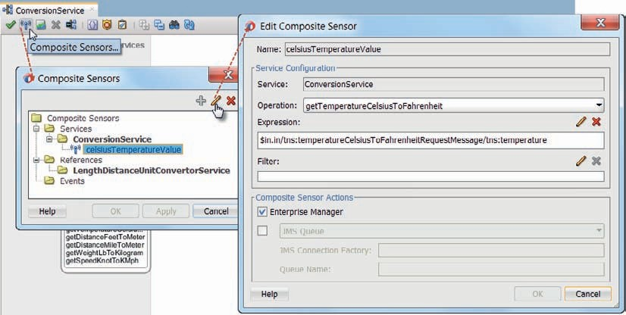

**FIGURE 5-28.** *Creating a Composite Sensor celsiusTemperaturValue for the ConversionService*

*SOA composite*

in the request message. Ensure that the sensor action checkbox for Enterprise Manager is checked. Leave the checkbox for the JMS action unchecked. Press OK to complete the definition of the Composite Sensor. Then press OK to close the Composite Sensors window. You will notice that a small icon has been added to the ConversionService element in the Exposed Services swimlane, indicating the existence of at least one composite sensor.

Deploy the SOA composite to the Integrated WLS. Make one or more calls to convert a Celsius temperature. Then open the overview page for the *ConversionService* composite in the EM FMW Control. Click on the Flow Instances tab. Search for all recent instances. Click on the last instance. On the bottom part of the page, activate the Sensor Values tab. There you will find the value for the *celsiusTemperatureValue* sensor, as shown in Figure 5-29.

Instances can be filtered by the value of their sensors, both at the level of a single composite as well as at the level of the entire SOA Suite node.

On the search tab, by clicking the Add/Remove Filters link, a popup window is brought up. In this window, the checkbox labeled Flow Instances should be checked in order to be able to filter instances by composite sensor. With that checkbox checked, up to six composite sensors can be used to filter on.

Browse for, or type the name of the sensor. In the browse dialog, you can specify which operator should be used in conjunction with the values of this sensor: equality, like, less than (or equals) or greater than (or equals). In the search tab itself, the value is set with which the composite sensor values for all composite instances should be compared. Figure 5-29 shows a filter that searches for instances that have a composite sensor *celsiusTemperatureValue* with a value of exactly 67.

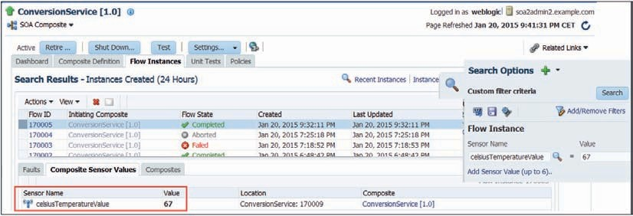

**FIGURE 5-29.** *Composite Sensor values providing additional context for instances of SOA*

*composites—note how you can search for instances with a specific value for the composite sensor*

### Add Height and Distance Conversion Support Using an External Service

The SOA composite *ConversionService* has only support for one of five operations in the service interface: the temperature conversion that is locally implemented using the Echo routing rule and a simple message transformation. Just like the Service Bus pipeline in chapter 3 that used an external service to implement the operation *getDistanceFeetToMeter*, we will now add support for that operation to the SOA composite. To that end, we will add a reference to the external service that does the actual distance conversion and define a new routing rule in the mediator that maps and routes messages received for operation *getDistanceFeetToMeter* to the reference. We will be able to reuse some of the artifacts we used with the Service Bus pipeline in Chapter 3.

#### Create a Reference for the External Conversion Service

Service Bus projects use a Business Service to locally represent an external service and configure details about how to access the service. In SCA, this is done using a Reference (binding). Such a reference is created in the composite editor by dragging the appropriate component from the component palette and dropping it in the External References swimlane. Create a reference binding in this way using the SOAP binding component, as is shown in Figure 5-30.

A dialog appears for configuring the Web Service binding (Figure 5-31). Set its name to

*LengthDistanceUnitConvertorService*. Set the WSDL URL to <http://www.webservicex.net/length>

.asmx?WSDL. Select Port Type *lengthUnitSoap* from the drop-down list that is populated from the WSDL document. Check the checkbox to copy the WSDL document and associated artifacts into the project. Press OK to complete the configuration.

The Reference binding *LengthDistanceUnitConvertorService* is now created in the External References swimlane. Connect the *ConversionMediator* to this reference. In the Choose Operations dialog, map the *getDistanceFeetToMeter* operation from the *ConversionService* interface to the *ChangeLengthUnit* operation in the reference binding, as shown in Figure 5-32.

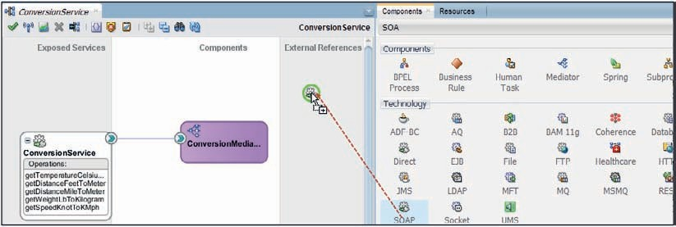

**FIGURE 5-30.** *Add a SOAP Web Service Reference Binding to the SOA composite*

Wiring the mediator to the reference has caused an update in the composite.xml file—you may want to take a look how this wire is configured. It has also resulted in a new routing rule in the mediator—one that routes request messages for the *getDistanceFeetToMeter* operation to the *ChangeLengthUnit* operation on the reference. We need to further configure this routing rule, to have it perform the necessary transformations of the request and response messages.

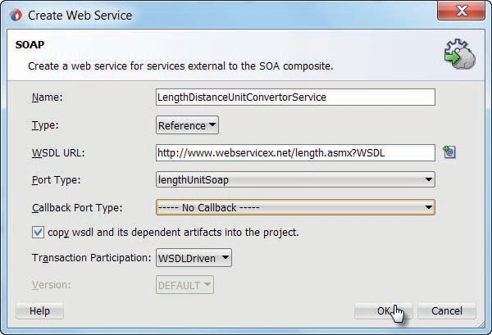

**FIGURE 5-31.** *Configuring the Web Service binding for the external service (dependency)*

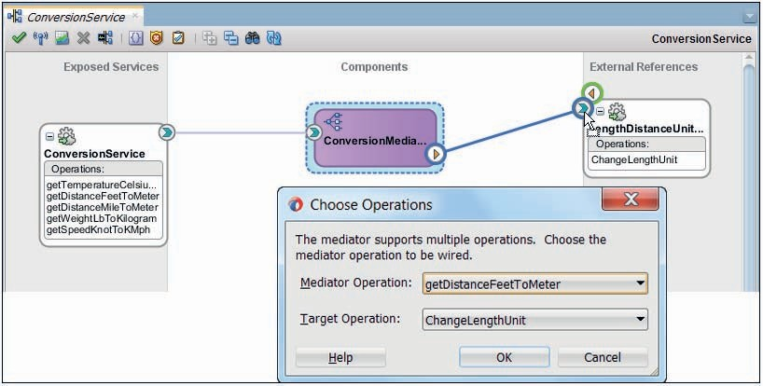

**FIGURE 5-32.** *Wiring the ConversionMediator to the LengthDistanceUnitConvertorService*

*reference and mapping the operations*

###### NOTE

*Many organizations adopt as a best practice that all access to external services is routed through the Service Bus. For each external service invoked from the enterprise, a proxy service is published on the Service Bus. The proxy routes to a business service that is set up*

*for the external service. The same practice is generally adopted for services in different domains inside the organization.*

*This proxy is the local endpoint for the external service that all consumers can make use of. It virtualizes the external service—its location, its availability and other aspects. If a new provider of the external service is engaged, this change will not impact internal consumers of that service, since their only dependency is on the proxy.*

*Using this practice, SOA composites would never directly reference external services such as the* LengthDistanceUnitConvertorService*.*

*The limitations in the Reference binding compared with the Service Bus business service—such as runtime property adjustment, load balancing, fail over, result cache, service throttling, and SLA monitoring that are only available on the Service Bus—are then irrelevant*

*because there still is a business service between the composite and the external service.*

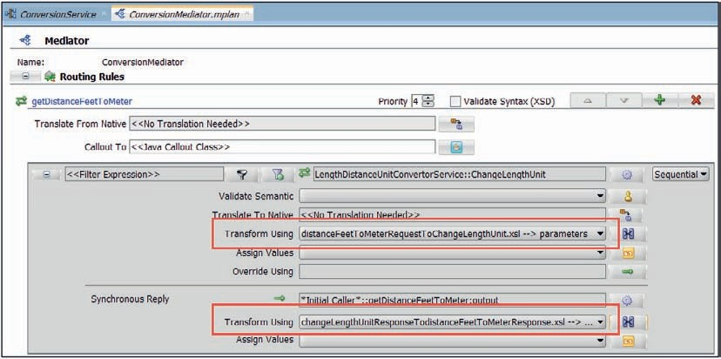

**FIGURE 5-33.** *The routing rule for the getDistanceFeetToMeter operation with the two*

*transformations set up*

#### Configure Routing Rule in Mediator

Edit the *ConversionMediator*. You will find the new routing rule for the *getDistanceFeetToMeter* operation. Click on the transformation icon for the request message. Select the XSLT file distanceFeetToMeterRequestToChangeLengthUnit.xsl in the Transformations folder to perform the transformation of the request message. This is the same mapping that was used in Chapter 3 in a Replace activity in the Service Bus pipeline and which we have copied into the project earlier.

Next, set up the file changeLengthUnitResponseTodistanceFeetToMeterResponse.xsl to perform the mapping of the response message. The routing rule is shown in Figure 5-33.

#### Deploy and Test

Deploy the *ConversionService* composite to the Integrated WLS. Test the service—this time calling the *getDistanceFeetToMeter* operation to convert a 1000 feet into the meter equivalent. Once you have received the response, you can check the instance flow trace. See Figure 5-34.

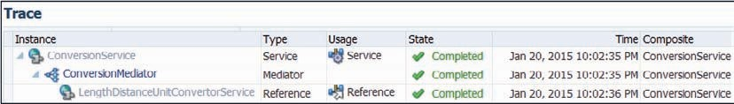

**FIGURE 5-34.** *The flow trace for the ConversionService composite handling a call*

*to the getDistanceFeetToMeter operation and engaging the external reference for the LengthDistanceUnitConvertorService*

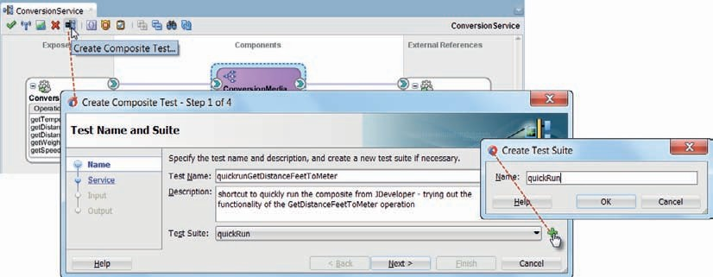

##### Short-Cut to Run SOA Composite from JDeveloper

When you are doing development work on the SOA composite—for example, working on transformations or validations—it is helpful to frequently try out the intermediate results from your most recent changes. It would be very convenient to be able to quickly do deploy-and-run cycles from within JDeveloper. For Service Bus composites, the IDE provides the Run option on the context menu for proxy service, pipeline, and business services. Activating that option will deploy the composite and open the service tester, poised for the right service. This facility however is not available for SOA composites, but there turns out to be a pretty good alternative.

For SOA composites, the SOA Suite has a built in testing framework for conducting unit tests. A quick first introduction to this framework follows next—more details are in Chapter 22.

A SOA composite can have one or more associated test suites. A test suite contains one or more test cases. Each test case represents a call to one of the operations in a service exposed by the composite. Part of a test case are a request message, the expected response message and optionally the emulated replies from external references or components within the composite. Assertions can be added to test case to verify if the results conform to the expectations. A test suite is deployed along with the SOA composite and can be run from the Enterprise Manager FMW control. It can also be run directly from JDeveloper. When the latter is done, the SOA composite is redeployed if it has been changed since the last deployment, the test calls are made from JDeveloper to the freshly deployed composites and the results are shown in JDeveloper. A new instance of the SOA composite is created and can also be inspected in EM FMW control.

This means: by running the test from JDeveloper, we achieve the goal of build-deploy- run (and show results). Note that we do not necessarily want to test the outcomes of the service call in detail—we only use this as a short-cut to try out the current state of the composite.

The steps for the *ConversionService* are as follows:

Click on the icon to Create Composite Test—shown in Figure 5-35.

**FIGURE 5-35.** *Creating a Composite Test [Case] for the ConversionService composite*

A wizard for creating a Composite Test [Case] appears. Provide the name of the Test Case, for example, *quickrunGetDistanceFeetToMeter* for a test case we will use to try out the *getDistanceFeetToMeter* operation. Provide a description. This is the first test case in our composite, so click on the icon to create a Test Suite, as shown in Figure 5-35.

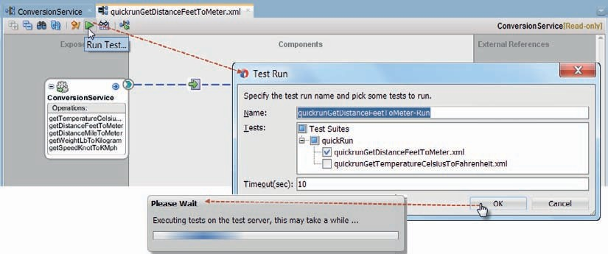

Set the name of the new Test Suite to quickRun; this will be a test suite with shortcuts for all operations in the composite.

In step 2 of the wizard, select the operation to call in this test. In step 3, provide the content for the request message to use in this test. In step 4, specify the expected response message (or accept the default if you do not actually need to test the results but merely want an easy way to fire off the operation). Press Finish to complete the wizard. The Test Suite is created as a new folder under the *testsuites* project folder.

The new test case is created as a file in the test suite folder. In its context menu, the option Run Test can be used to run the test. The file can also be opened through double click. In that case, the composite editor opens in a special mode (see Figure 5-36) that has an overlay with details of the test case. The test case can be further refined in this mode—emulations of response messages and assertions on intermediate results can be added to the wires.

**FIGURE 5-36.** *Run the Test Suite from the SOA composite editor in Test Mode*

With the run icon in the top menu bar, the test case can be kicked off. The first time a popup window will appear to have you select the server on which to deploy the SOA composite and run the test. Usually this will be *localhost*—where the Integrated WLS is running. If you check the checkbox in this popup, this selection is saved in the preferences and the question is not asked again.

A second window gives you the option to refine the selection of test cases to run. Next, if the SOA composite has been changed since the last deployment, a window appears to

|  |
| --- |
| have you confirm that redeployment should take place. Then, build and deploy steps are executed and the test(s) are run. A dialog appears to inform you that the tests are in progress. When running the tests is done, a tab opens in JDeveloper with the test results. You can inspect the response message produced by the composite instance.  You can also inspect the composite instance and its flow trace details in EM FMW control. Note that instances created by running test cases are marked with a yellow indicator in the instances overview, as shown in Figure 5-37. |
|  |
| **FIGURE 5-37.** *Test instances of the ConversionService, marked with the test indicator: a yellow square* |

### Exposing SOA Composites through the Service Bus

A SOA composite is one of several ways to create a service implementation. Others include JAX- WS, ADF BC, EJB, JAX-RS, and third party technologies. Services can be exposed through the Service Bus, that takes care of virtualization of the location and underlying implementation.

Service Bus will also help scale the services to handle higher volume of requests, monitor their activity, and provide caching and fail over. It is a best practice to not have consumers directly access SOA composites. Instead, the SOA composite’s service is registered on the Service Bus and thus exposed to consumers.

In this section, we will register the SOA composite ConversionService on the Service Bus and expose its interface through a proxy service. Consumers can then invoke ConversionService operations on that proxy and have the SOA composite take care of handling their request, without dealing with that composite directly.

#### Create Service Bus Project

In JDeveloper, create a new Service Bus Application with a new project, both called *ProxyConversionService*. Create the two folders WSDLs and Schemas. Copy files ConversionService.wsdl, ConversionService.xsd and common.xsd from the SOA composite to these two folders.

###### NOTE

*In real life, we would use MDS (Meta Data Services) to hold and provide access to these artifacts, instead of copying and moving them around. We will discuss MDS in Chapter 21.*

#### Register SOA Composite as Business Service

Drag the HTTP component from the palette to the external references swimlane and drop it. In the Create Business Service wizard that appears, set the name of the business service to *ConversionServiceBS*. Click Next. On the second page, select the WSDL as the service type.

Browse for the file ConversionService.wsdl in the SOA composite project *ConversionService*. The correct port type is automatically selected. Click Next.

On the third page of the wizard, you have to provide the endpoint URI for the *ConversionService*.

You can find the URI for the service exposed by the SOA composite *ConversionService* in the Enterprise Manager FMW Control. Select the *ConversionService* composite in the navigation tree. Then click on the icon to the right of the settings button, as shown in Figure 5-38.

The URI probably has this value: http://localhost:7101/soa-infra/services/default/ ConversionService/ConversionService.

Copy the URI and paste it into the *endpointURI* field. Click on Finish to complete the business service definition.

##### HTTP vs. SOA-DIRECT Transport

A business service can make use of several transports. HTTP is one that is frequently used, for example, to access SOAP Web Services. Others include JMS, EJB, and SOA-DIRECT. The latter is a transport that connects a Service Bus Business Service to a direct binding service exposed by a SOA composite. This transport exchanges messages over a remote method invocation (RMI), and is the recommended transport if you need transaction or security propagation. For interactions between Service Bus and SOA composites where transaction or security propagation are not relevant, HTTP is the preferred transport.

#### Expose Proxy Service

Right click on the ConversionService.wsdl and select the menu option Service Bus | Generate Proxy Service, to generate the Proxy Service and Pipeline for this WSDL.

The Create Proxy Service wizard appears. Set the name of the proxy service to *ProxyConversionServicePS* and the name for the pipeline to *ProxyConversionPipeline*. Change the endpoint for the proxy service to /utility/ConversionService, on the second page of the wizard.

Press Finish to complete the creation of the proxy service and pipeline.

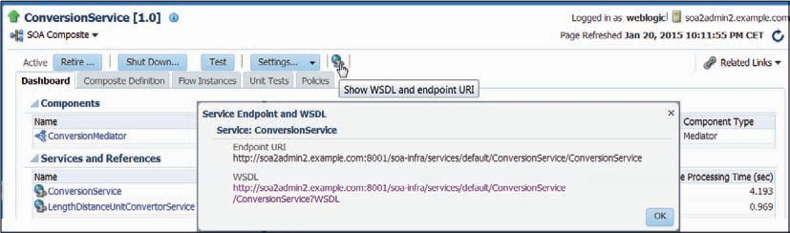

**FIGURE 5-38.** *Finding the endpoint of the SOA composite web service from the EM FMW Control*

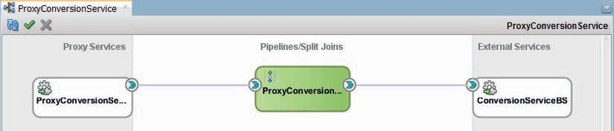

**FIGURE 5-39.** *Service Bus project to expose the ConversionService SOA composite*

JDeveloper will now inform you about the need to change the operation selection configuration, because two operations use the same request message and therefore the message type cannot be used as the basis for the operation selection. On the tab for Operation Selection Configuration in the proxy service editor, select SOAP Action Header as the algorithm for picking the operation to execute.

In the *ProxyConversionService* overview editor, wire the pipeline to the business service. The project now looks as shown in Figure 5-39.

This will create a route node with a routing activity in the pipeline that routes every request message through the business service, to the SOA composite. At this point, no validation, enrichment or transformation is required, just routing—as shown in Figure 5-40.

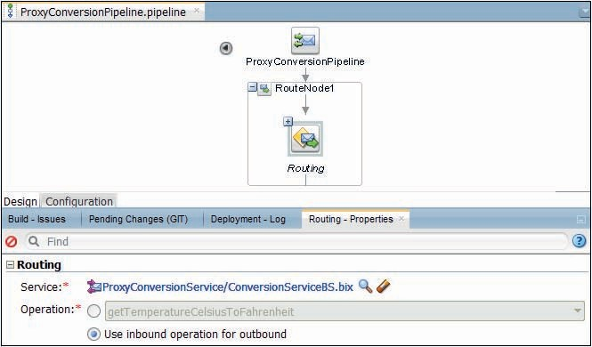

**FIGURE 5-40.** *The ProxyConversionPipeline only has to do routing to the business service for*

*the SOA composite*

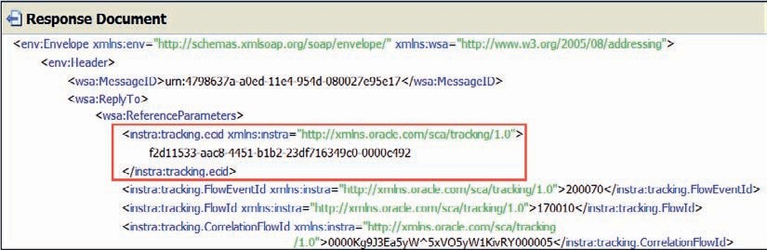

**FIGURE 5-41.** *Header details that betray the passage through the SOA composite*

#### Deploy and Invoke

Run the proxy service from within JDeveloper using the context menu. This will automatically trigger deployment of the Service Bus project to the Integrated WLS, and open the test dialog. Either invoke the operation to convert feet to meters or Celsius to Fahrenheit. You should receive a response message—that also contains information in the header about the trip the message took through the SCA container when processed by the SOA composite, such as the unique ECID or execution context identifier (a unique identifier assigned to a request by Fusion Middleware that can be used to track a request or transaction across tiers—more on ECID in Chapter 23) (see Figure 5-41).

This same ECID is used to compose the message flow trace that you can inspect for the call to the proxy *ConversionService* exposed on the Service Bus. This trace (Figure 5-42) shows how the request traveled from the Service Bus (indicated as OSB) to the SOA composite and from there to the Mediator and in the case of the feet to meter conversion if the request was for the feet to meter conversion also the invocation of the external reference.

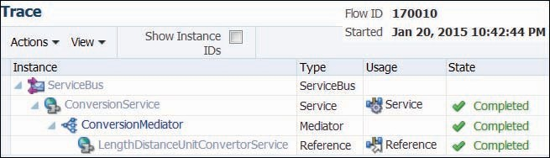

**FIGURE 5-42.** *Flow trace of a message sent to the Service Bus proxy and routed to the SOA*

*composite*

##### Failed Deployment Because of Conflicting Endpoint

The deployment might fail because the endpoint configured for the proxy service is the same one we used for the Service Bus project we developed in Chapter 3, and that may still be deployed to the Integrated WLS. The Service Bus cannot listen on one endpoint on behalf of two different services, so if that is the case, let’s remove that Chapter 3 *ConversionService* project to make way for the current project.

In order to do so, open the Service Bus Console—at http://localhost:7101/servicebus. Select project *ConversionService* in the project browser. Click on the Create button to start an editing session. Click on the red cross-shaped delete icon. Confirm your decision. The click on Activate to apply these changes for real.

#### Suggested Guidelines

Most organizations define guidelines that describe how they make use of technology components. Common guidelines around the SOA Suite include:

Keep the Service Bus clean, mean, and lean—have the pipelines do their essential (VETRO) task and as little else as possible. The implementation of services is not what the Service Bus should be used for. This may go as far as ban all outbound adapters from the Service Bus—and only use them in SOA composites.

Consumers should only invoke services exposed on the Services Bus and never call implementations or external services directly. The Service Bus virtualizes all services, provides additional functionality—including monitoring, caching, fail over—and is the decoupling point that allows implementations to be modified or completely swapped in and out. This would mean that calls to SOA composites should only come through the Service Bus—and never directly.

A slightly less strict guideline could make a distinction between different domains or functional areas and allow direct calls between SOA composites within a domain but not across.

### Summary

This chapter introduced SOA composite applications. SOA composites are based on the SCA (Service Component Architecture) standard. SCA composites expose services, consume references and implement their logic using service components, such as the mediator. Other SCA service components in the SOA Suite are BPEL, Human Task, Business Rule, and Spring Java.

The SOA Suite contains two run-time engines that run services—one for SCA composites and one for Service Bus projects. Interactions between the two engines are easily implemented through simple service calls—that could propagate transaction and security context if required. A common approach is to implement all but the simplest services through SOA composites and virtualize access to all services through the Service Bus. Nearly all SOA composites are then registered on the Service Bus and exposed through a proxy.

Administration tasks for both engines and both types of applications are performed in the same console: Enterprise Manager Fusion Middleware Control. Development is done in JDeveloper for both types of applications.

The structure of a SOA composite with a mediator component is very similar to that of a Service Bus composite with a pipeline. The SOA composite exposes services—called proxy service in Service Bus terminology—and consumes external references—called business service in the context of Service Bus. A mediator looks a lot like a pipeline: it does validation, transformation, and routing. Compared to the pipeline, a mediator adds parallel routing rules and

dynamic routing rules based on a Business Rule, content based filtering, asynchronous operations, and built-in Schematron validation as well as the SOA composite fault handling framework. In that same comparison, mediators have less capabilities to manipulate messages, handle faults locally, implement enrichment and use programming logic to tune the message flow.

This chapter introduced semantic message validation based on Schematron, that goes beyond what XSD can do. It also discussed the fault handling framework for SOA composites, using fault policies and fault bindings. The chapter describes how composite sensors can be used to add tags to instances of a SOA composite, that can be used to find and identify instances in the

EM FMW control.

In subsequent chapters, we will discuss how SOA composites can use multiple interconnected service components to implement complex functionality, that for example allow long running, stateful processes and asynchronous interactions.

#### More on Mediator

This chapter scratched the surface with regard to the Mediator component. Its core features were shown. Many more interesting options and capabilities have not yet been discussed, including these:

* Native transformation—support for native, non-XML data such as JSON or CSV; mediators can take native input and map it to XML prior to the regular transformation

and also produce native output from the outcome of the regular transformation and send it onward.

* Leverage Domain Value Maps and Cross References in transformations and value assignments
* One way and Asynchronous—handling requests for which no response is expected or for which the response is sent through an asynchronous callback.
* Response forwarding—forward the response from a target to another target (instead of sending a response to the invoker).
* Resequencing—rearrange incoming messages (per time interval) in the proper order according to custom logic.
* Parallel rules—execute multiple routing rules at the same time in parallel threads.
* Condition-based routing—executing routing rules according to conditions that inspect the headers or contents of messages using boolean XPath expressions.
* Assign values (headers)—manipulation of header properties, for example to dynamically influence JCA Adapter behavior.
* Callouts—hooks for adding message processing in custom Java classes at predefined moments in the Mediator processing lifecycle (before and after executing routing rules),

for example, to add advanced validation, enrichment, and transformation as well as custom logging and tracking.

* Dynamic Routing Rules—using a business rule component to implement the routing logic external to the mediator using a decision table to determine the endpoint of the

target service.

* Attachments—support for processing attachments to request and response messages.



CHAPTER

# 6

## One-Way Services and

More Protocols

JMS

Adapter AQ

Adapter

WS

ll services we have discussed in the previous chapters share at least one characteristic: they are all synchronous, two-way, request/reply services. This means that consumers of these services are blocked for the duration of the service execution, waiting for a response.

**A**

There are many situations where a service does not need to return a response, or at least not synchronously. One-way (aka fire and forget) services have operations defined in their interface with an input but no output or fault. When invoked, the service returns an HTTP 200 acknowledgment (without payload) of the reception of the message, before it starts processing the request. It will not return a response message. That means the consumer is blocked for only a very short period of time. It also means that the connection between service and consumer is severed and no result can be returned (in a regular way). In Chapter 12, we will discuss two-way asynchronous services—that have the benefit of the nonblocking execution of the service in combination with the ability to return a response in the form of a call-back message. Various mechanisms are available to deliver deferred results to consumers, including events, correlation, and (temporary) storage such as data grid, queue, and database table.

The SOA Suite supports several outbound transports that are intrinsically one way: they hand over a message to an external resource without waiting for a response. The technology adapters for JMS, MQ, UMS (User Messaging Service), and AQ support this one-way, fire and forget message exchange pattern—illustrated in Figure 6-1. The adapter for JMS is introduced in this chapter, used in its outbound mode for sending messages to a JMS destination where it will be consumed by a financial application for collecting details to calculate landing fees for incoming aircrafts. To learn about the similarities between various outbound adapters, especially those for asynchronous actions, we will replace that JMS adapter with an AQ adapter as an alternative implementation.

(J)EJB JMS

Transport Transport

EJB

**FIGURE 6-1.** *Overview of the Outbound JCA Adapters and Service Bus Transports for EJB, JMS,*

*AQ, and User Messaging*



EJB

RMI

**Pipeline**

JMS

HTTP

**Service Bus**

**SOA Composite**

AQ

RMI

**Mediator**

Email Chat/IM

…

Direct Binding

EJB Adapter

SOAP Binding

HTTP Transport

JEJB Transport

EJB Transport

UMS

Adapter

EJB

Adapter

EJB

The external resource targeted by the SOA Suite component can be a human. We people are extremely asynchronous in the eyes of automated systems: if we respond at all, we do so rather tardily. The SOA Suite caters for humans through the User Messaging Service (UMS) and the UMS adapter. Through UMS, we can have messages sent from composites through email, instant messaging (chat), and text message (SMS). In this chapter, we will see how flight updates— changed gate, adjusted ETA, new status—can be communicated by a service to an interested (human) party through either email or instant messaging.

The UMS Adapter also supports inbound interactions. This means that services can be triggered through the reception of an email or chat message. We will discuss this in Chapter 13.

An important type of communication in a Java EE environment is based on EJBs. Both Service Bus and SOA composites can invoke Enterprise Java Beans that run locally or remotely. Additionally, they can also both expose an inbound EJB service, allowing Java clients to consume the composite in a native way that can even propagate transaction scope and security context. All four EJB interactions—inbound and outbound and both Service Bus and SOA composite—are discussed.

### Flight Updates through Email and Chat Using the UMS Adapter

One example of a one-way (or at least asynchronous) communication is from machine to human. It is not easy for an automated system to draw the attention of a human resource, let alone have that human respond to a request within typical time out periods. In this section, we will focus on the one-way interaction from the world of automated systems and human actors.

The mechanisms for this interaction include email, instant messaging (IM), SMS, and VoIP. Additionally, social media—Twitter, Facebook, and so on—expose APIs that could also be leveraged by SOA Suite components to inform their human partners of relevant developments and questions.

The SOA Suite ships with the UMS adapter, a JCA adapter that makes the User Message Service (UMS) functionality available from within Service Bus and SOA composites. Through UMS, messages can be sent over various channels, such as email, IM, SMS, and VoIP. The UMS adapter also supports an inbound mode. In this mode, incoming emails and chat messages can be forwarded to a running SOA composite instance or they can trigger execution of a service exposed by a Service Bus project or an SOA composite instance.

In this section, we will implement the *FlightUpdateNotificationService* through an SOA composite that uses an outbound UMS adapter binding to send emails and chat messages (IM). The composite exposes a service interface that expects a flight update message. The information about the changed flight status is transformed into a human readable format and then sent through the channel specified in the request message. The composite contains a mediator component that makes use of content-based routing to route the message to the UMS adapter binding for the selected channel.

#### Flight Updates Reported through Email Notifications

The first step en route to the composite that handles both *email* and *chat* communication is the implementation of the email channel. This requires the definition of the service, the implementation of the composite and the configuration of the email driver properties for the UMS adapter. In a few steps, we can start informing interested parties through email about the latest flight status.

##### Prepare SOA Composite Application and Project

Create a new SOA application called *FlightUpdateNotificationService* with an SOA composite project with that same name. Initially, the composite can be left empty. We will add a mediator component later on.

When the composite editor has opened, add a UMS adapter to the external services swim lane. The adapter configuration wizard opens to allow us to configure an outbound adapter binding that supports sending emails (to parties that are to be informed about a flight update).

Set the name to *EmailSender*. Press Next. Accept the default JNDI name for the UMS adapter connection to use in the run-time environment (eis/ums/UMSAdapterOutbound). Press Next.

Accept the preselected Operation Type (*Outbound Send Notification*) and the default Operation Name *SendNotification*. Press Next.

The page *Outbound Notification Details* (Figure 6-2) contains many properties that are typically specified at run time. On this page, set the type of notification to email—that is the one thing that will not change. You could set the subject—to something like “Flight Update” — although in reality you may want to add the flight number to that subject at run time. The *From* and *Reply To* email address can perhaps be set, although these two can be set at run time as well. However, the wizard will not let you proceed unless you provide a value for the To email address. Use a dummy value, like [dumm](mailto:dummy@design.time)[y@design.time.](mailto:y@design.time)

Press Next. Check the check box for *Message is String Type*. Press Next and press Finish. The outbound UMS adapter binding is created, poised for sending emails (to a dummy address).

Our next step will be to create a mediator that exposes the interface of the *FlightUpdateNotificationService*, routes to the UMS adapter with the proper destination email address set and performs the transformation from XML message with flight status update to a human readable message in between.

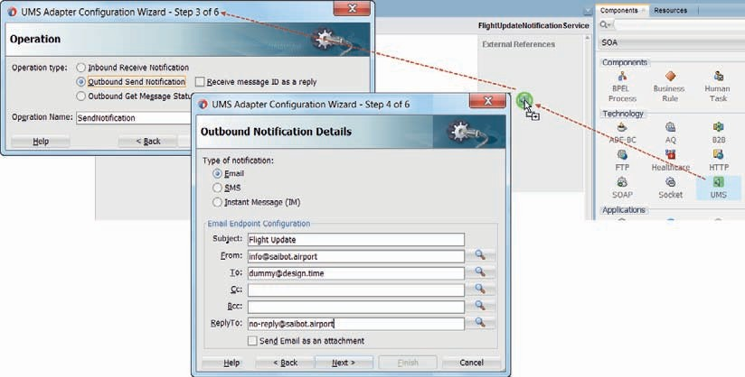

**FIGURE 6-2.** *Configuration of the outbound UMS adapter for sending email notifications*

##### Add the MachineToHumanMediator Component

Drag a mediator component to the SOA composite. Configure the mediator with its name set to *MachineToHumanMediator*. Set the template to *Interface Definition from WSDL* and select the FlightUpdateNotificationService.wsdl interface definition from the source folder for this chapter. Leave the checkbox *Expose as an SOAP service* checked; this will result in a service wired from the mediator to the exposed services swim lane and therefore the service published at the composite level. Press OK to create the mediator. Wire the mediator to the *EmailSender* reference, as shown in Figure 6-3. This will create the routing rule in the mediator.

Right click the exposed service and use the option Rename on the context menu, change the name of the service to *FlightUpdateNotificationService*.

Next, we need to create a way to transform the incoming request message into a proper email body. The easiest way is through an XSL Map that maps from the *sendFlightUpdateNotificationRequestMessage* to the message payload expected by the *EmailSender*—which could well be an XHTML snippet for a rich mail body. Compose the payload element with a suitable message, using at least the salutation element in the *communicationMetadata* section of the request message.

XQuery may be more suitable for composing the text of the email body, because of the relative ease with which we can extract data from the source and combine it with text and html elements. You are encouraged to give that a try.

Configure the routing rule in the mediator to make use of the appropriate transformation.

The destination email address also needs to be set. This is done through the Assign [Properties] dialog in the mediator editor. Click on the icon behind the Assign Values field. The editor shown in Figure 6-4 pops up. On the left side, select the ToAddress property in the CommunicationMetadata element in the request message. On the right side, locate and select the property jca.ums.to.

This will make the Mediator pass to the UMS adapter the email address to send the email to.

You would typically also add a rule for the *jca.ums.subject* property in order to dynamically assign a value to the subject of the email.

The SOA composite is now complete. It can be deployed to the Integrated WLS. However, we will not yet be able to send any mails, because the email driver used by UMS for emails sent on behalf of SOA Suite has yet to be configured with the mail server details.

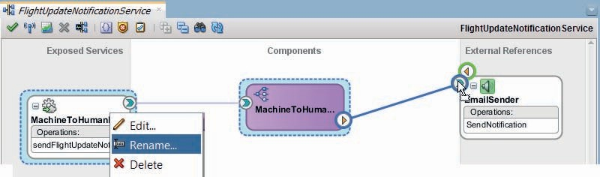

**FIGURE 6-3.** *Wire the mediator to the outbound UMS adapter binding and rename the*

*exposed service*

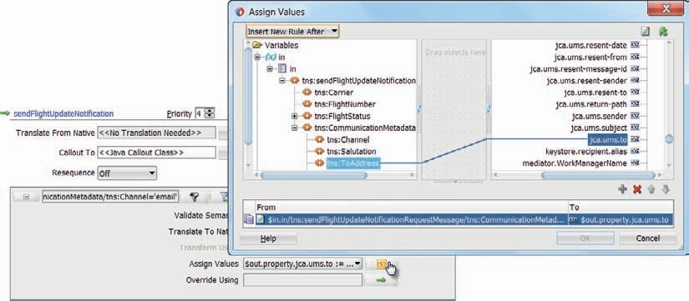

**FIGURE 6-4.** *Configuring the jca.ums.to property with the destination email address.*

##### Configure UMS Email Driver

Outbound emails are sent from a mail server—the SOA Suite does not act on its own. Therefore, at domain level, the UMS email driver has to be configured for both outbound (and inbound if so desired) interaction with the email server that handles the actual communication with the outside world. This configuration is done through the EM FMW Control. Instructions are provided on the book’s website.

Before doing the upcoming configuration, you need to have the access details for a mail server—both host and port as well as a mail account from which the emails sent by the SOA Suite are going to originate.

###### NOTE

*For inbound emails, you would have to configure the mail account in which the incoming messages are gathered. This is discussed in Chapter 13.*

Apply all settings of the email driver properties. This will enable the SOA Suite to properly process outbound email interaction from UMS adapter bindings such as the one we are about to create.

###### TIP

*In Chapter 17, Human Tasks are introduced. Communication about these tasks is typically done using the same User Messing Service leveraged by the UMS adapter. Mails sent to inform our users about tasks assigned to them, are sent through the mail server that is configured as per the online instruction.*

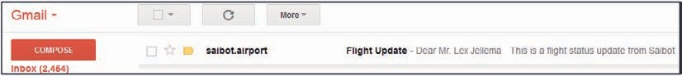

**FIGURE 6-5.** *Email sent by the FlightUpdateNotificationService*

##### Test the Email Sending Capability of the FlightUpdateNotificationService

After deploying the *FlightUpdateNotificationService* composite and configuring the email driver, now is the time to try out how a flight status update is turned into a notification sent to the indicated email address.

Send a request message to the *FlightUpdateNotificationService*, see whether it processes successfully and then wait for an email to arrive, like the one shown in Figure 6-5.

#### Add Flight Updates through Instant Messaging

Not all interested parties prefer email as their (only) notification channel. Therefore, we will extend the *FlightUpdateNotificationService* with support for the IM channel that uses chat conversations to push messages. IM is also supported by the UMS adapter. That means that to support this channel, we can make use of a second outbound UMS adapter binding. The service interface of the SOA composite does not change. However, the mediator has to be extended to also cater for both the new channel as well as the message format expected by the new UMS adapter binding.

##### Configure the UMS Driver for Instant Messaging

In much the same way as we have configured the UMS driver for email, we also should configure the driver for instance messaging. To use the XMPP driver in UMS, you must have access to a Jabber/ XMPP server and an XMPP account for the UMS XMPP driver instance with which to log in. All instant messages sent from any SOA composite in the SOA Suite are going to be sent from a single UMS driver configuration. We need to specify an XMPP server and port as well as the username and password on that server. Note: You may enter a complete Jabber ID if its domain name is different from the Jabber/XMPP server hostname (e.g., saibotInfoDesk or saibotInfoDesk@jabber.lexville).

See the book’s website for instructions on how to configure the UMS XMPP driver—including suggestions for how to create chat accounts on XMPP servers and which client tools to use.

##### Add an Outbound UMS Adapter Binding for Chat

Open the SOA composite editor. Drag the UMS adapter once more to the external references swim lane. Set the name to *ChatClient*. Press Next. Accept the default JNDI name. Press Next. Accept the defaults for Operation Type and Operation Name. Press Next. On the tab for Outbound Notification Details (Figure 6-6), set the Type of Notification to Instant Message (IM). Only one property can be set now: the To property that specifies the IM endpoint to which the message is to be sent. We will set this destination at run time. Therefore, it is best to provide a dummy value. Then press Next. Specify that the message is a string, press Next and press Finish.

##### Configure Content-Based Routing in the MachineToHumanMediator

Some of the request messages handled by the mediator will have to be routed to the new ChatClient, because they are destined for the *IM* channel. Therefore, wire the mediator to the ChatClient UMS adapter binding.

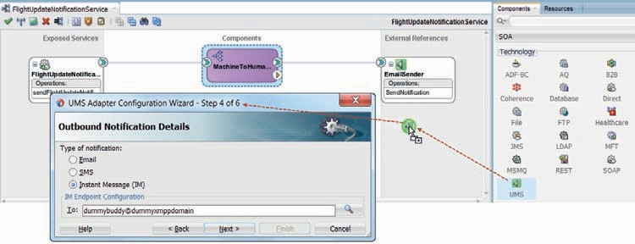

**FIGURE 6-6.** *Configuration of the outbound UMS adapter for instance messaging*

Open the mediator editor. There are now two routing rules that both process all messages and passes them to their respective UMS binding. That is not what we desire: all messages that have the *email* channel set in the request message should go to the *EmailSender*—but the routing rule for the *EmailSender* should not process messages with their channel set to *IM*. Likewise, the routing rule for the *ChatClient* should ignore the requests that contain Email as the channel. This conditional processing based on the content of the request messages is called *content-based routing*. In the mediator component, this is implemented using filter conditions that determine whether or not a message should be processed by a routing rule.

Click on the *filter* icon in the routing rule to the *EmailSender*. Set the filter expression to

 $in.in/tns:sendFlightUpdateNotificationRequestMessage/ tns:CommunicationMetadata/tns:Channel='email'

Do the same thing for the routing rule for the ChatClient. Replace the string *email* with *IM* in this case (Figure 6-7).

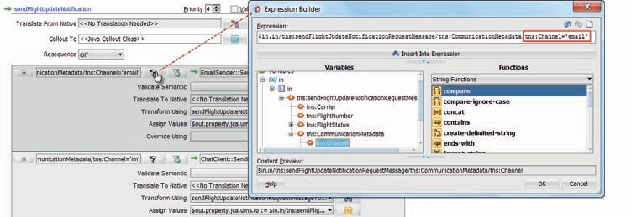

**FIGURE 6-7.** *Configuring the filter expression for content-based routing to the ChatClient*

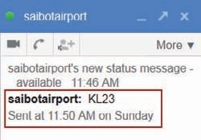

**FIGURE 6-8.** *Reception of the chat message from the FlightUpdateNotificationService*

The routing rule for the chat client has to be refined in two additional ways to have the required values set at run time:

* + The jca.ums.to property has to be assigned a value, based on the *ToAddress* element in the request message (just like we did for the email routing rule)
  + A transformation should be configured that turns the request message with the flight status into a proper chat message

Once these alterations have been applied, the SOA composite is ready for deployment.

##### Deploy and Test Flight Status Updates via the Chat Channel

Deploy the SOA composite. Subsequently, invoke the *FlightUpdateNotificationService* with a request message that specifies *IM* as the Channel. Verify that content-based routing did indeed kick in and routed the message to the *ChatClient* (and not to the *EmailSender*).

Also check if a chat message is indeed received at the destination address, containing the expected information about the flight status—similar to Figure 6-8.

Also invoke the *FlightUpdateNotificationService* with a request message that specifies *email* as the Channel. Verify that content-based routing did indeed kick in and route the message to the *EmailSender* this time and ignored the routing rule for the ChatClient. Check what happens if you set Channel to an unknown value, such as *bloemkool*.

### Feeding the Financial Queue through JMS

Saibot Airport charges airlines for the use of the airport and its facilities. The fees charged are based on several factors, including date and time of day, weight of the aircraft—Maximum Take- off Mass of the aircraft (MTOM)—as well as its noisiness, number of passengers, origin or destination, and the airline involved. The financial department will process all reports of landings and take-offs and prepare invoices for the airlines accordingly. This department operates rather independently of other divisions at Saibot Airport, and at its own pace. For its technical implementation it has a backend system that will read accounts of aircraft movements from a JMS Queue. Since it involves a fire-and-forget process it won’t return a response.

We will create a Service Bus project that puts the aircraft movements on the financial queue. A proxy service is exposed by this project that consumers can invoke to report landing and taking- off of aircrafts, with the required details. The composite will convey these messages in the appropriate text-based format to the JMS queue.

The Service Bus has two ways of interacting with JMS destinations. One is through the JMS transport and one uses the JCA adapter for JMS (that is also available for SOA composites). Both methods support outbound as well as inbound interactions. They also both implement request/ response message exchange over JMS that allows them to do synch-to-asynch bridging and expose a synchronous interface on top of a JMS-based business service.

The functionality of these two options is similar but not entirely the same. The Oracle product team indicates that the JMS transport is the preferred option whenever its functionality suffices for the task at hand. That is the reason this option is part of the *Technology* category in the component palette, rather than the *Advanced* category. The underlying explanation lies in the history of the two major components in the SOA Suite (Service Bus and SCA engine) that were independently developed—Service Bus originated at BEA Systems—and have been converging ever since Oracle acquired BEA.

For educational purposes, we will use both approaches in the *AircraftMovementsService* Service Bus project—one with the JMS transport and one with the JCA adapter for JMS. Instead of a Service Bus project, we could use an SOA composite with a mediator component to provide the same functionality. Which implementation to choose is largely a matter of taste, as laid down in the guidelines an organization has adopted.

#### Introducing JMS

JMS (Java Message Service) is a Java EE standard (JSR-194) that describes an API for interacting with a messaging infrastructure. Many open source projects and commercial vendors offer messaging technologies—such as Apache ActiveMQ, SonicMQ, WebLogic JMS, WebSphere MQ (aka MQSeries) from IBM, Oracle AQ, or EMS from Tibco—that can be accessed via JMS, either directly or through adapters. Java EE Application Servers also contain messaging frameworks that publish a JMS API—including JBoss Messaging, Glassfish Sun Java System Message Queue, and Oracle Enterprise Messaging Services (based on WebLogic JMS or Advanced Queuing).

Messaging according to JMS comprises two main models:

* Publish a message to a *queue* and have it consumed by one and only consumer.
* Publish a message to a *topic* from where it can be consumed by potentially many consumers.

This fundamental model is embellished and refined in many ways, including topics that persist messages until all registered consumers have consumed it—even when they were unavailable at the time of publication, various retry patterns for delivering messages, high availability and performance features, transactional support, etc.

##### JMS and SOA Suite

The SOA Suite supports interactions from and to JMS destination in various ways, both in Service Bus projects and in SOA composites. For Service Bus we can use the special JMS transport to configure a business to send messages to JMS or a proxy service to receive inbound messages over JMS. Both Service Bus and SOA composites use the JCA adapter for JMS for both outbound and inbound interactions. Note that behind the scenes, the Service Bus and SOA Suite also use JMS on various levels and for multiple functions in their internal infrastructure. One example of this is the Event Delivery Network (EDN) that we will discuss in Chapter 15.

#### Setup the JMS Destination for AircraftMovement Reports in WebLogic

JMS destinations, queues and topics, are created at WebLogic level—for example, through the WLS Admin Console. These are not specific to SOA Suite but can be used by all components and applications running on WebLogic. For the next sections on creating SOA Suite projects that interact with JMS for publishing messages, it is assumed that you follow the detailed instructions that are published on line, resulting in a JMS queue with a JNDI name of jms/finance/ AircraftMovementsQueue in the SOAJMSModule and a Connection Factory called jms/finance/ FinanceConnectionFactory in that same JMS Module. Note: In real life you should be creating your own JMS Module instead of using the SOAJMSModule that SOA Suite uses itself; the online instructions describe this as well.

#### Implementation of the AircraftMovementService with the JMS Transport

The JMS queue that was set up in the previous section provides a buffer between the operational division of Saibot Airport and the financial department. Messages are put on the queue, entrusted to the platform infrastructure. The operations side of things can continue with their responsibilities and in due time and in their own way, the financial systems will take care of those messages.

Decoupling in optima forma. Whenever systems inside an enterprise require interaction that can be asynchronous (either fire and forget or callback in your own time), this type of JMS based- communication is a good option, especially when the availability or processing speeds differ between the systems involved.

We will create a Service Bus project that implements the *AircraftMovementService*. This is a regular SOAP Web Service with a single one-way operation that is invoked with a SOAP/XML message that contains details about the landing or take-off of an aircraft. The Service Bus project ensures that this message ends up on the JMS queue.

##### Prepare the Application and Project

From the New gallery, create a new Service Bus application with a Service Bus project. Call both

*AircraftMovementService*.

Import Service Bus Resources from the file aircraftMovementServiceStartpoint.jar. This will create the folders WSDLs and Schemas with the interface definition of the *AircraftMovementService*.

##### Create the Business Service with JMS Transport

The essential aspect of this project is the business service that uses the JMS transport to connect to the world of JMS. Open the overview editor for the *AircraftMovementService*.

Drag the JMS Transport component from Technology category on the component palette to the External References lane, as shown in Figure 6-9. When you drop it, the business service wizard appears. Set the name of the business service to *FinanceAircraftMovementsReporter*. The transport is already set to jms.

Click Next.

Set the Service Type to Messaging. For the Request, select Text as the Messaging type. Set it to None for the Response, as we are implementing a one-way service where we expect no response. In an asynchronous JMS request/response scenario setting the response is necessary, in order to define the JMS message being returned and correlated to the request message.

Press Next.

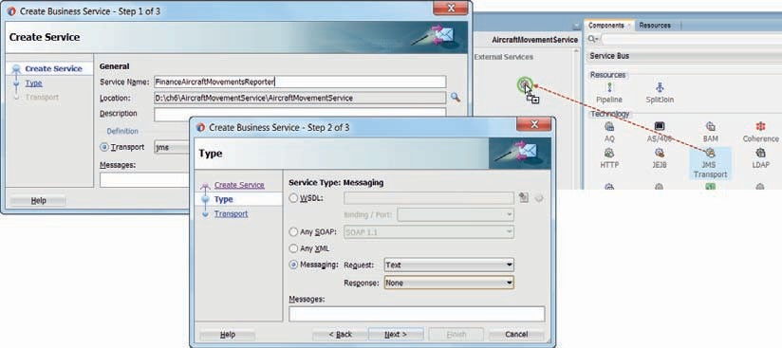

**FIGURE 6-9.** *Drag the JMS Transport to the External References area in the Service Bus project*

The Endpoint URI for the JMS destination that this transport will interact with has to be set on the third page (Figure 6-10). The format of this URI is: jms://host:port/<JNDI name of Connection Factory>/<JNDI name of the destination queue>. Note that in the JNDI names, the slashes have to be replaced with periods. You have created this destination according to the online instructions. The Endpoint URI in this case should therefore probably be set to: jms://localhost:7101/jms

.finance.FinanceConnectionFactory/jms.finance.AircraftMovementsQueue.

Press Finish.

The business service is created and added in the project overview.

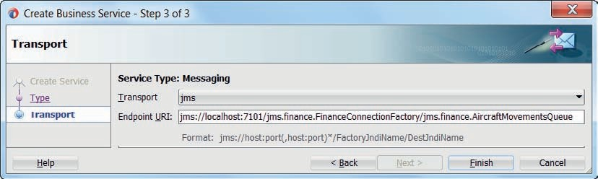

**FIGURE 6-10.** *Set the JMS Endpoint URI for the outbound JMS transport*

##### Test the Business Service

Run the business service from its context menu. The Service Bus composite is deployed and the familiar test interface displays. You can enter the contents of the message to be published to the JMS destination. The message is of type text with no further constraints—so you type anything you like. Press Execute. There is no response message—obviously, because this is a one-way operation. There is, however, some response metadata and a response code with value 0 if the interaction was successful or a fault if it was not.

To find out if indeed the message was published to the *AircraftMovementsQueue*, we can do several things. We can run a Java Client to retrieve messages from the queue, we can use a convenient tool like QBrowser, Hermes, or JMSBrowser to inspect the contents of the queue or we can simply inspect the queue in the WebLogic Console.

Open the console. In the Domain Structure window, select Services | Messaging | JMS Modules. In the list of JMS Modules, click on *SOAJMSModule*. In the Summary of resources, locate queue jms/finance/AircraftMovementsQueue. Click on it. Then open the Monitoring tab. This tab presents an overview with all messages that are currently on the queue and have been published to the queue in the past. Whenever you re-execute the business service from the tester in JDeveloper and subsequently refresh this monitoring tab, the messages total listed should increase by one. You can also drill down and inspect the metadata of individual messages as well as their contents.

##### Proxy Service and Pipeline

Completing the Service Bus composite is pretty straightforward now, because it is not really different from creating a proxy service and pipeline for any other type of Business Service. The fact that this business service communicates to a JMS destination is not relevant to either pipeline or proxy service.

The WSDL document AircraftMovementService.wsdl was imported during the initial preparation of the project, along with the referenced XSD-documents, and are now in the appropriate folders (WSDLs and Schemas). Generate a proxy service *AircraftMovementServicePS* from the WSDL and an associated pipeline *AircraftMovementPipeline*. Set the Endpoint URI for the proxy service to

/monitor/AircraftMovementService.

Wire the pipeline to the business service *FinanceAircraftMovementsReporter* (see Figure 6-11).

You can easily test the proxy service, by running it from the context menu. The composite is again redeployed and the service tester opens with a sample XML message. Because the contents of the request message will simply end up on the JMS queue, you can press execute to invoke the AircraftMovementService with the sample message.

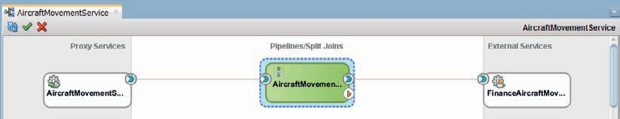

**FIGURE 6-11.** *Wiring the AircraftMovementPipeline to the FinanceAircraftMovementReporter*

*business service*

The meta response code should be 0—to indicate a successful transfer of the request message to the one-way service. Check the contents of the queue to verify whether the message was delivered; this can be done through the Admin Console for the Integrated WLS (http:// localhost:7101/console) or through external tools such as QBrowser.

#### Alternative Implementation Using the JCA JMS Adapter

SOA Suite ships with a JCA adapter for JMS that can be used with both Service Bus and SOA composites. In Service Bus projects, the JMS transport is the preferred choice for JMS interaction, although the differences with using the JCA adapter are fairly small. When the requirement is to synchronously read (rather than poll) a message from a JMS queue, the outbound JCA adapter is the only option available.

The next sections describe how to use the JCA adapter for JMS with a Service Bus project— to perform the same operation that we previously used the JMS transport for.

To use the JCA JMS adapter, we have to configure the JMS adapter deployment in the WebLogic Server that also runs the SOA Suite. Subsequently, a JMS adapter binding is added to the Service Bus project. This binding is configured with the JMS destination it should target and the JMS adapter connection it should leverage.

##### Configure the JMS Adapter Connection

Just as with the Database Adapter and other JCA adapters, some generic, cross-service configuration of the adapter is done on the adapter deployment in the target WebLogic Server. A connection is created in that deployment—that forms the link between the usage of the JMS adapter in the service implementation and a specific JMS connection factory that is to be used by the JMS adapter.

In the WLS Admin console, show the list of deployments. Locate the JmsAdapter. Click on it.

This brings up a pane titled *Settings for JmsAdapter*. Open the Configuration tab. Click on the New button to create a new outbound connection. This is a prescription for the JMS adapter to connect to a JMS Connection Factory from which it can gain access to Queues and Topics.

A two-step wizard starts for creating the connection. Accept the default (and only) option in the first step. Set the JNDI name to eis/Finance/Queue in the second step, as shown in Figure 6-12.

Then press Finish.

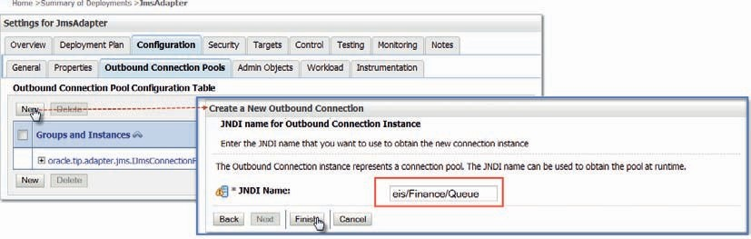

**FIGURE 6-12.** *Configure a new outbound connection for the JMS adapter*

The list of all connections appears. Click on the newly created connection eis/Finance/Queue to configure its reference to a JMS Connection Factory (Figure 6-13). A list with Outbound Connection Properties appears. Click on the property value for the *ConnectionFactoryLocation*.

Enter the value jms/finance/FinanceConnectionFactory. Press enter to set the value. Then click on the Save button to commit it.

At this point, even though the changes have been activated, the JmsAdapter still needs to be redeployed in order for the changes to become effective.

Go to the Deployments summary, mark the checkbox for the JmsAdapter, and click on the Update button above the table. On the Update Application Assistant page, select “Redeploy this application using the following deployment files” and press Finish. After a few seconds, you will get a message that the selected deployment was updated. At this point, the new JMS Adapter connection can be used.

##### Configure the Outbound JMS Adapter Binding

Drag the JCA JMS adapter from the Advanced category to the External References lane. When you drop it, the adapter configuration wizard appears, to configure the JMS adapter binding. Detailed instructions in the online chapter complement.

On the first page, set the name of the Reference to *FinanceAircraftMovementsReporterJCA*. Set the Service Directory to the Adapters folder. Click Next.

Select the Oracle Enterprise Messaging Service JMS provider and specify the Oracle WebLogic JMS option on page two. Press Next.

On the third page, select the AppServer connection to the Integrated WLS. This connection is used to browse for the JMS adapter connection and the JMS queue. Press Next. Select *Import an existing WSDL* and select the AircraftMovementService.wsdl as the source.

On the Operation page, set the Operation Type to Produce Message. The name of the operation is derived from the WSDL and is set to *reportAircraftMovement*.

The next page of the wizard (Figure 6-14) is titled Produce Operation Parameters. Set the Destination Name to the JNDI name of the JMS queue the adapter binding should publish messages to: jms/finance/AircraftMovementsQueue. Accept the defaults for Message Body Type (JMS_PP_TEXT_TYPE) and Delivery Mode (Persistent). Set the TimeToLive to 15 seconds.

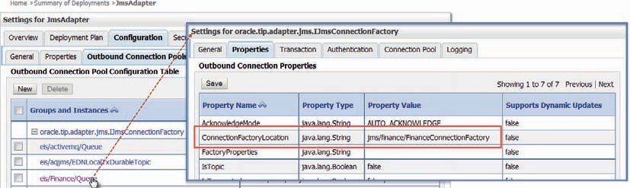

**FIGURE 6-13.** *JMS adapter connection properties—set the value for the*

*ConnectionFactoryLocation property*

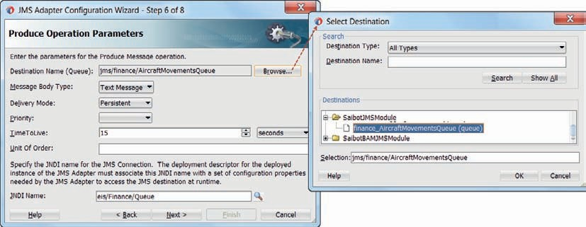

**FIGURE 6-14.** *Configure the outbound JMS adapter binding*

The JNDI Name [of the JMS adapter connection] should be set to eis/Finance/Queue—the name specified for the new connection that was configured for the JMS adapter.

Press Next. In the next page, if we have not yet defined the Adapter Interface, we can specify the format of the messages that the JMS adapter should pass onward to the JMS queue. Checking the checkbox *Native format translation is not required (Schema is Opaque)* is used when a base64 payload should be passed. Alternatively, we can specify a native XSD definition for whatever format the JMS message payload should have. In this case, the WSDL specifies the *reportAircraftMovementRequestMessage* and this page in the wizard is disabled.

Press Next, then press Finish to complete the configuration of the outbound JMS adapter binding.

JDeveloper will create a business service with JCA transport that references the JMS adapter binding configuration file FinanceAircraftMovementsReporterJCA.jca. You can test this business service—by activating the run option in the context menu on the business service in the Service Bus composite overview.

###### NOTE

*There is no reason for first creating the JMS adapter connection and only then configuring the JMS adapter binding in the composite. The reference to the JNDI Name* eis/Finance/Queue *is only validated during deployment of the composite and used at run time. However, when you run the business service from within the IDE, the JMS adapter connection has to be in place in the target WebLogic Server.*

When you use separate managed servers for Service Bus and SCA engine, the JMS adapter invoked from Service Bus will run on the managed server for OSB where it will not find the JMS Module SOAJMSModule and therefore will also not be able to locate the jms/finance/ AircraftMovementsQueue. In this case, you need to define your own JMS Module, add the *AircraftMovementsQueue* to it and target this JMS Module to the managed server running Service Bus. Details are explained in the online instructions.

##### Redirect the Routing

The new business service for the JCA adapter is not yet used in the Service Bus composite. Open the pipeline editor and click on the routing activity (Figure 6-15). Browse for the *FinanceAircraftMovementsReporterJCA* business service as the new target for this activity. The reportAircraftMovement operation should be selected as the one to invoke.

Check the new wiring in the project overview (right side in Figure 6-15).

##### Run the Service

Run the proxy service, provide the details for an aircraft movement, and submit the request. No response is returned. In fact, you will not notice any difference in calling the proxy from when the JMS transport was used.

Verify the contents of the JMS queue to see whether a message was indeed published.

##### Comparing JMS Transport and JCA Adapter for JMS

The configuration details for the JMS transport is stored entirely in the business service. This means they are part of the service implementation and deployed along with it. With the JMS JCA adapter, similar settings are specified. Some of these are part of the JMS adapter binding—that is part of the implementation that gets deployed. Other properties are set on the connection that is configured on the JMS adapter (deployment) on the WebLogic server; these properties are set and managed outside of JDeveloper and the deployable unit. The connection can be reused across multiple JMS adapter bindings.

##### Alternative Implementation Using an SOA Composite

The JCA adapter for JMS is also available with SOA composites, but the JMS Transport is not. Creating an SOA composite that is functionally equivalent to the *AircraftMovementService* Service Bus project turns out very simple indeed, using the exact same JCA adapter configuration. The steps for this (details and step-by-step screenshots) are provided in the online chapter resources.

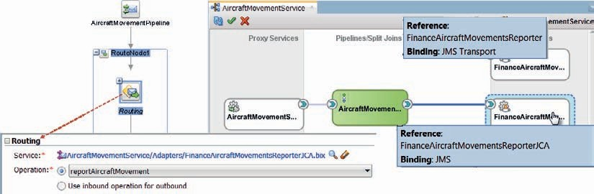

**FIGURE 6-15.** *Configure the routing node in the pipeline to route messages to the outbound*

*JMS business service; The pipeline is wired now to the new business service (based on the JMS adapter); the original business service (based on the JMS Transport) is currently not used*





|  |  |  |  |  |  |  |  |
| --- | --- | --- | --- | --- | --- | --- | --- |
| **Asynchronous Processing or the Mini-Batch**  Asynchronous processing of a request is a good way of decoupling (almost releasing) the consumer from the actual processing performed by a service. If the service is not going to respond—not with a result message nor with a fault—there is really not a good reason for a service to be implemented synchronously and have the consumer wait for the processing to complete. Instead, each service request will trigger a mini-batch to be started in the background. The work is ideally started pretty much instantaneously—in most cases, but on a separate thread—so as to not block the invoker.  However, one thing consumers should be able to rely on, is a promise that their message is not only received but is also securely stored and will be processed, if not immediately. The HTTP-200 acknowledgment only specifies reception by the Service Bus but does not give any guarantee about safe storage for subsequent processing.  In a common pattern for providing both asynchronous processing and a guarantee  of safe storage (illustrated in Figure 6-16), the service that receives the request message will start a transaction, send the message to a JMS (or AQ) queue, complete the transaction and send a response message. In this way, the service interface is not one-way: it is synchronous. The work done synchronously is minimal: perhaps validation of the request message, then securing the message by enqueuing it on a queue and sending a response message (typically with a unique tracking number that identifies the conversation) that signifies: your message was received and understood; we are now committed to processing it, at some later point in time. If this asynchronous message processing will result in a message to be sent to the original service consumer, the tracking number is used to refer to the original conversation. | | | | | | | |
|  | SB Proxy Web Service |  | JMS |  | SB  Proxy |  | Business services doing the work |
| **FIGURE 6-16.** *Synchronous operation for reliable, asynchronous processing*  At the back end, an inbound JMS (or AQ) adapter is used to listen to new messages on the queue that require processing. An incoming message triggers a service—Service Bus or SOA composite—that does the actual processing. When that background processing fails there is no easy way of informing the original service consumer and it usually falls to the service provider to handle the problem. | | | | | | | |

### Content-Based Routing in Service Bus Pipelines

Earlier in this chapter, we have seen how the Mediator component supports content-based routing—through filter expressions on routing rules that determine whether or not a routing is executed. In Service Bus pipelines too, we can implement conditional routing.

We have already seen operational branches that define a path based on the operation that was invoked on the pipeline’s interface. A similar construct, called conditional branch, can be configured with multiple branches, one of which is executed according to an XPath expression. Whichever condition is satisfied first determines which branch is executed. If none of the branch conditions is satisfied, then the default branch is performed. Routing Table is a similar activity where multiple routing options are configured, one of which is executed depending on the evaluation of an XPath expression.

The *dynamic routing* activity is another mechanism with which a form of content-based routing can be realized. The business service or pipeline to route the message to is determined using an XQuery expression—one that could for example read a routing table from an XML file or Domain Value Map.

We will use content-based routing in the *AircraftMovementPipeline* to easily switch between the JMS Transport and JCA JMS adapter as business service to route the *AircraftMovementReport* messages to. Then we will add an Advanced Queue Adapter to the mix.

###### NOTE

*This example of content-based routing is used for educational purposes. In real-life systems, it would make no sense at all to have this kind of conditional routing between three mechanisms that are basically the same. You would normally pick one and be done with it.*

**Switching between JMS Transport and JCA JMS Adapter Using Conditional Branching**

A conditional branch is introduced into our pipeline to implement content-based routing. Depending on the value set in a pipeline variable $channel, the conditional branch will either execute the branch that routes to the JMS Transport (business service) or the JCA JMA Adapter (business service). First we add the variable and its assignment, next we use the variable in the conditional branch.

Add a pipeline pair called SetChannel as the first node in the pipeline. Add an Assign activity.

Configure this activity to assign a value

 <ChannelValue>JMSTransport</ChannelValue>

to variable *channel*, as shown in Figure 6-17. Alternatively, the values JMSJCA and AQ can be assigned to the ChannelValue element in this expression.

By setting the value of variable $channel, we want to govern the routing of the request through the pipeline. The pipeline activity we use to implement that behavior is called Conditional Branch.

Drag the Conditional Branch from the component palette and drop it in the pipeline, right after the pipeline pair *SetChannel.* Set the Expression field to channel (to indicate that this expression operates in the context of that variable). Set the expression itself to ./text()—or

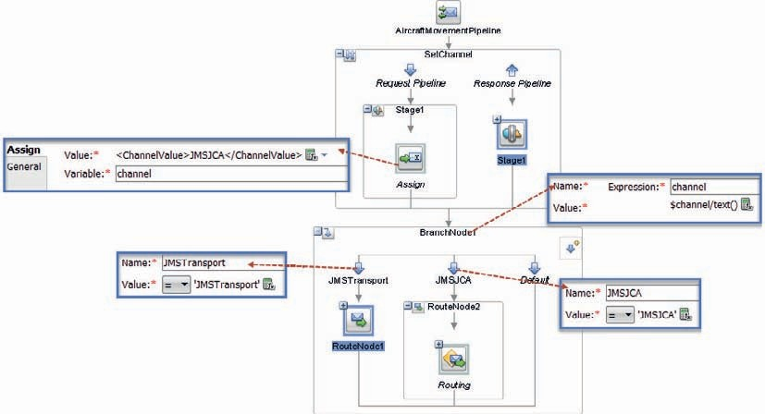

**FIGURE 6-17.** *Assign activity to set the $channel variable that governs the routing and configure*

*a conditional branch with branches for various conditions based on $channel*

$channel/text(). This instructs the conditional branch to derive the text value in the root element of the $channel variable. This evaluates to one of the values JMSTransport, JMSJCA, or AQ. Note: Conditional branching is driven by an XPath expression (not XQuery).

Add branches inside this activity that are labeled JMSTransport and JMSJCA. Configure them to trigger on the values “JMSTransport” and “JMSJCA,” respectively, by setting the operator to the equality operator and the XPath expression to the appropriate string value.

Add the Route node with Routing activity to the JMS JCA business service—including the Replace activity—to the JMSJCA branch, by simply dragging and dropping it. Add a route node with routing activity to the JMS Transport business service to the JMSTransport branch.

The Service Bus project overview will now display two wires from the pipeline to the business services.

You can test the implementation by running the pipeline and check in the trace whether the expected business service as engaged.

##### Conditional Pipelines

Instead of performing the necessary logic directly in the conditional branch—such as the transformation of the request message in the JMS JCA branch—we could instead create pipelines for each conditional branch and include the logic in the designated pipeline. The first pipeline would only hold the conditional branch and the logic for invoking the required pipeline, whereas the actual work for each condition is done in the condition-specific pipeline that ends with doing the routing to the associated business service. Note: The communication between local pipelines

is very efficient; there is no noticeable difference in performance overhead between the single pipeline and this multi-pipeline approach.

The result of that approach is shown in Figure 6-18.

###### NOTE

*Service Bus composites offer yet an alternative implementation of content-based routing, through the Dynamic Routing activity.*

*A dynamic routing activity determines at run time which business service to route a message to. A target can be both a business service or a pipeline, as well as a split-join or a proxy service.*

The dynamic routing activity is configured with an XQuery expression that has to produce the Business Service and Operation to invoke in the following format:

 <ctx:route>

<ctx:service>AircraftMovementService/Business Service/ FinanceAircraftMovementsReporter

</ctx:service>

<ctx:operation>report</ctx:operation>

</ctx:route>

The service element contains the fully qualified name of the business service, in the format

<project name>/<foldernames>/<name of business service [file without .bix extension]>.

Routing to a pipeline requires a similar XML snippet:

 <ctx:route>

<ctx:pipeline>Pipelines/AircraftMovementPipelineJMSTransport</ctx:pipeline>

</ctx:route>

With this dynamic routing to pipelines, instead of using a conditional branch we can use a dynamic routing action to determine which pipeline to invoke, assuming that for each condition we have a separate pipeline.

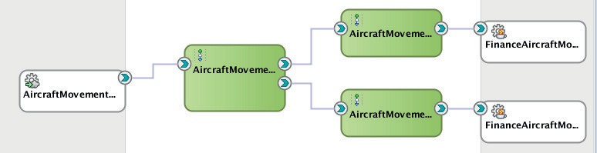

**FIGURE 6-18.** *First pipeline with the conditional branch, routing to condition specific pipelines*

*to handle the work*

### Using AQ instead of JMS

Advanced Queuing is the enterprise queuing mechanism in the Oracle Database. Its role and use cases are very similar to JMS—with one large difference: PL/SQL handlers can be associated directly with AQ queues, and not with middleware-based JMS destinations. If the messages queued are to be processed by stored procedures inside an Oracle Database, then publishing them to AQ could be preferred.

From the perspective of the SOA Suite, there is hardly any distinction between JMS and AQ as destinations. After setting up the AQ queue and backing table, we will configure the AQ adapter deployment on WebLogic—similar to how we did it for the Database Adapter and the JMS adapter. The outbound AQ adapter binding is configured in very much the same way as the JMS adapter binding was. We will modify the Service Bus composite created in the previous section by adding a new branch. Instead of JMS as destination, we will use AQ as the target for the *AircraftMovement* messages. And this requires very little work with very little impact.

###### NOTE

*JMS Queues in Web Logic can be backed by an Advanced Queue in the Oracle Database. Publishing messages to the JMS Queue then*

*indirectly means publishing them to the underlying Advanced Queue. PL/SQL handlers could pick up messages from that queue as well.*

**Configure Advanced Queue in Database**

We assume a user SAIBOT_FINANCE has been set up in the database. As a DBA (e.g., as user SYS), grant the aq_administrator_role to user saibot_finance. Also execute this statement:

 EXECUTE dbms_aqadm.grant_type_access('saibot_finance');

These next statements are to be executed by the user SAIBOT_FINANCE in order to create the type that defines the payload for messages on the queue, and also create the queue and the queue table and subsequently start the queue.

 CREATE TYPE aircraft_movement_report_t AS OBJECT ( message_id NUMBER(15)

, movement_timestamp timestamp

, flightnumber number(3)

, carrier_iata_code varchar2(3)

, airport_iata_code varchar2(3)

, arrival_or_departure varchar2(1)

, aircraft_iata_equipment_code varchar2(3)

, number_of_passengers number(4,0)

);

BEGIN

DBMS_AQADM.CREATE_QUEUE_TABLE (

queue_table => 'saibot_finance.aircraft_movements_qt'

, queue_payload_type => 'saibot_finance.aircraft_movement_report_t'

); DBMS_AQADM.CREATE_QUEUE (

queue_name => 'aircraft_movements_queue'

, queue_table => 'saibot_finance.aircraft_movements_qt'

, queue_type => DBMS_AQADM.NORMAL_QUEUE

, max_retries => 0

, retry_delay => 0

, retention_time => 1209600

, dependency_tracking => FALSE

, comment => 'Aircraft Movement Reports Queue'

, auto_commit => FALSE

);

DBMS_AQADM.START_QUEUE('aircraft_movements_queue');

END;

At this point the AQ queue *aircraft_movements_queue* has been created and started. It accepts messages with a payload of type *aircraft_movement_report_t*. The queue is backed by a queue table called *aircraft_movements_qt*.

#### Configure AQ Adapter Connection in WebLogic Server

First create a JDBC Data Source connecting to the database schema that either owns the queue or has at least a usage grant on the queue. Set the JNDI name for this Data Source to jdbc/ SaibotFinanceDS.

Then find the AQ adapter deployment in the summary of deployments. Click on this deployment to go to the Settings. Open the Configuration tab and within that the Outbound Connections Pool. Click on the New button, to create a new connection.

Another two step wizard, in which you accept the default and only Outbound Connection Group on the first page and set the JNDI name for this new connection on the second page. This name will be referenced from the outbound Adapter binding in the service implementation. Set the name to eis/aq/SaibotFinance.

Press Finish to complete the creation of the connection. Next, return to the *Properties* tab for the connection. The DataSourceName or XADataSourceName (depending on how you created the data source—XADataSource if you accepted the default driver) property has to be set with the JNDI name of the data source: jdbc/SaibotFinanceDS.

Press enter and press the Save button. Now to ensure the new AQ adapter connection is available for use, update the AqAdapter deployment. See for more details and screenshots for all steps described here the online chapter complement.

#### Configure AQ Adapter Binding

The JCA AQ adapter too can be used in both Service Bus projects and SOA composite applications. We will add it to the *AircraftMovementService* project that contains the Service Bus artifacts. The configuration of the adapter binding is exactly the same in the context of an SOA composite.

Open the overview editor for the *AircraftMovementService*. Drag the AQ adapter to the External References lane and drop it (see Figure 6-19).

The AQ adapter configuration wizard appears. Set the name of the reference to

*FinanceAircraftMovementReporterAQ*. Click Next.

Select or create a database connection to the SAIBOT_FINANCE database schema that contains the queue to publish to. Set the JNDI name [of the AQ adapter connection] to eis/aq/ SaibotFinance. Click Next.

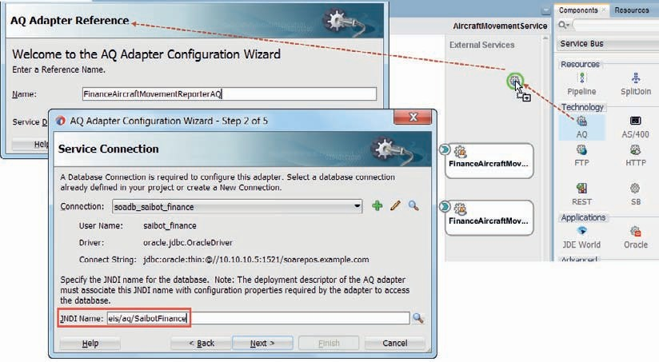

**FIGURE 6-19.** *Add the outbound AQ adapter to the Service Bus project*

*AircraftMovementService*

Click Next again on the Adapter Interface page: we will define the interface from the operation and schema (specified later).

Set the Operation Type to *Enqueue*. Set the name of the operation to *Report*. Click Next. Browse for the AIRCRAFT_MOVEMENTS_QUEUE in the SAIBOT_FINANCE database schema,

as shown in Figure 6-20. Messages will be enqueued by the newly created AQ adapter binding to this queue.

Press Next.

Do not specify a correlation id, because the enqueue operation we configure for this adapter binding is not in response to previously dequeued message that it should be correlated with.

Press Next.

The payload type for the queue is set in the database to AIRCRAFT_MOVEMENT_REPORT_T. The AQ adapter can either publish a message with a payload based on that entire object or one that contains but a single field in that object. In this case, select the *Whole Object* option. Press Next. And press Finish.

The AQ adapter binding is generated—both the JCA configuration and the business service that leverages it. The interface of the business service is described by the WSDL and XSD files that were generated by the AQ adapter wizard.

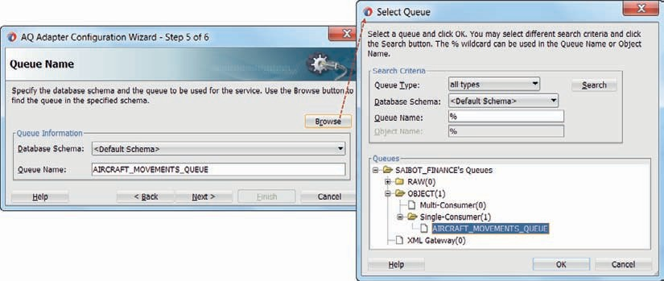

**FIGURE 6-20.** *Configuring the AIRCRAFT_MOVEMENTS_QUEUE to publish messages onto*

#### Add the AQ Path to the Conditional Branch in the AircraftMovementPipeline

Open the *AircraftMovementPipeline*. Add a new branch to the Conditional Branch node. Set the label of the new branch to AQ. Set the operator to “=” and the expression to “AQ,” as visualized in Figure 6-21.

Add a Route node with a Routing activity inside. Configure the routing activity for the *FinanceAircraftMovementReporterAQ* business service because we want the pipeline to route messages to this business service for the AQ adapter and have it publish the reports on the Advanced Queue instead of the JMS Queue.

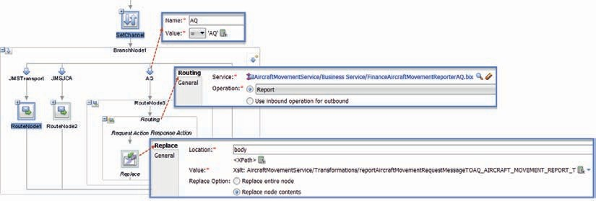

**FIGURE 6-21.** *Configuring the branch for the AQ channel*

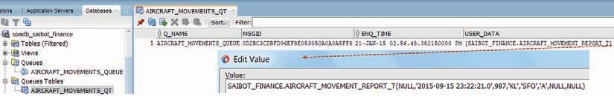

**FIGURE 6-22.** *Verifying the contents of the AIRCRAFT_MOVEMENTS_QUEUE in the JDeveloper*

*Database Navigator*

Additionally, we need a slightly different transformation of the message, because of the different schema required by the AQ adapter binding. Create the transformation and use it in a Replace activity in the request action of the routing node, to prepare the request message for the AQ adapter.

#### Run and Test

Change the assign activity in the SetChannel step—assign a value of AQ to the ChannelValue element in the $channel variable. This ensures that when we next deploy and run the service, our message is routed through the AQ branch of the conditional branch and hence to the AQ adapter binding.

Now run the pipeline or the service and send a message with an *AircraftMovementReport*.

At this point, there should be a new message on the AQ Queue in the Saibot Finance database. We can verify this in several ways, including the Database Navigator view in JDeveloper (as shown in Figure 6-22) and a simple SQL statement performed against the Saibot Finance database schema (select * from AIRCRAFT_MOVEMENTS_QT).

### Invoking an Enterprise Java Bean (EJB)

In this section, we will assume that the financial department considers publishing an EJB as the interface to send reports of aircraft movements to—possibly because it allows them to perform some validations on the reports sent in before actually accepting them. Apparently they receive too many incorrect messages to their liking on the queue and want to do more upfront— synchronous—checking. The method on the EJB has a similar role as the queue has: accept an object that describes an aircraft movement, validate it, and pass it onward for further processing.

The interaction from the SOA Suite with the EJB in this case will be synchronous, because the finance department will raise an exception when the input to the EJB does not pass the validation checks. The *AircraftMovementService* that calls out to the EJB will itself remain one way. That means that in real life exception handling would have to be implemented in the SOA Suite composite or Service Bus pipeline.

Invoking an EJB—whether it is local or remote—is one of several ways for Service Bus and SOA composites to access external Java-based code. EJBs can be SDO (Service Data Objects) enabled, or can be defined through a (remote) Java interface. The former means that the EJBs adhere to the SDO standard and the SOA composite transfers SDO parameters to the EJB in order to operate on business data. One easy way of creating such SDO powered EJBs is using ADF Business Components.

###### NOTE

*Interaction through EJBs is much more tightly coupled of course than JMS-based interaction, although the EJB to be invoked can be designated asynchronous.*

**Prepare the Financial Enterprise Java Bean to Invoke**

To set the stage, we will first create a rather simple EJB that we deploy as a stand-alone Java EE application. This EJB represents the service published by the financial department as an experimental alternative to the decoupled communication based on JMS queues.

The steps are straightforward: create a new project, develop the interface to be published, configure the EJB—such as its mapped name—and implement the EJB according to that interface. Finally, deploy the application.

##### Implementing the Financial EJB

Create a new JDeveloper project of type EJB project under the *AircraftMovementService* application. The name of the project is *FinanceAicraftMovementEJB*. The default package is saibot.airport.finance.

Accept the defaults on the third page of the EJB project wizard, indicating that EJB 3.1 is the release we are working with and annotations are the preferred way of configuring the EJBs.

Create a Java bean called *AircraftMovement*, with a toString() implementation, that implements the Serializable interface.

 public class AircraftMovement implements Serializable { @Override

public String toString() {

return "Aircraft Movement: at "+movementTimestamp+" for flight "+ carrierIataCode;

}

Date movementTimestamp ; Integer flightnumber ; String carrierIataCode ; String airportIataCode ; String arrivalOrDeparture ;

String aircraftIataEquipmentCode ; Integer numberOfPassengers ;

…

// accessor methods for these properties

}

Add fields and accessors for the bean properties.

Create a Java interface *FinanceAircraftMovementReporter* and add the @Remote annotation.

This will be the remote interface exposed by the EJB as stateless session bean.

 package saibot.airport.finance; import javax.ejb.Remote; @Remote

public interface FinanceAircraftMovementReporter {

public void reportAircraftMovement( AircraftMovement aircraftMovement);

}

Implement class FinanceAircraftMovementReporterBean that implements the FinanceAircraftMovementReporter interface. Implement method reportAircraftMovement: make it write some text to the output in order to show proof that the bean has been accessed:

 package saibot.airport.finance; import javax.annotation.Resource; import javax.ejb.SessionContext; import javax.ejb.Stateless;

@Stateless(name = "FinanceAircraftMovementReporterEJB", mappedName = "FinanceAircraftMovementReporter")

public class FinanceAircraftMovementReporterBean implements FinanceAircraftMovementReporter

{

@Resource

SessionContext sessionContext;

public FinanceAircraftMovementReporterBean() {

}

@Override

public void reportAircraftMovement(AircraftMovement aircraftMovement) { System.out.println("AircraftMovement has been reported "+

aircraftMovement);

}

}

##### Deploy and Test the EJB

Deploy the project, using the EJB deployment profile that was added when the project was first created as an EJB project.

Generate a sample client using the option New Sample Java Client on the context menu for the *FinanceAircraftMovementReporterBean*. A Java class is generated with the necessary statements to lookup the EJB. Add some code to actually invoke the method *reportAircraftMovement* of the EJB, for example:

…

final Context context = getInitialContext(); FinanceAircraftMovementReporter financeAircraftMovementReporter =

(FinanceAircraftMovementReporter) context.lookup("FinanceAircra ftMovementReporter#saibot.airport.finance.FinanceAircraftMovementReporter");

**AircraftMovement am = new AircraftMovement(); am.setMovementTimestamp(new Date()); am.setCarrierIataCode("KLM"); financeAircraftMovementReporter.reportAircraftMovement(am);**

…

Run the sample Java client just locally, in JDeveloper, and see if the expected line is written by the EJB to the console, by inspecting the logging of the running Integrated WLS. Note: You may have to add the library WebLogic 12.1 Remote Client to the project.

If a log entry was indeed written, the EJB is active at the mapped name used in the sample client code.

#### Calling Out to EJBs from Service Bus Composites

Callouts from a Service Bus composite are typically handled through a business service. The business service can leverage an adapter or a transport (preferred). And for callouts to EJBs, we even have two transports at our disposal. One is the JEJB transport and the other is the EJB transport. Both interact over RMI in terms of (serialized) Java objects with the remote EJB.

The JEJB transport interacts internally in terms of Java objects. That means that a pipeline that calls a JEJB business service has to pass a Java POJO payload. This is useful when the proxy service exposed by the composite and wired to the pipeline is also based on the JEJB transport— the message is never turned to XML and can stay a Java object all the way. We will discuss the JEJB transport in a later section, when we talk about an inbound EJB interface for a Service Bus composite. For now, we will use a business service based on the EJB transport.

##### Business Service with EJB Transport

Drag the EJB transport to the outbound references swim lane and drop it. The configuration wizard appears. Set the name of the business service to *FinanceAircraftMovementsReporterEJBTransport*.

On page two of the wizard, specify the Endpoint URI for the Enterprise Java Bean that is to be invoked, as shown in Figure 6-23. This URI pattern in the case of a locally deployed EJB (local means that the EJB is running on the same WLS domain as the SOA Suite run time) follows a pattern of: ejb::jndi_name. For remote beans, this pattern is ejb:jndi_provider:jndi_name. We will discuss this in a later section.

For EJB 3.x beans on Oracle WebLogic Server, jndi_name takes the form of mappedName#BusinessInterface. Therefore, in this current case, the Endpoint URI should be set to the local format: ejb::FinanceAircraftMovementReporter#saibot.airport.finance

.FinanceAircraftMovementReporter

Complete the wizard. Then double click the newly created business service and go to the Transport Details tab (Figure 6-24).

Select the checkbox for EJB 3.0. Click on the browse icon for the Client jar. Browse for the jar file AircraftMovementService_FinanceAircraftMovementEJB_ejb.jar that was generated in the deploy directory of FinanceAircraftMovementEJB project when that project was deployed.

The Import Service Bus Resources wizard appears. Import this jar file into the Resource folder of the project.

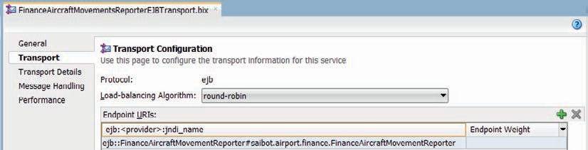

**FIGURE 6-23.** *Configuration of the outbound EJB transport to the*

*FinanceAircraftMovementReporterBean*

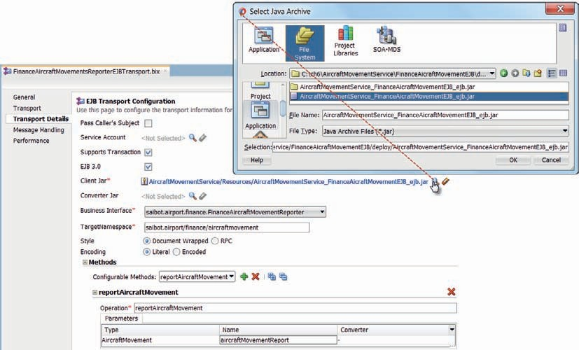

**FIGURE 6-24.** *Transport details for the EJB transport of the Business Service*

Set the Business Interface to the remote EJB interface saibot.airport.finance

.FinanceAircraftMovementReporter. Set the Target Namespace to saibot.airport/finance/ aircraftmovement.

The only available method is already selected. Change the parameter name to aircraftMovementReport.

This completes the configuration of the transport.

###### NOTE

*Converter classes can be specified to convert the Java payloads when the parameters exchanged with the EJB are too complex for the JAX- RPC engine to automatically convert them, for example, when they hold collections that are not strongly typed. The converter classes*

*are packaged in a single jar file. They must implement the com.bea*

*.wli.sb.transports.ejb.ITypeConverter interface that prescribes a single static method called convert that accepts a single input parameter.*

*We do not need that in this case.*

You can now run the business service, feed it some sample input, and check the output in the console window that indicates that the EJB was indeed invoked from the Service Bus composite.

##### Create the Routing to the EJB Business Service

In order to be able to map the request message that is sent into the *AircraftMovementService* to the XML message expected by the business service, we need to know the WSDL interface of the business service. JDeveloper can generate this WSDL for us. Right click on the business service node in the project browser and activate Service Bus | Generate WSDL (Figure 6-25).

Specify the location for the WSDL document—for example, the WSDLs folder. The WSDL gets generated and it contains the XSD definitions that we need for creating the XSL or XQuery transformation.

Create a pipeline *AircraftMovementPipelineEJBTransport*—based on the same *AircraftMovementService* interface used for all other pipelines. Add a route node with a routing activity inside this pipeline. Configure the latter to invoke the business service *FinanceAircraftMovementsReporterEJBTransport*.

Create an XSL Map to transform between the *reportAircraftMovementRequestType* and the

{saibot.airport/finance}AircraftMovement. Add a Replace action in the request pipeline to transform the body contents to the XML format required by the business service’s WSDL interface generated from the EJB interface using that XSL Map.

We now need to modify the dispatcher *AircraftMovementPipeline* in order to have it connect to the *AircraftMovementPipelineEJBTransport* pipeline. Change the assign activity inside this pipeline and have it set $channel/ChannelValue to EJB—to ensure that in our next test run, the conditional routing brings us to the EJB branch.

Add a branch to the conditional branch. Set its label to EJB and have its expression test for the value “EJB.” Add a route node with a routing activity to the branch, the latter wired to the *AircraftMovementPipelineEJBTransport*. The Service Bus project overview at this stage is shown in Figure 6-26.

##### Test the AircraftMovementService with the EJB Callout

Run either the new EJB business service, the proxy service, or one of the pipelines *AircraftMovementPipelineEJBTransport* or *AircraftMovementPipeline*. Each of these actions will deploy the Service Bus composite and invoke the EJB. The effect in each case is the same: a message is written to the console.

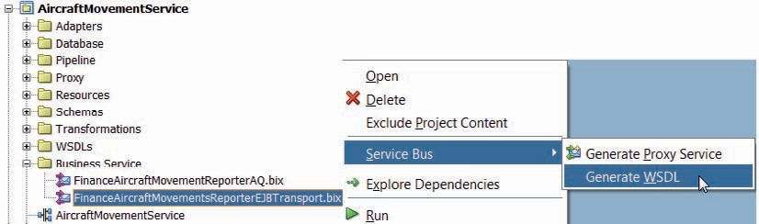

**FIGURE 6-25.** *Generate the WSDL for the Business Service with EJB transport*

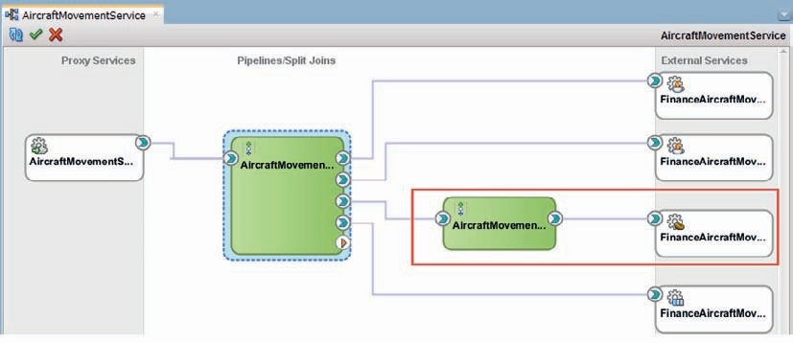

**FIGURE 6-26.** *Service Bus project with the dispatcher AircraftMovementPipeline and the*

*channel specific pipelines*

##### Invoking a Remote EJB Using a JNDI Provider

If your EJB is remote—running on a different Java EE Server (than the local WLS that also runs the SOA Suite)—then you need to add a JNDI provider for your EJB. A JNDI Provider resource allows you to specify the communication protocols and security credentials used to retrieve EJB stubs bound in the JNDI tree of remote Oracle WebLogic Server domains or third party application server instances.

In our case, where the EJB is really local, we can still configure a JNDI Provider that references the local EJB container and pretend it is remote, just for educational purposes.

Right click on the Resources folder. Select the context menu option New | JNDI Provider. The JNDI Provider wizard appears. Set the name of the JNDIProvider to *FinanceJNDIProvider*. Click Finish. The JNDI Provider is created—without configuration details. The editor opens to allow you to complete the definition.

Provide a description as you see fit. Most importantly: set the Provider URL property that specifies where the remote WebLogic domain is to be found. In our case: t3://localhost:7101.

In order to use the JNDI Provider, we have to use a different setting for the endpoint URI in the Transport section of the Business Service. The format of the endpoint URI in case of a JNDI Provider is: ejb:jndi_provider:jndi_name. In this case that means that the endpoint URI should be changed to:

 ejb:FinanceJNDIProvider:FinanceAircraftMovementReporter#saibot.airport. finance.FinanceAircraftMovementReporter

Save all changes and test the *AircraftMovementService* with the JNDI Provider inside.

#### Calling Out to EJBs from SOA Composite Applications

SOA composites can call out to external services over an SOAP and REST binding—both over HTTP—as we have seen in the previous chapters. Using JCA adapters, they also can talk to file system, database, JMS destination, and email server. There is support too for EJB bindings that interact over RMI with local or remote Enterprise Java Beans.

The EJB binding reference in SOA composites is configured through the EJB Adapter wizard. The wizard asks for the JNDI lookup name for the EJB, the Java Remote EJB Interface, and whether the EJB Binding is WSDL (SDO) based or Java based. In case of an SDO style EJB the wizard requires the WSDL that describes the service provided by the EJB. The parameters sent into the EJB service and returned by it in that case are SDO types. That means that they are described in an XSD that follows the SDO specifications. As we have the parameter definitions generated for us, it is not too large a burden on the developer to work with these SDO enabled EJBs. However, it means that we have the EJB has to be implemented in the SDO way—which may not be possible or desired at all. Working with a Java (interface) based EJB Binding is usually the easier option.

##### Implement the Outbound EJB Interaction

Open project *AircraftMovementServiceSOAcomposite* and open the SOA composite editor. Drag the EJB Adapter from the Technology section of the component palette to the External References lane and drop it.

The EJB Adapter Configuration wizard appears, see Figure 6-27. Set the name of the adapter binding to *FinanceAircraftMovementReportEJB*.

Set the Type to *reference* (for outbound) and Version to EJB 3. The interface is Java. The JNDI name is the same as before with the EJB transport in the Service Bus composite: FinanceAircraftMovementRe porter#saibot.airport.finance.FinanceAircraftMovementReporter. Select the jar file that was deployed in the EJB project and that was previously imported into the Service Bus project. Again, JDeveloper prompts you to import the JAR file. Accept the offer to have the file copied to the SCA-INF/lib directory.

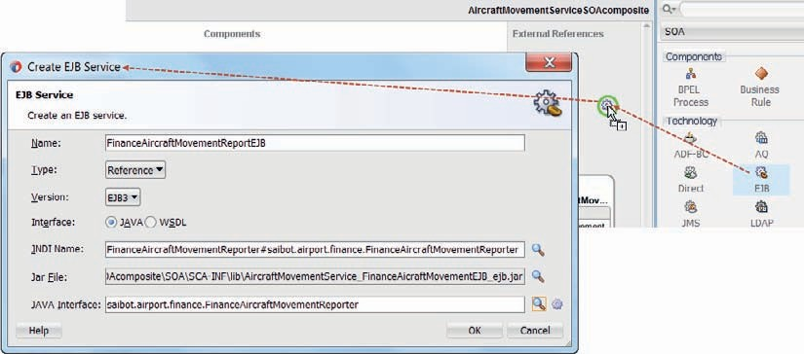

**FIGURE 6-27.** *Configuring the EJB Reference binding for the EJB FinanceAircraftMovementReporter*

Browse for the Java interface saibot.airport.finance.FinanceAircraftMovementReporter. Then press the OK button to have the EJB Adapter binding generated.

Next, create a wire from the mediator component to the new EJB Adapter binding.

At this point, we can choose: either the Mediator will have a single routing rule to the JMS adapter or the EJB binding, or it will have two routing rules that are both executed. In the latter case the aircraft movement is reported to both the JMS queue and the Financial EJB. Mediators can have multiple routing rules—as we have seen in the beginning of this chapter—and they can all be executed (in case of a one-way service interface).

Ensure that at least one routing rule in the mediator is set up to invoke the EJB binding. Then deploy the SOA composite and invoke its *AircraftMovementService*. Verify the message flow trace or the console window with the logging from the Integrated WLS to establish whether indeed the EJB has been invoked.

### Expose Inbound EJB Interfaces

Services exposed from the SOA Suite—whether they are implemented through Service Bus or SOA composites—can be exposed in various ways. The most common is the web service binding or transport that supports SOAP/XML calls over HTTP. We have discussed support for RESTful services, also over HTTP. And now we will look at exposing the service as an EJB over RMI. Both Service Bus composites—using the JEJB transport and SOA composites, through the EJB adapter— can easily be exposed as EJBs. Consumers of these services interact with such EJBs like they do with regular EJBs—no specific SOA Suite aspects are involved. The onus of translating from the world of the Java interface and serialized Java objects to WSDL and XML is on the SOA Suite.

###### NOTE

*With the ever increasing support for web service interaction in Java— through for example JAX-WS and JAX-RS—the relevance of direct EJB interaction is somewhat decreasing. EJBs are primarily used when transaction and security scope are important.*

The online complement to this chapter describes how to expose both the *AircraftMovementService* Service Bus project and the *AircraftMovementServiceSOAComposite* through an EJB interface, next to their existing web service endpoints. It introduces various inbound EJB interaction styles supported by the SOA Suite: inbound JEBJ transport, the inbound EJB adapter, and the direct binding facility.

### Summary

This chapter introduced a number of new ways of interacting with and from the SOA Suite. In addition to the HTTP-based REST and SOAP style web services we had encountered in previous chapters, we have seen how using special transports in Service Bus or with JCA adapters in both Service Bus and SOA composites, we can achieve interaction over JMS, AQ, and EJB/RMI with external systems. The UMS adapter adds the option of interacting over email or instant messaging with external human actors.

Most interactions discussed were outbound—with the initiative from the SOA Suite service. These services were all asynchronous and more than that: one way (only). A request message is

delivered at the SOA Suite’s endpoint to be handled after the HTTP handshake is completed and without the invoker waiting for the result. This message exchange pattern adds a level of decoupling that is frequently desirable to simplify in complex architectures. Of course, most of these adapters and transports can also be used for inbound interactions and for other message exchange patterns such as request/reply.

Additionally, this chapter demonstrated how we can publish services from the SOA Suite with an EJB interface over the RMI protocol—using the JEJB transport in Service Bus or the EJB adapter and the Direct Binding API with SOA composites.

A topic on top of all these protocol discussions is content-based routing or the ability to handle messages in a way that is dictated by their specific contents. The conditional branch in Service Bus proves an excellent way of routing messages based on conditions evaluated against the message contents. In SOA composites, the filter expressions on routing rules in the mediator do a very similar thing.

